POLITICS
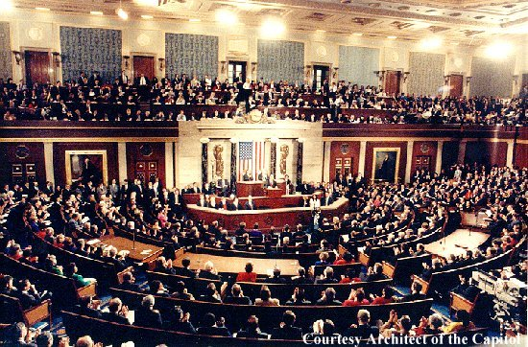

+

THEATER
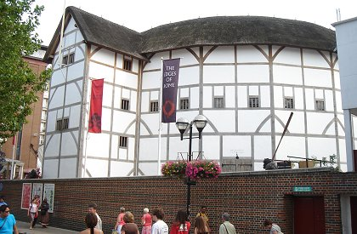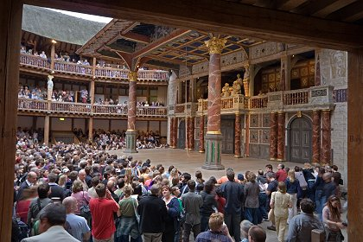

=
The THEATRICALITY of POLITICS



- “Unity” New Hampshire?
- “She rocks”?!
- “Unite for Change”?!
- “To anyone who voted for me and is now considering not voting or voting for Senator [John] McCain, I strongly urge you to reconsider […] to create an unstoppable force for change we can all believe in.”
- “Unity is not only a beautiful place as we can see, it's a wonderful feeling, isn't it?”
- “I've admired her as a leader, I've learned from her as a candidate. She rocks. She rocks. That's the point I'm trying to make. […] I know firsthand how good she is, how tough she is, how passionate she is, how committed she is the causes that brought all of us here today.”

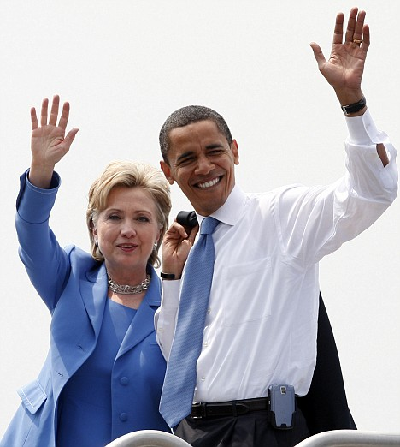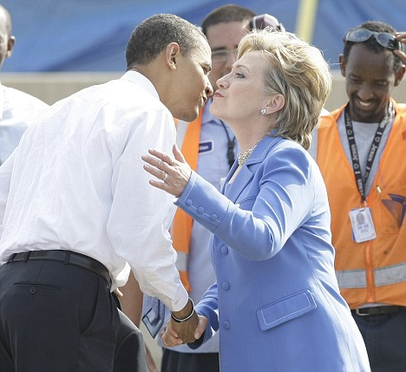
<http://www.dailymail.co.uk/news/worldnews/article-1029952/
Unity-Clinton-Obama-helps-pay-debts-declares-We-family.html>
<http://www.abcnews.go.com/Politics/Politics/story?id=5260946&page=1>
QUESTION EVERYTHING!

- Your GOVERNMENT
- Your FAMILY
- Your TEACHERS
- Your FRIENDS
- Your ROMEOS & JULIETS
- Your Presumptions
- Your Prejudices
- Your Likes & Dislikes
- Your Values
- Your Actions
- Your GOD
- 

