RACISM in STAR WARS

5.
Watto and the Toydarians
Watto runs a pawn store in Mos Espa where he owns Anakin Skywalker and his mother. He’s is a greedy merchant, so obsessed with money and property that he even buys and sells humans as slaves. George Lucas obviously thought long and hard about what characteristics to give his ultra-capitalistic greed alien, and then decided that the most important feature was a long, hooked nose.
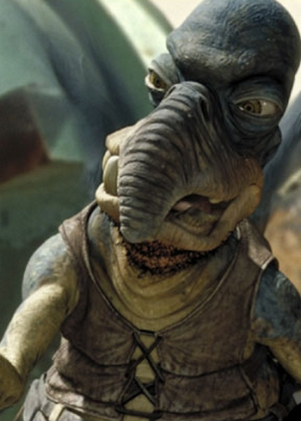
The B’nai Brith isn’t going to like this one.
As if the nose and the noticeable Middle Eastern accent didn’t beat the audience over the head enough, in the second movie, Watto has gained both a beard and a spiffy hat that somehow looks familiar.
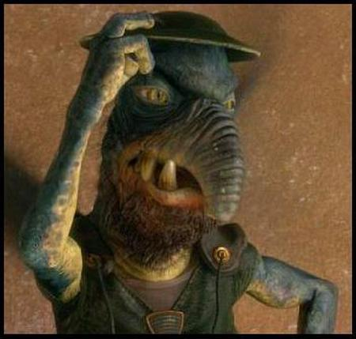
Well that’s really not so ba…

Oh.
That’s right, Watto is Jewish. And apparently, he’s also embraced Hasidism by the time of Attack of the Clones. Perhaps that’s why Jedi mind tricks, associated with Christianity in The Phantom Menace via Anakin’s virgin birth story, don’t work on him? He obviously doesn’t accept the Midichlorians as his personal lord and savior.
4.
The Sandpeople
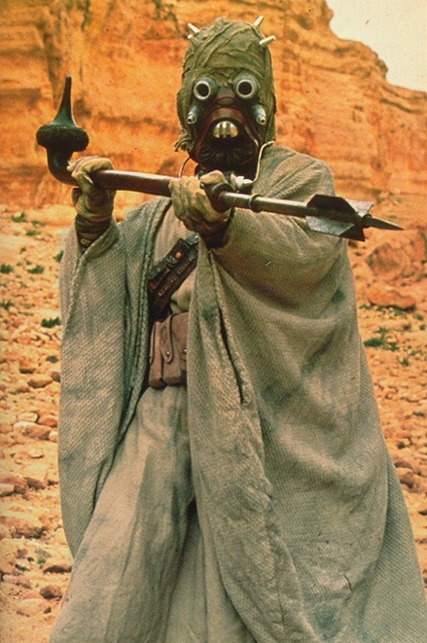
Sandpeople, or Tusken Raiders, are Tatooine-based vicious brutes who live out in the desert. They wear long pale robes and keep their faces covered. And they’re apparently so incompetent and backwards that Ben Kenobi calls their blasting skills less accurate than those of the Imperial Stormtroopers.
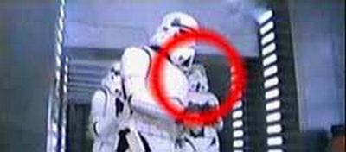
Yeah, these sharpshooters.
And then there’s the fact that they are called sand people, for god’s sake. It’s no huge leap to figure out which ethnic group Lucas is trying to smear with this particular race of aliens.
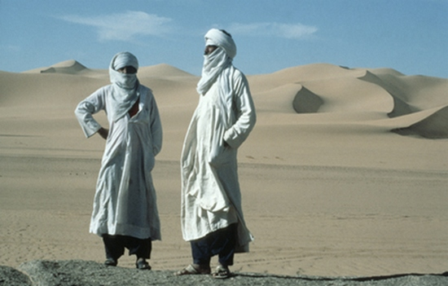
They have much nicer robes though.
That’s right, the Arabs are next on the long list of groups that Star Wars apparently has a problem with. And when it comes to the new trilogy’s depiction of Sandpeople, it’s no longer enough just to embrace racial stereotypes. Lucas must also make his main characters act towards them with chilling bigotry. After Anakin attacks a village of Sandpeople, ruthlessly slaughtering their women and children, he confesses the act to Padme, one of the enduringly ‘good’ characters who we’re presumably meant to find heroic. “They’re like animals, and I slaughtered them like animals,” he says. “I hate them!”
“Anakin,” Padme responds to his anguished confession. “What’s wrong?”
In other words, a man has just told her that he has slaughtered a bunch of innocents of a different race, and she’s asking him what the problem is.
3.
Nute Gunray and the Neimoidians
Neimoidians are the race who ran the Trade Federation, several members of whom conspired with Emperor Palpatine and several other evil dudes to undermine the Republic. They tend to talk in a funny accent, mixing up their ‘l’ and ‘r’ sounds. Their colony planets had Japanese-sounding names like Cato, Deko and Koru. They also wear funny hats and gowns that make them look like a cross between Chinese emperors and felt elephants.
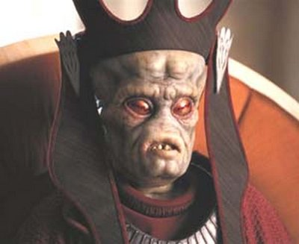
Also, a chin butt that would make Ben Affleck blush.
We’re a bit confused about these aliens, though. Sure, they’re evil, cowardly and scheming like all the non-white races in Star Wars are, but Lucas didn’t really go for any of the ripe ethnic stereotypes that he could have. Nute Gunray is at no point shown enjoying Sarlaac tentacle porn, and the Neimoidians never once come at Anakin one by one to beat him with their kung-fu skills. But hey, maybe these scenes were just left on the cutting room floor.
1.
Jar Jar Binks and the Gungans
The planet Naboo is inhabited by two races: the cultured humans who build beautiful palaces and hold a cultured royal court and the Gungans who live underground and don’t understand technology. The main Gungan in Star Wars is Jar Jar Binks, a dimwitted but ‘loveable’ klutz who ends up helping out our beloved heroes. In the world of George Lucas, Gungans are also known as black people.
But Jar Jar’s skin is orange, you say. And black people don’t have long ears! Well, here’s a picture of the guy who played Jar Jar, and provided him with both his voice and gait:
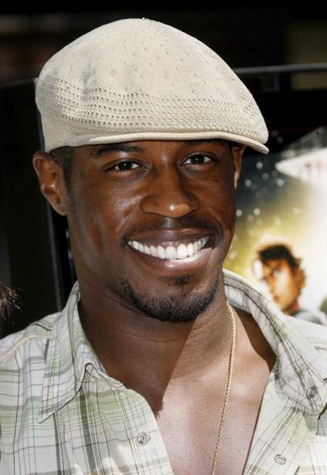
It’s okay to be jealous of his hat.
Is there something George Lucas is trying to tell us?
Jar Jar speaks in a barely understandable simplified language. At first the audience assumes that English is not his first language, and that a kind of lingua franca has developed between the English-speaking human inhabitants of Naboo and the Gungans to allow them to communicate. However, when we see Jar Jar’s home, we discover that he communicates to the King in this language and that it’s all they’ve got. Since it seems to be based on English, one assumes that before they met the pale, cultured people of Naboo, they simply communicated by flinging mud at each other.
The Gungans don’t have much to offer in way of culture, either. Political debates are settled by simply arguing really loudly and occasionally blowing raspberries. Wars are fought by slingshot, since the Naboo human weaponry apparently is too complicated. When Jar Jar actually gets his hands on a gun, tragedy is avoided only by the fact that the movie is clearly aimed at children.
It’s not that Gungans are bad people (or whatever), per se. They’re just simple, childlike loveable folk who are in firm need guidance by the upper races. One might say that they are the Nabooan’s burden.

- Steinfetchit:
- 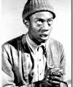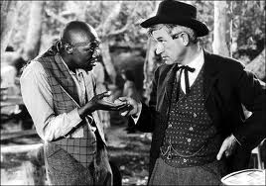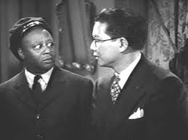e
- 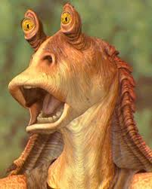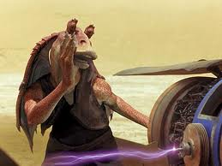
- Darth Vader is Dutch for Dark Father, the tall blond character conducting genocide
- Jimmy Smits’ character (Bail Organa) in a low rider
- 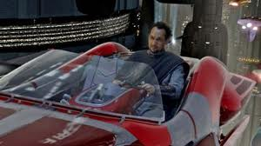

Links:
- http://www.weirdworm.com/the-five-most-racist-star-wars-characters/
- Critics say 'Clones' has racial stereotypes:
  - http://www.screamingpickle.com/members/SW/detroit_racist_panel_episode_II.htm
- The Merchant of Menace
  - http://www.slate.com/articles/news_and_politics/hey_wait_a_minute/1999/05/the_merchant_of_menace.html
- George Lucas' Jedi mind trick
  - http://www.salon.com/2000/03/22/lucas_2/
- http://black-face.com/

A Galaxy Far, Far Off Racial Mark?

Commentary

Movies: 'Star Wars' characters like Jar Jar Binks, Nute Gunray and Watto prompt comparisons to insensitive stereotypes.
May 26, 1999|ERIC HARRISON | TIMES STAFF WRITER
Even before the newest entry in the "Star Wars" saga opened last week, a comic-book store clerk in Seattle had organized a group called the International Society for the Extermination of Jar Jar Binks and set up a Web site with an address that sounds like a battle cry: http://www.jarjarmustdie.com.
From all indications, the digital animated character who debuted in "Star Wars: Episode I The Phantom Menace" is irritating moviegoers across North America. A floppy-eared amphibian who speaks a Caribbean-flavored pidgin English, Jar Jar has a snout like a sea horse and an anteater's quick darting tongue. He has been described variously as an annoying distant cousin to Disney's character Goofy and as a racially offensive throwback to Stepin Fetchit.
"I've talked to 100 people and nobody likes him," says John Hernandez, 29, a Los Angeles county worker who was among the first to see the movie. "When I came out of the theater people were talking about how annoying he was. At first I thought I was the only one, but I've heard it everywhere."
Rarely has a movie character--and a glorified cartoon character at that--inspired so much vehemence. Much of the criticism centers on what some see as Jar Jar's stereotypical racial traits. An Internet discussion group dedicated to him on deja.com had more than 13,000 postings as of Tuesday morning, many along the lines of this one: "He's written like a character out of an Uncle Remus story, and does everything but call Qui-Gon (the Liam Neeson character) 'Massah.' "
Some other Internet postings compare Jar Jar to the radio and TV characters "Amos 'n' Andy." One writer says of the movie: "It could be 'Sambo Wars.' "
Lynne Hale, a spokeswoman for Lucasfilm, called such interpretations "absurd."
"There is nothing in 'Star Wars' that is racially motivated," she said in a statement. " 'Star Wars' is a fantasy movie set in a galaxy far, far away. It is populated with humans, aliens, creatures, droids, robots and other fantastic creatures. . . . To dissect this movie as if it has a direct reference to the world that we know today is absurd."
Still, some people say the racial references are obvious.
Audience members have complained that Nute Gunray, the evil Viceroy of the Federation, seems based on Asian stereotypes. And Watto, young slave Anakin Skywalker's sleazy owner, strikes some viewers as an offensive caricature of an Arab. In addition, the Gungan, the primitive tribe of which Jar Jar is a member, is ruled by a fat, buffoonish character, seemingly a caricature of a stereotypical African chieftain.
Even though Jar Jar was performed by a black actor who says he had free rein to create the character, movie reviewer Joe Morgenstern, in an essay last week in the Wall Street Journal, called Jar Jar "a Rastafarian Stepin Fetchit on platform hoofs, crossed annoyingly with Butterfly McQueen."
The complaints call to mind the animated cartoons of the 1930s and 1940s, some of which used animal species knowingly to represent specific racial groups. (Think of the jive-talking, jazz-singing crows in Disney's 1941 classic "Dumbo.")
Todd Boyd, a USC cinema studies professor, says the practice continues in animation today, although in subtler form and sometimes for different purposes. Many American animated cartoons were blatantly, unrepentantly racist before their makers bowed to protests in the 1950s. Today, racial subtexts are more likely to promote brotherhood. Sometimes, though, even those cartoons skate on thin ice.
In "Who Framed Roger Rabbit" (1988) the sympathetic cartoon characters--"Toons," they're called, and they inhabit Toontown--were clearly treated as a racial group separate from the human race. But while the movie did not seem in any way an endorsement of racism, Boyd says he was struck by how much "Toon" sounded like "Coon," a derogatory term used against African Americans.
"It seemed so obviously racial that I didn't want to believe that one could get away with being so overt and not know it and have no one else pick up on it," he says. "It was so obvious to me, and yet it wasn't made into an issue."
He thinks that is because non-human cartoon characters and fantastic settings can obscure the subtextual messages of movies.
"If you take 'American History X' and say the character's a racist, people have no problem understanding that," he says. "But if you were to suggest that 'Roger Rabbit' had issues that were problematic racially the response would probably be, 'It's a cartoon.' The assumption seems to be that if something is geared for children then it couldn't be sophisticated enough to carry those sorts of messages."
To be sure, many viewers--particularly younger ones at whom George Lucas says the film is aimed--love these characters and see nothing offensive about them. Elliot Hartsen, a Seattle college student who saw the movie last week, said Jar Jar was "under my age bracket," but said, "If the movie is going to generate long-term appeal it has to appeal to the young generation. These are people who will be into it when the next series comes out."
But others leave the theater asking what was Lucas thinking.
The filmmaker is a famous cinephile who crams his films with borrowings and references to other works, from Saturday morning serials to classic westerns, from war movies to Japanese samurai films. "Phantom Menace," far more than the earlier movies in the series, also seems to show the influence of old Disney cartoons. (It even recycles the cartoon visual gag of a big fish gobbling up a smaller one only to get swallowed by one that's even bigger.)
Jar Jar and the other digital characters behave more or less realistically and interact with human actors in an almost seamless fashion, yet the movie could be described with little exaggeration as an elaborate, state-of-the-art cartoon featuring live action. (With three times as many computer-generated shots as any film in history, very little of this 2-hour, 12-minute movie is free of animation or digital enhancement.)
The question is whether Lucas, in rummaging through an earlier generation's musty cartoon archives, had trouble separating what is valuable and good from outdated attitudes best left undisturbed.
Problem With Race Dates Back to First 'Star Wars'
Grumbling about Lucas' work has never before been this public, but some viewers have found his handling of race problematic since he released the first "Star Wars" movie in 1977. Grousers privately noted that the movie had Wookies, robots, jazz-playing aliens and--inexplicably in this far-off galaxy--white people who spoke with British accents. But nowhere on screen were there humanoids with non-pink skin.
Lucas seemed to be trying to make up for that in "The Empire Strikes Back" (1980) and "Return of the Jedi" (1983) by introducing Billy Dee Williams as Lando Calrisian. But by then his strategy was clear. Different racial groups were represented by aliens, much like those old cartoons that used animals as stand-ins for racial groups. Thus Calrisian's race was insignificant while Chewbacca, the big, strong, over-emotional Wookie, could be seen as the hairy equivalent of Mr. T.
The frequent put-downs directed at Chewbacca underscored that, while he may be individually loved and needed, his kind was looked down upon. "I'd rather kiss a Wookie," Princess Leia spits when Han Solo gets flirtatious. "He's only a Wookie," C-3P0 says of Chewbacca in "Empire," even while being carried on the Wookie's back.
In an interview with Leonard Maltin on the digitally mastered video of "Return of the Jedi," Lucas says he'd originally intended to introduce Wookies as a "primitive race" in the third film of the trilogy. After he decided to use Chewbacca in all three films and give him the ability to fly spaceships and perform complex tasks, he created a substitute race of pint-sized Wookies for "Jedi" and called them Ewoks.
The Gungan are the Ewoks of "Phantom Menace." This tribe of incompetent but happy natives with their vainglorious leader comes straight out of the movies and cartoons of another era. That the Ewoks and the Gungan both save the day and that both movies end with the advanced and primitive races joined together in harmony is of little consequence; it's clear who holds the upper hand. "Dumbo's" crows save the day, too (and sing that movie's most infectious song to boot), but by using exaggerated stereotypes the cartoon's creators still indefensibly hold a race of people up to ridicule
and perpetuate attitudes that permeated the culture in the 1940s.
All of this said, it should be noted that many of the people who detest the character of Jar Jar say it has nothing to do with race. One Internet user observed: "He is the worst character in 'Star Wars' history, a pathetic excuse to sell toys."
Jeremy Mueller, the 23-year-old who founded the International Society for the Extermination of Jar Jar Binks, says that he started his jarjarmustdie.com Web site five days before "Phantom Menace" opened when he saw television shows about the movie that gave a flavor of what the character would be like.
"They were quoting lines from the movie, including, 'Oh, da force is maxi big,' " he says. And on the back of the Jar Jar action figure, he says, were lines that the character utters: "Mesa called Ja Ja Binks."
"How can you like a character like that?" Mueller asks. "It's a great movie, but Jar Jar really detracted from the movie as a whole."
Copyright 2012 Los Angeles Times
- http://articles.latimes.com/1999/may/26/entertainment/ca-40965/2

