UNINTENDED SUBTEXT: Subtext Gone Awry
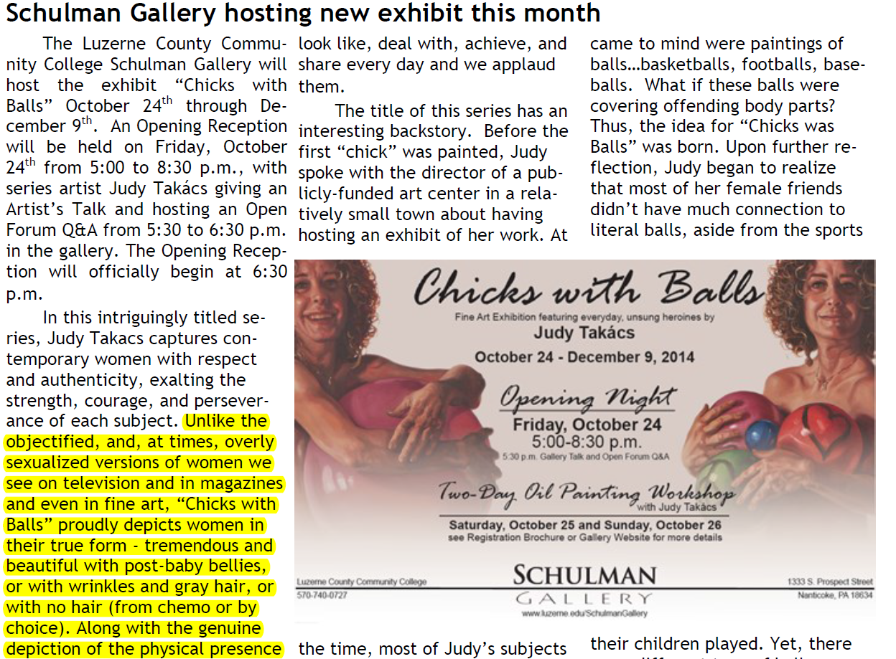
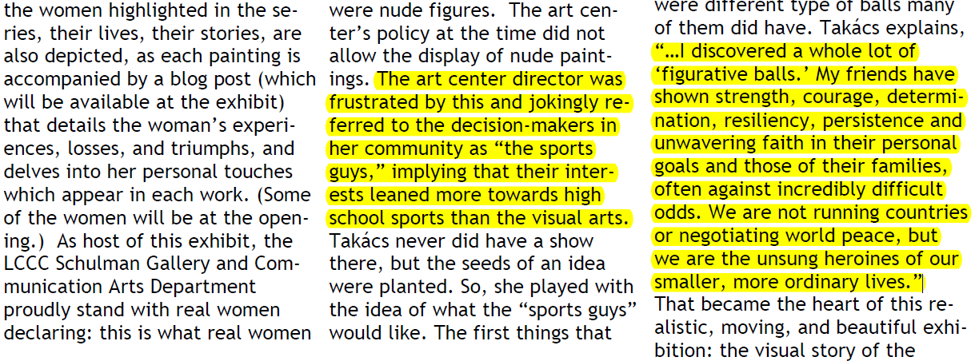
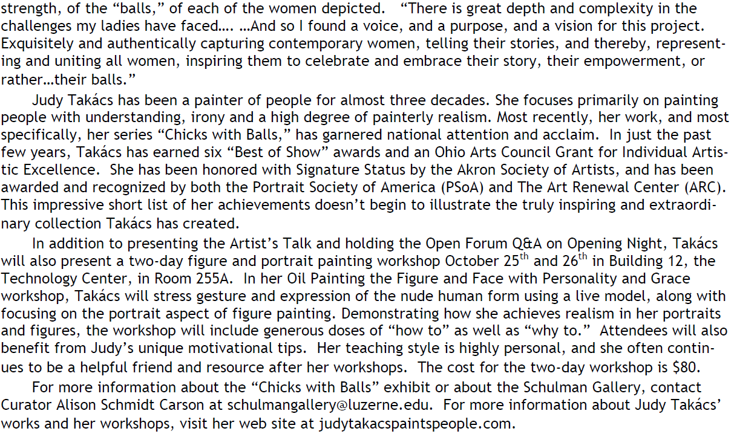

- "chicks": derogatory term for women (animal name, like dog or ....)
- "balls": adolescent use of double entendre
- *strength, courage, determination, resiliency, persistence, & unwavering faith = masculine traits
  - only men can be possess these traits b/c they have "balls"
- *similarly, women must be defined through men
  - women cannot be defined in & of themselves, regardless/independent of men
  - "wo-men"
- covers female sex organs with masculine balls
- sexist against men: all men = "sports guys" (especially if they disagree with her)
- still objectifying women (to sell her art); sex for titillation

