SIDE #3

This paper is more REPORT than ARGUMENT: Your objective is to report on the 2 sides to the issue – fully, fairly, and objectively; your objective is not to “win” or “beat” your opponent. Since, then, the Body essentially summarizes the issue/debate, Side #3 at the end is a way of moving the issue forward – a conclusion to the Conclusion, if you will.

It can be your opinion; it can also come from one of your sources (cite!); or it can come from both -- I'm looking for suggestions (plural) for a compromise.

At that point in the essay, we may ask: OK, so that’s what Side #1 has to say & that’s what Side #2 has to say, so where do we go now, how do we move forward, how do we resolve the deadlock? Think “bi-partisanship” in politics: where can both sides come together, what concessions can a side make? Take the best of both sides.

Dr. Tannen in her article speaks against our “argument culture,” in which everything’s always a war, a battle, so 2 sides butt heads ad infinitum & ad nauseam & nothing ever gets done or resolved.


Envision 2 rams smashing heads: no “communication” is going on here & no one is “listening” to the other.

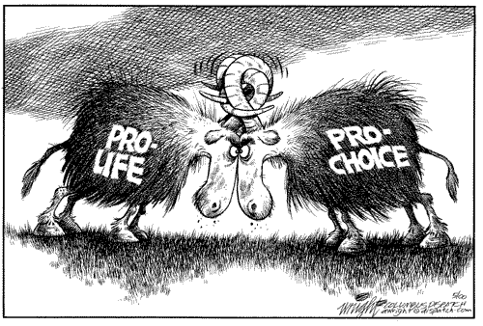
The issue of ABORTION provides us with a valuable example: Proponents and opponents have been butting heads for decades now and nothing has been resolved. However, the issue does, in fact, have a common Side #3: its common points involve late-term abortions, cases of rape, and cases of incest. Thus, both sides can typically agree to these points without compromising their respective values/beliefs.

For me, Side #3 is the most important part of the paper, for it represents the critical thinking skills at the heart of this course’s learning objectives – the theme of the course, if you will. So it should NOT be “blown off,” completed half-heartedly because you’re tired at the end of the paper and have something better to do; no, it should be plural & it should be well-considered. I’m not asking you to have all the answers, to have the perfect solution to this complex problem, but I am asking you to think critically, think long and hard about ways this can be resolved (spitballing, as it were). Do your hard work justice and end the paper on a high note that points the way to a solution, to an “adult” temperament, and to another essay.

