SHAKESPEARE AUTHORSHIP
(Notes from Shakespeare Bites Back: Not So Anonymous)

CONTEMPORARY EVIDENCE:
- Attribution:
  - 39 title pages of 16 plays in 1st editions & early reprints
  - plays in the registers of the Stationers’ Company of London (est. 1403/inc. 1557, publication – license to publish a work)(trade guild, livery co. of printers, publishers, & booksellers)
    - Stationer = “meaning a practitioner of any of the trades involved in book production, including binding, parchment making, and copying, and after 1557 referring more strictly to a member of the Stationers' Company, which was incorporated in that year” (UPenn, below)
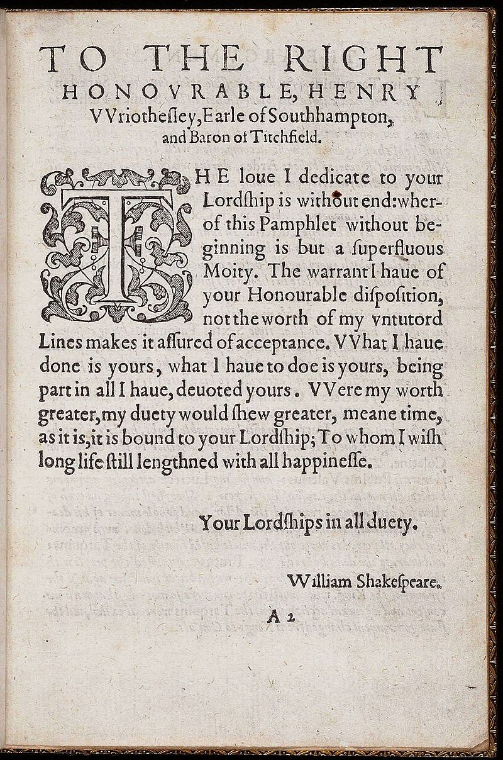
    - “All books had to be approved, or allowed, by the authorities before they could be printed. This was usually the responsibility of the bishop of London or the archbishop of Canterbury. There were fees for such approval, and the regulation was not always enforced. In addition, all books approved for printing had to be licensed by the Stationers’ Company before the work could be done. The licence, which cost 6 old pence, gave the owner of the copy (usually the publisher or the printer) the exclusive right to print the text. The owner often entered his copy in the register of the Stationers’ Company, as proof of his ownership. // There was no copyright, in the modern sense, in Shakespeare’s time. The author of a book had no rights in his work. The owner of a manuscript had no right to publish it. Only the Stationers’ Company licence gave the owner of the copy the right to publish a work. Once a stationer had a licence, he could publish the work without the knowledge or consent of the author.” (book trade UK, below)
- Signature: (1593)
  - The Rape of Lucrece
  - Venus & Adonis
    - the dedications to both bear his signature
- POEMS:
  - Rape & V&A, printed in London, by friend & Stratfordian Richard Field
  - maybe w/SHK’s presence (1st editions = neat, error-free)
- POEM: (1601)
  - “The Phoenix & the Turtle” = attributed to SHK
  - by Robert Chester in Love’s Martyr (1601)
- SONNETS:
  - published in 1609
  - title page = “Shakespeare” (no “William” = wellknown/popular)
- CONTEMPORARIES on SHK:
  - by name, as a writer (of plays & poems)
  - Henry Willobie, William Covell, Richard Barnfield, John Weever, Thomas Freeman, Anthony Scoloker, anonymous Parnassus playwright (w/a character who wants a “pin-up” of SHK, poet of V&A)
  - Henry Chettle, William Camdem, William Barksted, Leonard Digges, John Webster
- FRANCIS MERES: (1598)
  - Palladis Tamia, Wit’s Treasury
  - names 12 plays by SHK
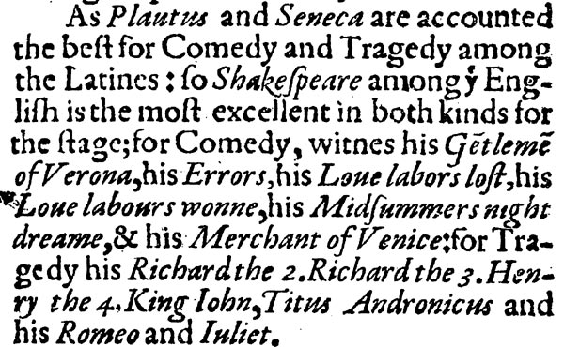
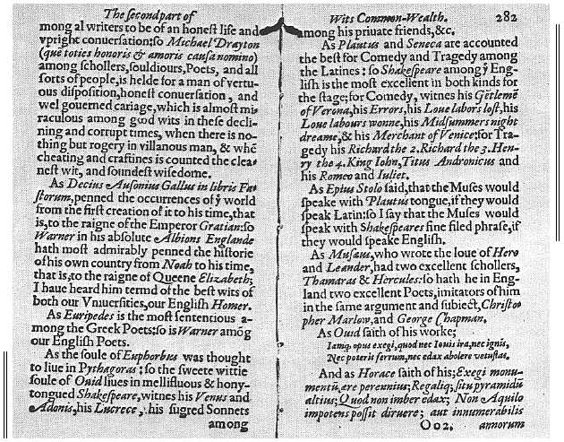
  - SHK as writer of comedies, tragedies, histories
  - mentions Earl of Oxford (as a writer of comedies only) in the SAME sentence, as 2 different people
- OTHER REFERENCES:
  - SHK as actor & shareholder in Lord Chamberlain’s Men & King’s Men
  - SHK as actor in Ben Jonson plays

POSTHUMOUS EVIDENCE:
- 1st FOLIO: (1623)
  - FF = dedicated to brothers & theater patrons Earl of Pembroke, Earl of Montgomery
  - Ben Jonson x2 – verse tribute to SHK (“sweet swan of Avon”) & poem
  - Heminges & Condell’s letter – “advertisement,” apology, to SHK’s readers
    - how SHK wrote (came out so well no need for r/w)
    - apology for bad quartos
- TIMBER JONSON (1640)
  - notebook entry
  - how SHK wrote (“never blotted out a line”)
- BEN JONSON (1619)
  - conversations w/William Drummond (1618-19, over Christmas)
  - from the notes of Drummond
  - BJ on SHK (+/-)
- COMMENDATORY POEMS:
  - Ben Jonson, Hugh Holland, James Mabbe, Leonard Digges
  - 1633 elegy on SHK by William Basse (written soon after SHK’s death)
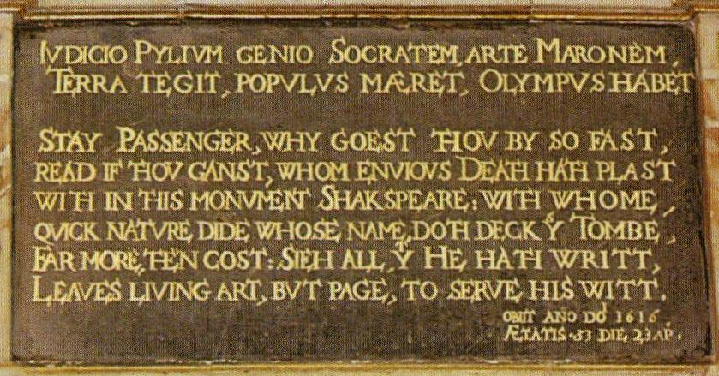
    - connects SHK to Francis Beaumont, Edmund Spenser, Geoffrey Chaucer
    - SHK as a writer & actor of tragedies
- 2nd FOLIO: (1632)
  - John Milton’s tribute sonnet
- HOLY TRINITY CHURCH:
  - Stratford-upon-Avon
  - memorial verses on monument
  - SHK as a writer (x3) & compares to Virgil & Socrates

ANTI-SHAKESPEARE CONSPIRACY THEORIES:
- 1850s & Delia Bacon’s theory
  - DB: works = written by committee, headed by Sir Francis Bacon
  - Mid-19th C era:
    - inherited Gothic & Romantic tradition
    - reacting to Darwin
    - beginnings of detective fiction
    - emphasis on biographical readings of literature (which often formed a basis for literary works of the time – Wordsworth’s Lyrical Ballads Romanticism that suggests art arise from personal experience; Bronte’s Eyre, Dickens’ Copperfield, Tennyson’s In Memoriam)
- ALTERNATIVES:
  - @ 77 possible people
  - Queen Elizabeth I, James I
  - Francis Bacon, Christopher Marlow, Edward de Vere (17th Earl of Oxford)
  - Earl of Rutland, Lady Mary Sidney, Fulke Greville, Sir Henry Neville
  - Daniel Defoe, Lancelot Andrewes, Miguel de Cervantes, Edmund Campion, Sir Thomas More
- NAMES:
  - Derek Jacobi, Mark Rylance – actors who’ve shifted allegiances
  - Mark Twain, Sigmund Freud (fallacious biographical readings)
  - Academia: Concordia University (Oregon), Brunel University (UK)
    - “SHK Authorship Studies”
  - Dean & Chapter of West Minster Abbey (? by Marlowe’s death, commemorative window in Poets’ Corner)
- CLAIMS:
  - evading taxes, hoarding grain, litigiousness, bad handwriting
  - autobiographical reading of works
  - Richard II performance at Sir Edward Hoby’s home
  - no books mentioned in SHK’s will
  - no evidence he went to grammar school
  - his children = illiterate
  - bad handwriting = illiterate & uneducated
  - couldn’t have written about Italy b/c he couldn’t have travelled abroad
  - couldn’t have written about aristocracy or royalty b/c he was a commoner
  - biographical readings of plays & poems

REBUTTALS:
- COLLABORATION:
  - SHK didn’t write alone, start & end of career had assistance (common for age)
    - George Peele parts of Titus Andronicus, Thomas Middleton on versions of Macbeth & Measure for Measure, Thomas Middleton on Timon of Athens, George Wilkins in Pericles, John Fletcher in Two Noble Kinsmen & Henry VIII/All Is True (joint authorship)
  - Yet…conspiracy theory would have their Alternative as an isolated genius
- “Misplaced learning & false reasoning are superficially dressed up as scholarship.” (p.12)
- follow the $$$$: relative of Earl of Oxford, relative of Bacon
  - whoever pays most = most popular candidate for “real” SHK
- *BIOGRAPHICAL READINGS…w/CAUTION:
  - death of Hamnet (1596) & Lady Constance’s speech in King John (3.4.93-8)
  - death of John SHK (1601) to Hamlet (Freud’s faulty theory, based on wrong dates of play)
  - sonnets
    - puns on his own name (Will) in 134, 135, 136, 143
    - ties to events in his own life?
  - Hamlet – Elsinore = QE court & start making parallels, of Earl Ox’s secret adventures veiled as dramatic confession
  - R2 @ Hoby House-
    - no mention of a play (painting, book)
    - no mention that it’s R2 (just King Richard)
    - no mention that it’s SHK’s R2
    - no mention that SHK would be there
    - assumption that SHK would be out of place among aristocracy
  - Richard Field as Richard du Champ in Cymbeline

  - *based on belief that writing MUST be autobiographical
    - NO imagination, ONLY through personal, 1sthand experience
      - (Stephen King?)
      - (so, only the rich, educated can make art?)
    - BUT??:
      - book learning
      - objects of art
      - what about plays set in Ancient Rome, Egypt, medieval England
  - *biographical readings must be derived from facts of history, knowledge of era, analytical skill for applying this data to the author & work
      - cannot use conjecture or conspiracy theories, instead of facts
  - *CT enslave works to biographical readings ONLY – no other kind of readings are possible
- GAPS:
  - lack of evidence used as evidence
  - gaps in SHK’s historical record
    - no personal diary, no letters, ledgers
    - BUT this is common for the time
- Social Mobility:
  - SHK’s & Elizabethan society
  - (presuming SHK wouldn’t fit in w/aristocracy or wouldn’t know anything about court)
  - upwardly mobile family (father in Stratford)
  - upwardly mobile in London (as playwright – Lord Chamberlain’s Men, King’s Men)
    - plays performed at court
    - increased access to court circles
- books in will:
  - books = chattels (belongings) = in inventory – which is lost to history
- grammar school:
  - was a grammar school in Stratford since 1490s
  - established under Edward VI charter in 1553
  - attendance records = from 1800 onward only
  - entitled to free education, as son of alderman
- grammar school:
  - only a grammar-school education would have been required to write the works of SHK
- illiterate children:
  - Susanna (eldest child) signed documents & was described as “’witty above her sex’” (p.23)
- Revisionist History VS. Conspiracy Theory
  - RV re-examines existing evidence w/an open mind
  - CT comes w/a pre-ordained, close-minded conclusion (subjective) & looks to “prove” it by purposefully ignoring existing evidence
- *CONSPIRACY THEORIES:
  - not objective: biased, come w/an agenda
  - deny existing historical evidence
  - feel a need to fill in historical gaps (w/non-historical conjecture or fantasy)
  - or, claim the gaps = evidence of a cover-up
  - parasitic: sucking on the blood of a healthy host
    - attack the truth to feed off it
    - has no independent life of its own
    - “existing only in contradiction to well-established truths” (34)
  - claim to be “keeping an open mind”
    - but come w/prefabricated conclusions
    - & insinuate that everyone else is being close-minded
  - Tannen’s “Argument Culture” – must be an opposite side of the argument
    - if there was a SHK, then there must be a claim (equally valid) that there wasn’t (bastardization of Newton’s 2nd Law of equal & opposite reaction)
    - true debate can only exist when “only where there is room for plausible and rational disagreement or difference of opinion” (34)
  - CT “set out to offend, disrupt, and undermine the truth” (34)
    - parasitic motives, anarchy in academia
  - Historians & SHK scholars vs. well-educated non-specialists
  - limit the interpretations/readings of works to Biographical Criticism only
  - ANALOGY: “As the former director of The Folger SHK Library, Gail Kern Paster, has said, ‘to ask me about the authorship question is like asking a paleontologist to debate a creationist’s account of the fossil record’” (p.26)
- SHK Conspiracy Theory = cultural phenomenon:
  - magical thinking era
  - post-modern era
  - treatment of or understanding of history
  - psychology of conspiracy theories
  - treatment of literature & texts
- ANONYMOUS Film:
  - based on a book by a relative of the Earl of Oxford
  - starring 2 anti-Shakespearians (Jacoby & Rylance)
  - basis: Earl used SHK actor as a front man to avoid the shame of an aristocrat writing plays for the public theater
  - shows SHK the actor as drunk who can barely form words, paid by Earl (too drunk to talk = too drunk to write)
  - shows Earl as isolated genius (though most collaborated)
  - claims SHK took credit for Earl’s works (some written after Earl died historically in 1604)
  - Earl = supposed child prodigy, writing & starring in MSND in 1559 at court (several decades before the play was actually written)
  - Earl = secret lover of & father of illegitimate child with Queen Elizabeth (though also supposed to be the secret illegitimate child OF Queen Elizabeth)
  - has audience call for “playwright!” (though the word isn’t recorded until 1687)
  - SHK the actor = backwater hick
    - portrays fantasy as historical fact
    - anachronisms & inventions
    - $$$$
- HISTORY:
  - = complex, messy, with gaps
  - Historical facts & evidence = informed by deep knowledge in order to understand them (34)
  - “History is never as tidy as conspiracy theories would have us believe” (34)
    - gaps = natural: we know @ SHK more than some & less than others; # of SHK’s gaps = about the same as others
- PLAGIARISM:
  - theft of intellectual property
  - steal the reputation & achievements of one person & give to another

FALLACIES:
- Ad hominem: Consp. Theorists attack SHK:
  - evading taxes, hoarding grain, litigiousness, bad handwriting
  - “couldn’t have”
- Ad hominem: Consp. Theorists attack SHKians:
  - anti-postmodernism
    - PM makes much of gaps in narrative/history/documents
    - regards all evidence as relative
    - regards all evidence on equal terms
      - BUT no gaps, gaps are not evidence of cover ups
  - leaving abusive, slanderous, offensive messages on SHK sites
- Snob Appeal:
  - alternatives = ALWAYS aristocratic or university-educated people
    - “aristocratic privilege” (35)
  - “couldn’t have” arguments (education, travel, court)
- Understatement, acting innocent:
  - “we’re just”
  - “only” asking people to consider the intellectual & cultural phenomenon of the discussion
  - false claim of impartiality
    - wolf in sheep’s clothing
    - the “innocent flower” excuse
- *AD IGNORANTIUM:
  - lack of evidence used as evidence
  - “absence of evidence is never the same as evidence of absence” (24)(34)
  - gaps in the historical record (no personal letters, diary) -
    - MUST be filled
    - are “evidence” of a cover-up/conspiracy
  - “couldn’t have” arguments (no evidence he went to Italy, so didn’t PLUS couldn’t have b/c of no evidence of his education)
- *CARD STACKING:
  - purposeful ignoring of existing evidence
  - denial of history, of contemporary & posthumous evidence
- assumption that SHK would be out of place among aristocracy
  - ad hominem attack on SHK as “hick”
  - not enough info, historical understanding of social mobility
- faulty induction:
  - presume 1 perceived “problem” in history
  - will “prove” the whole case against SHK
    - R2 @ Holby House
- *Magical Thinking
  - Conspiracy Theory (& Academia’s allowance of it)
  - “allow these fantasies to have the same status as properly informed interpretations of the facts. It might be enticing to believe in stolen documents, secret codes, buried treasure, and illegitimate children of Elizabeth I.” (p.19)
    - Deborah Tannen & Holocaust deniers
    - History Channel showing Ancient Aliens next to actual history
- Cart before horse fallacy:
  - “It is easy for anyone to have an opinion or to start speculating & then to set out to try to create an argument to support their case” (34)

OTHER SOURCES:
- James Shapiro:
  - Contested Will: Who Wrote SHK? (2010)
- 60minuteswithshakespeare.com
- esu.org/news/item.asp?n=12890
- shakespeareauthorship.com
- shakespeare.org.uk
- BloggingShakespeare.com
- Finding-Shakespeare.co.uk
- RememberingShakespeare.com
- Livingshakespeare.com
- MaryArdensFarm.com
- ShakespeareGuides.com

- SHK & the STATIONERS:
  - Stationers’ Company of London
  - http://www.upenn.edu/pennpress/book/toc/15049.html
  - https://www.google.com/url?sa=t&rct=j&q=&esrc=s&source=web&cd=2&cad=rja&uact=8&ved=0CCUQFjAB&url=https%3A%2F%2Fkb.osu.edu%2Fdspace%2Fbitstream%2Fhandle%2F1811%2F28932%2FSHAKESPEARE_AND_THE_STATIONERS.pdf%3Fsequence%3D1&ei=o-aTVejmC8mUyASY6KjwAw&usg=AFQjCNE2vqj2h0b3vATHee6c6MPW5N1Gpw
  - http://www.bl.uk/treasures/shakespeare/booktrade.html
  - http://www.britannica.com/topic/Stationers-Company

- Authorship:
- http://shakespeareoxfordfellowship.org/discover-shakespeare/
- Shakespeare Authorship
shakespeareauthorship.com/
  - Cached
  - Similar
This page is dedicated to the proposition that Shakespeare wrote Shakespeare. Anti-Oxfordian arguments from a traditional point of view.
‎How We Know That ... - ‎List of References to ... - ‎Non-literary References - ‎Shaxicon
- The Shakespearean Authorship Trust, who really wrote ...
www.shakespeareanauthorshiptrust.org.uk/
  - Cached
  - Similar
For four hundred years, doubts have been recorded about whether William Shakespeare actually wrote the works attributed to him. This website offers the ...
- Authorship Debate - Absolute Shakespeare
absoluteshakespeare.com/trivia/authorship/authorship.htm
  - Cached
  - Similar
The Shakespeare authorship debate continues to rage unabated.
- Welcome | Shakespeare Authorship Coalition at ...
https://doubtaboutwill.org/
  - Cached
  - Similar
The Shakespeare Authorship Coalition runs this website to introduce the Shakespeare authorship controversy, or Shakespeare authorship question, and let ...
- Declaration of Reasonable Doubt | Shakespeare Authorship ...
https://doubtaboutwill.org/declaration
  - Cached
  - Similar
This page shows the Shakespeare Authorship Coalition's "Declaration of Reasonable Doubt About the Identity of William Shakespeare," which provides an ...
- Shakespeare Authorship 101 | Shakespeare Oxford ...
shakespeareoxfordfellowship.org/discover-shakespeare/
  - Cached
Jul 18, 2013 - Shakespeare, alone of all the great writers in Western civilization, presents a unique enigma. Despite two hundred years of scholarly attempts ...
- Shakespeare Authorship Roundtable - Home
www.shakespeareauthorship.org/
  - Cached
  - Similar
Aiming to offer an opportunity for the independent scholar to be heard by a critical but receptive audience.
- Authorship of Shakespeare's Plays
web.cn.edu/.../shake_did_write_plays.html
  - Cached
  - Similar
Carson–Newman University
Loading...
Yes. There is an academic minority view (held by perhaps a handful of serious scholars at any time) that somebody besides Shakespeare wrote the plays, but I ...

- Shakespeare: The Question of Authorship
www.nytimes.com/2010/05/02/books/review/McCarter-t.html?...all
But the alternate histories offered by people who reject Shakespeare's authorship are far stranger, abounding in secret ciphers, baroque conspiracies and readings of the plays as ...
- Who Wrote Shakespeare's Plays? Debate Goes On
www.npr.org/templates/story/story.php?storyId=92142217
Shakespeare Authorship Research Center. In the mid-1800s, Americans were so enthused about William Shakespeare that a rivalry between the two foremost Shakespearean actors ...
- Who really wrote Shakespeare?
www.theguardian.com/culture/2010/.../who-wrote-shakespeare-james-shapi...
Entitled Contested Will, it bore a fatal subtitle, "Who Wrote Shakespeare?". Apparently, Professor Shapiro had gone over to the dark side, the blasted heath of the authorship question.

Searches related to SHAKESPEARE AUTHORSHIP
shakespeare authorship controversy
shakespeare authorship debate
shakespeare authorship essay
francis bacon shakespeare authorship
shakespeare authorship conspiracy
shakespeare authorship question
shakespeare authorship controversy articles
shakespeare authorship coalition

