ANALOGY:
NURSES are like MOTHERS (or fathers or parents)

- Caring: 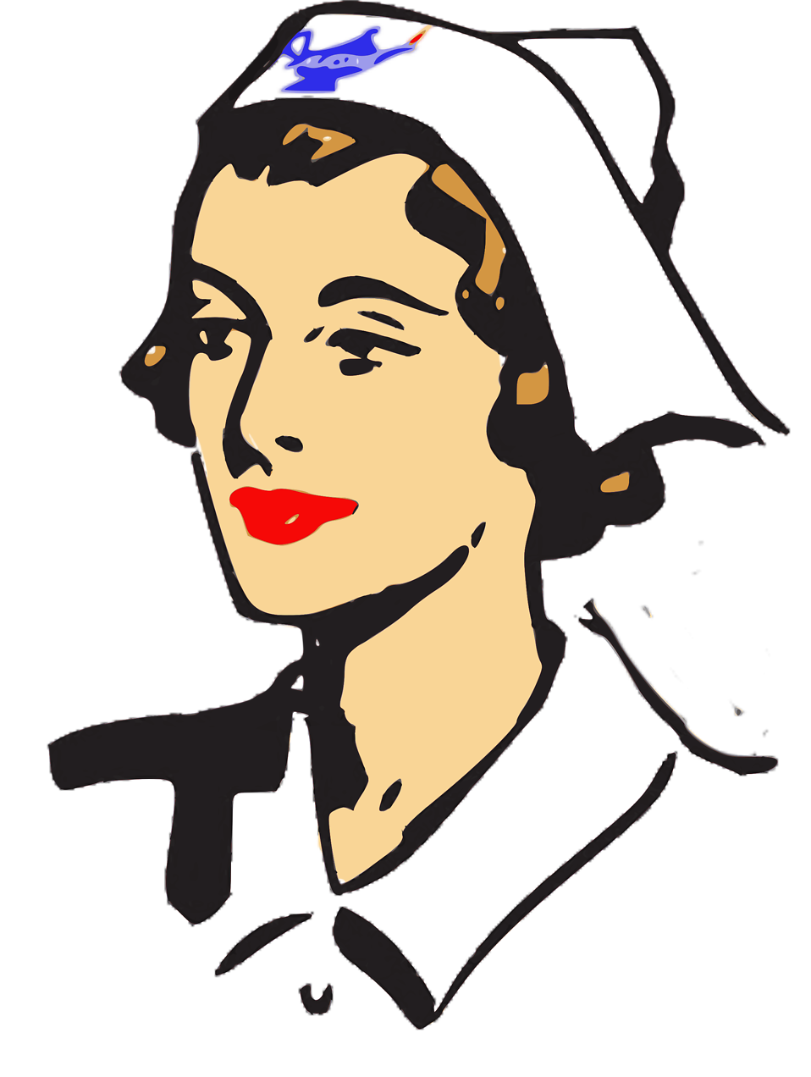
- Tend to sick: 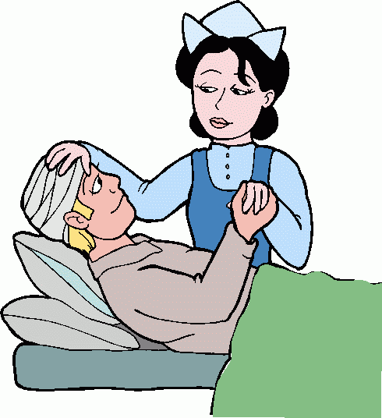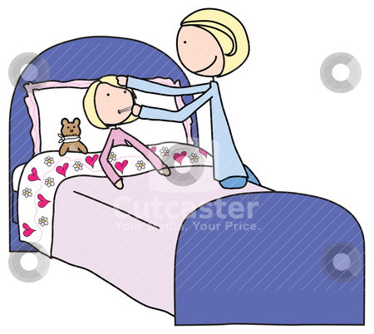
- Mulitaking: 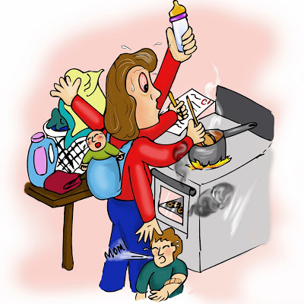

- Even when youd rathe not: 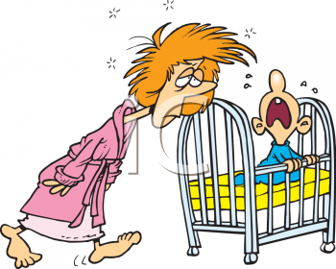

OR
- What about being a specific type of nurse:
  - RN, LPN, CNA,…
- What about being a specialized nurse:
  - pediatric, geriatric, oncology, ….
OR
- What about being a MALE nurse

BUT…..DIFFERENCES:
- uniforms
- schooling, education
- pay
- benefits
- bosses
- mobility, career track
- shifts
- leave, go home
- vacations
- specialization

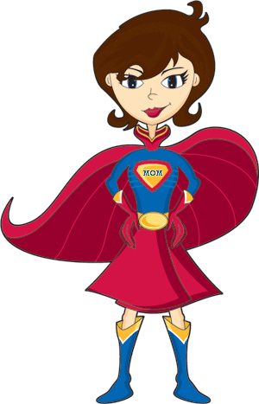
- Moms (or dads, parents) are like Superheroes:
- Here, mom becomes the Subject X
- Though super-powers & spandex would be important differences (& a sad creation story, too)


