Shirley Jackson’s “THE LOTTERY”
- 1948:
  - New Yorker magazine (June 26)
  - received 450 letters from states and foreign countries,
    - mostly in OUTRAGE at “the allegory of man's darker nature”

PART 1

- TONE:
  - 3rd person, non-omniscient
  - objective
  - matter-of-fact, historical
  - → grounds in reality
    - horror at end
    - universal themes
- SETTING:
  - June 27
  - “clear and sunny,” bright, beautiful, life in bloom, perfect summer day
  - near the Summer Solstice
  - near the start of planting season
  - kids just got out of school & don’t yet know how to act
    - uneasy freedom
  - small town
  - New England feel (Puritans → “A&P”)
  - TIME: from 10 AM to 12N
- IRONY:
  - “to allow villagers to get home for noon dinner”
  - INCONVENIENCE – OUTDATED RITUAL:
- FORESHADOWING: stones
  - collected by the boys (Bobby Martin, Harry Jones, Dickie Delacroix), smoothest & roundest
- ORDINARY:
  - boys being boys (stones, "boisterous play," talk of school); girls looking at the boys; young children rolled in dust or stayed with older siblings; men staying together, little emotion, heads of households, talking of crops, rain, taxes; women gossiped, joined their husbands, called their children
  - children: of school
  - men: of crops, work, money
  - women: of gossip
  - (grounded in reality)
    - → seems historical, adds to horror of ending
- FORESHADOWING:
  - men stood away from stones, smiled instead of laughed (reserved) --not a game
  - fear, reverence

Mr. Summers:
- conducted the lottery, square dances, teen-age club, Halloween program
- (*IRONY, SYMBOLISM: these other rituals:
  - they are outdated, arbitrary; they are innocent so SJ is setting up the reader for the twist, the lottery is just like them & they're ordinary, accepted)
- round face, happy man
- coal company
- people felt sorry for him → no children, wife = "a scold"
- (seems innocuous BUT wields tremendous power – power arbitrarily given to him)

Mr. Graves:
- postmaster
- helped Mr. Summers with the lottery
- *IRONY-SYMBOLISM:
  - names "summer" and "graves" (life & death),
  - *equals the contrast between the setting and the story

FORESHADOWING:
- the villagers kept their distance from the black box upon the stool
- no one wanted to volunteer to help Summers keep the stool steady while he poured in the slips of paper (Mr. Martin & his son Baxter stepped up)

*BLACK BOX *
- symbol: "as much TRADITION as was represented by the black box"
- black = death, evil
- all that remains to link to the past ritual
- * “The original paraphernalia for the lottery had been lost long ago, and the black box now resting on the stool had been put into use even before Old Man Warner, the oldest man in town [93/94], was born.”
  - the lottery goes back over 100 years
  - the lottery is OUTDATED
- made with pieces of the black box that preceded it (leftovers)
- falling apart:
  - splintered badly, faded, stained
- **SYMBOLIZES STATE OF THE LOTTERY:
  - shabby, in disrepair, needing to be replaced/updated; Mr. Summers wants to replace it (but villagers hold on to an EMPTY tradition--sentimentalism)

- IRONY: & INCONVENIENCE – EMPTY, OUTDATED RITUAL:
  - Mrs. Hutchinson "Clean forgot what day it was."
    - washing dishes
- her "friend" Mrs. Delacroix
- everybody joking as she joined her husband ("good-humoredly")

- INCONVENIENCE – EMPTY, OUTDATED RITUAL:
  - “get this over with, so’s we can get back to work.”
- Clyde Dunbar:
  - not there, broke his leg, wife will choose for him, Horace is "not but 16 yet" (not part of lottery)
  - question = part of the formality of the ritual
  - SACRIFICIAL VICTIM = must be pure, clean, sinless

PART 2:
- immediate change in TONE: "A sudden hush fell on the crowd...."
  - (fear descended on them like a cloud passing over the sun)
- INCONVENIENCE – EMPTY, OUTDATED RITUAL:
  - goes over the rules → "only half-listened to the directions"

**fear: (foreshadowing)
- sudden hush
- Steve Adams as he picked 1st ("humorlessly and nervously")
- Mrs. Delacroix as her husband picked (held her breath)
- Janey Dunbar's hesitation to go pick
- "a long pause, a breathless pause" before the men unfolded paper
- Tessie Hutchinson's reaction (not we expect from someone who just "won" the lottery)--IRONY

- IRONY:
  - Mrs. H: "Get up there, Bill" and everyone laughed
- INCONVENIENCE – EMPTY, OUTDATED RITUAL:
  - north village talking about giving lottery up;
  - "some places" already quit it

Old Man Warner = symbol
- stubborn resistance to change, blind obedience to ritual
- blames talk on the "young folks"
- 77th time he's participated in the lottery (77 + 16/17 = 93/94)
  - lucky!!
- JUXTAPOSITION: OMW (77th time) and Jack Watson's 1st time

PART 3:
- revealing who had "it" (SUSPENSE--what is "it"??)

- Mrs. Tessie Hutchinson--resists:
- points out the flaw in the ritual: "You didn't give him enough time to take any paper he wanted."
- refrain: "It wasn't fair."
- *IRONY:
  - not the reaction we'd expect from someone who just "won" the lottery
  - Mrs. Delacroix = her friend?! "Be a good sport, Tessie."
    - as if this is only a game, that she's not about to die
    - (turn on her friend = village turn on one of its own = WORSE than animals)

- Bill Hutchinson's reaction:
  - "Shut up, Tessie."
  - = blind obedience, doesn't fight, acceptance, surrender

- INCONVENIENCE – EMPTY, OUTDATED RITUAL:
  - "...now we've got to be hurrying a little more to get IT done in time"
    - (BUT we still do not know what "it" is)
  - strips of blank paper just spilled onto the grass & blown away
- Tessie: turns on her daughter (Eva, married to Don), tries to bring her into the lottery
  - self-preservation, selfishness
- family of 5 (excluding Eva) Bill, Tessie, Bill Jr.(awkward age), Nancy (12), little Dave

Little Dave = SYMBOL:
- innocence
  - thinks drawing the paper is a game
  - goes willingly to the black box, laughs,
  - looks at Mr. Graves “wonderingly”
- innocence corrupted:
  - later, he is given some pebbles to throw at his own mother! = turning on their own
- = continuation of the lottery, passing it on to the next generation
- Perpetuation of evil
  - of the Lottery
  - of family traditions, prejudices, arbitrary rituals
  - of social rituals, traditions, conventions, practices
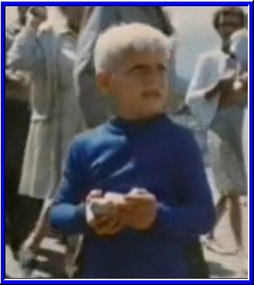
    - racist jokes, chauvinistic attitudes/behaviors
    - Sunday church, holiday meals, St. Patrick’s Day, Black Friday
- Get ’em while they’re young:
  - candy cigarettes, chewing tobacco chewing gum
  - toy guns, toy tattoos, toy cell phones
  - Hitler Youth (Hitler Jungen)
  - clothes, music

change: (change in attitude @ scapegoat)
- "I hope it's not Nancy." = change in attitude (used to be seen as a privilege, honor to be a sacrifice or to have one's friend as the sacrifice, now they hope against that)
- crowd glad it wasn't little Dave ("general sigh" of relief)

- Bill Jr. & Nancy unfold theirs together, laugh when not theirs
  - nervous laughter
  - self-preservation, selfishness
- Tessie refuses to open hers
- Bill opens his (process of elimination, it's Tessie)
- Bill forces slip from Tessie's hand
- BLACK SPOT

- INCONVENIENCE – EMPTY, OUTDATED RITUAL:
  - “Let's finish quickly.”

IRONY: Mrs. Delacroix, her friend, picks up the biggest rock she can find, has to carry it with both hands
IRONY: someone gave little Dave a few pebbles

- separation of the scapegoat:
  - they cleared away from Tessie
  - this = 2nd time they separated for her

- “and then they were upon her.”
  - objective tone = horror of the act
  - animalistic, bestial
  - all that’s left = the violence
  - they relish in the violence
    - while their attitude thus far = casual, now it’s time for business, fun
    - all that rising fear explodes into violence upon the sacrifice
    - catharsis: purging of pity & fear (???)
____________________________________________________________________________________________________________________________________________________________________________________
FEMINISM:
- woman = victim
- woman = only person to question authority
  - question authority → death
- men run lottery
- women go to men & stand by side dutifully
- gender roles:
  - men work
  - women house work
  - (“Chrysanthemums”)
- son vs. mother (although mother turned on daughter)
---------------------------------------------------------------------------------------------------------------------------------------
?? FATE-RITUAL punished Tessie b/c:
- she forgot about the lottery/ritual
- she was late
- she joked, made light of the situation (no reverence)
- resisted the "luck" of the draw
- wouldn't open her slip
---------------------------------------------------------------------------------------------------------------------------------------
**SCAPEGOAT:
- apart from: separate from the community
- a part of: part of the community
- supposed to be guiltless/pure, untainted
- takes on the sins of the community
- sacrificed or banished
- BIBLE:
  - Abraham & Isaac:
    - God tests A’s faith
    - God sends angel to stay his hand
  - Jesus and “Mary Magdalene”
    - guilty of adultery, punished by stoning,
    - “Let he who is without sin cast the first stone.”
      - (hypocrisy of judges)
      - (none are sinless, therefore no pure scapegoat)
  - Jesus sacrificial Lamb
    - Christian orthodoxy – only through Jesus
    - there can be only 1 true sacrifice to expiate sins
- Definition:
  - 1 : a goat upon whose head are symbolically placed the sins of the people after which he is sent into the wilderness in the biblical ceremony for Yom Kippur
2a : one that bears the blame for others
  - 2b : one that is the object of irrational hostility (Webster)

**FAILURE OF THE RITE:
- "The original paraphernalia for the lottery had been lost long ago, and the black box now resting on the stool had been put into use even before Old Man Warner, the oldest man in town [93/94], was born."
- state of black box
- "much of the ritual had been forgotten or discarded"
- changed slips of paper for chips of wood (too many people in town [300+] to fit corresponding chips into the black box)
- too many citizens now for ritual to be efficacious
- the black box for remainder of the year:
  - in a barn, under the post office, on a grocery store shelf (no reverence paid to it other than June 27)
- "fussing": the steps/process of the ritual: making up of lists, swearing in of Mr. Summers by Mr. Graves; townspeople barely pay attention to the process/steps (formality)
  - empty: ask questions everyone knows the answer to
  - not paying attention to parts
- disregarded the chant, the ritual salute to each person picking a chip/slip
  - now Mr. Summers just speaks informally to each person
- (easily forgotten day—Mrs. Hutchinson)
- other towns have given/are talking about giving it up
- (no longer efficacious with the crops → USED to be a saying "Lottery in June, corn be heavy soon")
- change in attitudes:
  - hurry to get it over, an inconvenience, easily forgotten
  - pity (for the victim, glad it wasn't her friend Nancy, glad it wasn't "little Dave" Hutchinson)
- someone threw a stone out of turn (probably Bobby Martin)
- *VIOLENCE = all that remains:
  - "Although the villagers had forgotten the ritual and lost the original black box, they still remembered the stones."
  - "and then they were upon her"
    - like animals
    - (but worse than animals b/c they relished only in the violence/bloodshed
- Casual attitude = empty, outdated ritual:
  - jokes, get-this-over-with attitude (Mr. Summers, Mrs. Hutchinson, people)
  - casual dress = casual attitude (Mr. Summers)

---------------------------------------------------------------------------------------------------------------------------------------
WRITING:
- setting contrasts story
- characters = symbols
- outdated rituals:
  - present rituals that are outdated & could/should be removed
  - (proms, weddings, Christmas gifts, dating conventions, graduation ceremonies, frat/sorority pledging, hazing, sports, funeral services, Mother's/Father's/Presidents day)
- Biblical allusion related to this story
- superstitious thinking: evidence of it in our lives, mindlessness & brutality of it
- incidences of mass hysteria, mob mentality in history
- LITERARY TECHNIQUES:
  - Foreshadowing
  - Irony
  - Symbolism
  - Imagery
  - POV
- Military draft
- *Holocaust*
  - “unwitting, obedient people”
  - participating & forwarding atrocities
- Mindless rituals
- Church services
- “just following orders” excuses

____________________________________________________________________________________________________________________________________________________________________________________
SETTING:
- idyllic
- familiar
- ordinary
- any small town in post-WW II America: boys will be boys, girls, men, women

JUXTAPOSITION:
- Setting vs. Plot
  - note how the idyllic SETTING contrasts with the PLOT (ending).
- OMW’s 77th time & Jack Watson’s 1st time
- Mr. Summers & Graves = setting & story

FORESHADOWING:
- note how the ending is foreshadowed throughout the story.
- stones
- fear

IRONY:
- stones given to little Davey Hutchinson
- win but lose (oxymoron)
- Mr. and Mrs. “Summers” and “Graves”
- Mrs. Delacroix as Tessie’s friend
- Tessie turns on her daughter
- someone hands Little Dave some pebbles to throw at his own mother

Description:
- the town
  - flowers, people, town square
  - → grounds the story in reality
- The Black Box
- The black spot

POV:
- 3rd person non-omniscient
  - cool, distant
  - objective
  - journalistic (Hemingway, Bierce)

SYMBOLISM:
- lottery:
  - as blind adherence to impotent ritual
  - question-response formula of many rituals = mindless, rote (of many religious rituals)
  - history = unknown, yet still followed (failed rite)
- black box:
  - symbol of the tradition followed with reverence
  - black = evil, death
  - a sacred, revered icon (religious icon)
- black spot:
  - black = evil, death
- stones:
  - link to ritual scapegoating
  - ancient rites of sacrifice
  - hint of violence, foreboding throughout the story
- Mrs. Hutchinson:
  - guiltless victim
  - scapegoat
- Davey Hutchinson:
  - innocence (corrupted)
  - perpetuation of the ritual
  - cruelty: given pebbles to throw at his own mother
- other children:
  - perpetuation of the ritual
  - violence is all that remains
  - inherent evil nature of humans
- Old Man Warner:
  - stubborn, blind allegiance to the ritual (blind obedience, blind faith, unquestioning obedience)
  - resistance to change
  - YOUNG vs. OLD:
    - represents the old guard, the old way of doing things
    - grumpy old man railing against those “kids today”
    - (see Grandmother in “A Good Man Is Hard to Find”)
  - LUCK: (?)
    - 77 lotteries & still alive!
    - arbitrariness of lottery
    - his almost shaman-like role, since he’s lived so long
    - BLESSING or a curse??? – he’s lost everyone he knew/loved

---------------------------------------------------------------------------------------------------------------------------------------
THEMES
- young vs. old
- uneasy freedom:
  - humans don’t know how to act with our Free Will
  - sheep w/o shepherd
- against persecutions, discriminations
  - (age, sex, race, handedness, beliefs, appearance, religion, economic class, geographical region, family background, or sexual orientation, musical preference, …)
- against scapegoating
- against outdated rituals, traditions
- against blind obedience, blind faith, unquestioning obedience/allegiance
- against humanity, family:
  - patriarchal households
  - self-preservation, selfishness
- argumentum ad antiquitatem:
EMPTY HEARTS
- hearts vs. mouths
- empty faith, hypocrisy
- un-Christian Christians
- Prodigal Son
- Say Yes, Powder
- Cat in the Rain
- Story of Hour, Desiree
- GCP, Good Man, Revelation
- Chrysanthemums
- Everyday Use
- OCB
- Worn Path
- Lottery
  - appeal to tradition, common practice (antiquity)
  - right or acceptable b/c it’s been around for a long time
  - “it’s always been done that way”
  - (opposite of Argumentum ad Novitatem – right b/c new)
---------------------------------------------------------------------------------------------------------------------------------------
HISTORICAL ALLUSIONS--THEMES
- Blood sacrifices:
  - “Lottery in June, corn be heavy soon.”
  - Biblical, pagan → fertility rite transferred to modern times
- Stoning:
  - Jesus and Mary Magdalene
  - punishment for adultery;
    - Mrs. H =- adulteress?? (she & Clyde Dunbar??)
  - “let he who is without sin cast the first stone”
    - anti-scapegoating theme
- Holocaust:
  - written shortly after World War II, indirectly expresses Jackson’s horror at the Nazi Holocaust
  - → the massacre of the Jews was carried out by unwitting, obedient people like the villagers in the story
- US military draft:
  - satirizing the draft in which men are selected for military service via a lottery
  - → the men “win” the lottery but “lose” their lives (in a pointless, outdated ritual called war)
- *Tradition, conformity, mob mentality:
  - satirizes the blind obedience to traditions, rituals
  - conformity to meaningless rituals, behaviors
  - self-delusion of the mob mentality
- Pre-1960s: satirizes the blind obedience to traditions, rituals (conformity)
- anti-religion
  - (any institutionalized religion)
  - satirizes the blind obedience to traditions, rituals
  - mindlessness & emptiness of Church services & their rituals
  - disconnect with original meaning of rites like Eucharist
- Hutchinson:
  - Anne Hutchinson (1591-1643), religious liberal (stressed individual intuition in finding salvation) tried & banished from Massachusetts Bay Colony for questioning established authority, one of the founders of Rhode Island
  - Salem Witch Trials: perhaps this possible allusion leads to a connection to these trials that elucidated mass hysteria/blindness/self-delusion
  - BUT: Tessie Hutchinson does not stand up to her community
- Derrida & Deconstructionism/Post-Structuralism:
  - the “gap” between the signifier & the signified
  - gap between original intent/purpose & current ritual (lost heritage)
  - points out meaninglessness
    - ** “heart of darkness”:
      - at the heart of every text is a “space” of emptiness, non-meaning, nothingness
      - an “abyss” of limitless or contradictory meanings
      - created by the “gap” between the signifier & signifier
- Rene Girard:
  - failure of rites and Sacrificial Crises
  - when the ritual has lost meaning, when the participants have lost connection to the original purpose of the rite, when violence is all that remains → rite fails
    - perhaps bad crops next year,
    - perhaps stoning outside of ritual,
    - perhaps villagers turn on themselves and stone everybody after the victim)

movie: < http://www.youtube.com/watch?v=tN5V8cQ2DAk&NR=1 >
stoning in the Bible: < http://www.skepticsannotatedbible.com/says_about/stoning.html >
AND < http://www.keyway.ca/htm2003/20031128.htm >

http://www.sparknotes.com/short-stories/the-lottery/canalysis.html

http://www.imdb.com/title/tt0997073/photosites
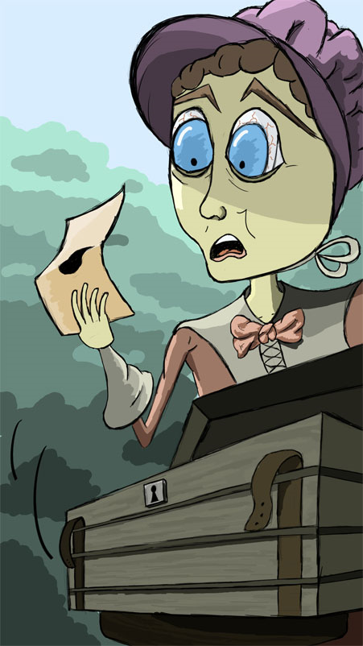
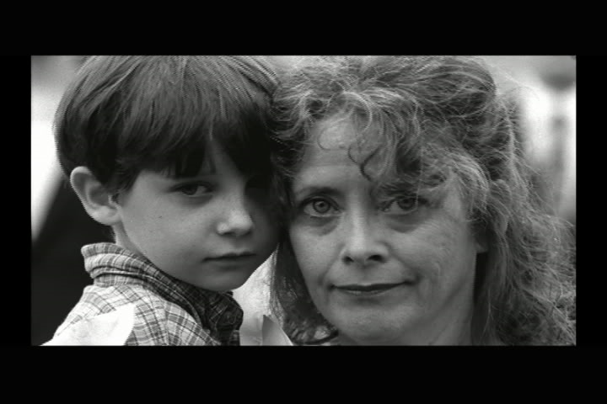

http://titania.stockton.edu/jbstory/image-collection/

