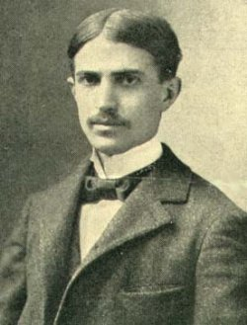
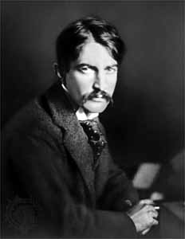
STEPHEN CRANE
(1871-1900)
- Father =
- Dr. Jonathan Townley Crane (DD)
- Methodist minister
- 14 children (Stephen = last, youngest)
- moved frequently: Paterson (NJ), Port Jervis (NY)
- principal at Pennington
- wrote books
- dead in 1880
- family = mid-1600s in USA

- childhood = frail, often sickly
- 9: 1880: father dies; moves to Paterson
- 12: Asbury park, New Jersey (1882-1888)
- 12-17: “sensitive, vulnerable, fatherless preacher’s kid”; isolated
- 13: 1881-88: Pennington Seminary (NJ)
  - mother’s wish for him to follow his father’s footsteps = to be minister
  - JT Crane = its 3rd principal (1849-58) for 10 years b/4 Civil War
- 1888: Claverack Military Academy (NY)
  - fondness for all things military
  - performed well, achieved the rank of 1st Lieutenant
- 1890: Lafayette College
- Syracuse University:
  - exceptional baseball player
  - poor student
  - left after 1 semester
  - (Joyce Carol Oates)
- 20: 1891: begins as JOURNALIST
  - several short-term jobs at New York City newspapers
  - poverty, privation
  - ** honed his skill of OBSERVATION of psychological & social reality
  - heard lecture by Realist Hamlin Garland (1860-1940)
- writing career: (why a writer?)
- father wrote several books
- Crane’s own experiences at a military academy inspired him to write a military book
- wrote insignificant/minor (inferior) works
  - 1st book = published w/own $$ under pseudonym Johnston Smith
- 1893: Maggie, A Girl of the Streets
  - published at his own expense (Hawthorne, Poe)
  - short novel
  - reflects his association with the lower class life
  - begun at Syracuse
  - realism
  - did not sell well →
** mass audience of late 19th century = ROMANCE, SENTIMENTALITY
    - escapism
    - distraction
    - easy reading
    - romances
    - all of which “falsified and obscured the social, emotional, moral nature of life”
    - contrary to REALISM

- 12/1894: The Red badge of Courage
  - begun in 1893
  - Civil War story
  - “pot-boiler”
  - his most popular work
  - originally published in 12/94 as a syndicated newspaper story
  - 1895 published in novel/book format →
  - 1st successful American modern-realist novel
  - $$$$$$
  - Bildungsroman:
    - coming of age
    - “a type of novel concerned with the education, development, and maturing of a young protagonist.” (dictionary.com)
    - “moral, psychological, and intellectual development of a usually youthful main character”
    - “Classic” story: Homer’s Odyssey
    - “American” story: Ben Franklin, Melville, Hemingway, …
  - Crane changes to formula:
    - * personal identity = complex, ambiguous (modern psychology)
    - makes the readers judge for themselves the adequacy of Henry’s responses (Reader-Response)
  - protagonist = tested:
    - young man, in extreme situation,
    - in a “psychological and philosophical pressure cooker”
- 1895: hired by same syndicate that bought Red Badge
  - roving reporter in US Southwest, Mexico
  - → The Bride Comes to Yellow Sky, The Blue Hotel
- 1895: 1st poetry collection The Black Riders and Other Lines
  - style = original, spare, unflinchingly honest (REALISTIC)
  - experimental in form
  - unconventional in philosophic outlook → unpopular
- 1896: challenged the NYC Police Department on behalf of a prostitute who claimed harassment
  - (Springsteen’s “41 Shots”)
- 1896-97: to cover Cuba’s insurrection against Spain (prelude to Spanish-American War)
  - met Cora Howorth Taylor in Florida
    - Jacksonville, FL.
    - madam/proprietress of “Hotel de Dream” (whorehouse)
    - he spent the remaining 3 years of his life with her (unmarried)
- 1/2/1897: the steamer Commodore sunk off Florida coast
  - published his account: “Stephen Crane's Own Story” in The New York Press, January 7, 1897
  - later, fictionalized the event in “The Open Boat”
- 1897: (foreign war correspondent)
  - covered Greco-Turkish War
    - 1st first-hand experience with war
  - moved to England
    - friends with Joseph Conrad, HG Wells, Ford Maddox Ford, Henry James
- 1898: covered the Spanish-American War for Joseph Pulitzer’s The World
  - first-hand experience with war
  - confirmed his accuracy of the realities of war/battle he depicted in Red Badge
- 1899: last months = impoverished, in debt, suffering from TB
  - Tuberculosis:
    - “consumption”
    - infectious disease (inhale t.b.)
    - caused by microorganism: Mycobacterium tuberculosis (tubercle bacillus)
    - symptomology: tubercles (lump, nodules, swelling—cluster of inflammatory cells) lesion on the lungs, coughing up of mucus and sputum, fever, weight loss, and chest pain
  - wrote furiously for $$$$$ (which made him sicker)
  - 13 stories for Harper’s magazine (set in fictional Whilomville)
  - War is Kind – 2nd volume of poetry
  - Active Service – novel
  - The Monster and Other Stories – American edition
  - lung hemorrhage at Christmas party
- 1900:
  - 9 articles on great battles
  - 1st 25 chapters of The O’Ruddy – unfinished novel
  - dead: 5/5/1900: Badenweiler, Germany (29)

STYLE
(reporting, poetry, fiction)
- religious, social, literary rebelliousness
  - anti-establishment:
    - religion, social issues, literature
    - Realism vs. Sentimentality (romance, escapism)
- alienated, unconventional stance
- journalistic style: reporting, objective, observation
- Bildungsroman:
  - coming of age (protagonist = tested)
    - young man,
    - in extreme situation -- in a “psychological and philosophical pressure cooker”
    - “a type of novel concerned with the education, development, and maturing of a young protagonist.” (dictionary.com)
    - “moral, psychological, and intellectual development of a usually youthful main character”
    - “Classic” story: Homer’s Odyssey
    - “American” story: Ben Franklin, Melville, Hemingway, …
  - Crane changes to formula:
    - * personal identity = complex, ambiguous (modern psychology)
    - makes readers judge for themselves the adequacy of protagonists’ responses (Reader-Response)

REALISM
- psychological and social realities
- personal identity = complex, ambiguous (R/R)
- response to escapism, sentimentality, Romanticism
- scientific method (objectivity, journalistic, laws/theorems, origins)
- photography: 1839

- objectivity
- common people (ordinary, middle-class, vernacular)
- “faithful representation of reality”
- “slice of life” — tranche de vie
- verisimilitude — likeness to truth, authenticity, probability (even when fantastic)
- “American” realism: accurate representation & exploration of American life in various contexts…dialects, vernacular, regionalism, vivid descriptions of scenery

NATURALISM
- applies scientific objective observation to the study of humans
  - see Crane’s journalistic style
- objectivity:
  - understanding the laws of FORCES that govern human lives
  - (1) humans = governed by instincts & passions
  - (2) humans = governed by hereditary & environment, instinct, chance
  - * humans = controlled (determinism)
  - scientific detachment
- “human beasts”:
  - Emile Zola: study with regard to relationships with surroundings
  - Humanity = “products”
    - thus, man = studied without moralizing about their natures (objective)
    - virtue & vice = “products”
    - humans = rats with “cheese of life”

- THEMES:
  - survival, determinism (external forces: heredity, environment),
  - violence, beast within, warring emotions

- “pessimistic materialistic determinism”
- “Calvinism without God”

- Trace Adkins’ “I’m Tryin’”

- SUBJECT MATTER: (obsessions)
  - common man:
    - average, un-heroic,
    - poor, middle/lower classes
    - violent deaths
  - the physical, emotional, intellectual responses of men under extreme pressure
    - (like a scientist, observing rats in an experiment—see “Rappaccini’s Daughter”)
    - Red Badge, “The Open Boat”
  - War:
    - Civil War, Cuban Insurrection, Spanish-American War, Greco-Turkish
  - Violence:
    - physical, psychic/psychological, philosophical
    - under extreme pressure (pressure-cooker)
- THEMES:
  - Nature’s indifference to humanity’s fate, consequent need for compassionate collective action
  - Red Badge, “The Open Boat”

- MATURE STYLE:
  - bitter irony (tragic irony)
  - his essential vision:
    - “grace under fire”
    - brotherhood, comradeship, compassion
    - Universe = indifferent, unfeeling towards humantiy
“a sympathetic yet unflinching demand for
- courage,
- integrity,
- grace, and
- generosity
in the face of a universe in which human beings, to quote from The Blue Hotel, are so many lice clinging ‘to a whirling, fire-smote, ice-locked, disease-stricken, space-lost bulb’”

PERSON
- REBEL:
- rejects religious & social traditions of father
- identified with the urban poor (whom he covered for newspapers)
  - years of privation: lacked “comforts of home”, necessities of life
  - lived among them as penniless “starving artist”
  - lived with his poor artist friends
  - lived with his brother Edmund (Lake View, NJ)
- “married” a whorehouse madam (Jacksonville, Florida’s finest whorehouse)
- PARADOX:
  - poor but a snob
  - poet but an impressionist
  - journalist, social critic but a realist
- RESTLESS:
  - restless, peripatetic (traveling) ← moved often
    - Paterson, 2 other places, Port Jervis, Asbury Park (by 7)
  - to experience the fullness of life

- Crane himself said, “A man is born into the world with his own pair of eyes and he is not at all responsible for his vision. He is merely responsible for the quality of his personal honesty” (Weinstein 6).

Spanish-American War
- Cuban Revolution, Insurgence: Cuba’s fight for independence, from Spain
- USS Maine explosion
  - (exaggerated by yellow journalism)
- 1st “media war”; William Randolph Hearst & Joseph Pulitzer;
  - “yellow journalism” (the yellow kid, in comic strip;
    - scandal-mongering, sensationalism, jingoism, or other unethical or unprofessional practices)
- 109 days (April-July 1898)
- ends with signing of the Treaty of Paris

- The Spanish-American War (April-July 1898) was a brief, intense conflict that effectively ended Spain's worldwide empire and gained the United States several new possessions in the Caribbean and the Pacific. Preceded by a naval tragedy, the destruction of USS Maine at Havana, Cuba, the Spanish-American War featured two major naval battles, one in the Philippines and the other off Cuba, plus several smaller naval clashes.

- American Expansionism & Spain’s foreign colonies: Cuba, Puerto Rico, the Philippines, Guam and the Caroline Islands
- American naval supremacy:
- Teddy Roosevelt an his “Rough Riders” (1st U.S. Volunteer Cavalry)

“THE OPEN BOAT”
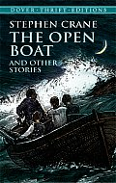

PREREADING:
- What selfless act have you done?
- What altruistic act have you performed?
- When was the last time you did something for someone else without having to be asked to do it, regardless of the personal dangers?
- How do you react under pressure: love, death, sports
  - emotional reactions
- measure out 10 feet and have 4 people sit together

- AUTOBIOGRAPHICAL:
  - While on his way to Havana, Cuba, to report on the Cuban Revolution against Spain (start of the Spanish-American War) for the New York Press newspaper, Crane personally experienced these events: On January 2, 1897, the steamer COMMODORE sunk in heavy seas off the coast of Daytona Beach and New Smyrna, Florida. Crane survived in a 10-foot lifeboat with Captain Murphy and 2 other crew members. Afterwards, Crane published a true account of the experience in “Stephen Crane’s Own Story”; later he fictionalized it in “The Open Boat.”
  - From “Stephen Crane’s Own Story”:
    - “Jan[8] 1897. [January 6]. He dashed into the water and grabbed the cook. Then he went after the captain, but the captain sent him to me, and then it was that we saw Billy Higgins lying with his forehead on sand that was clear of the water, and he was dead.”
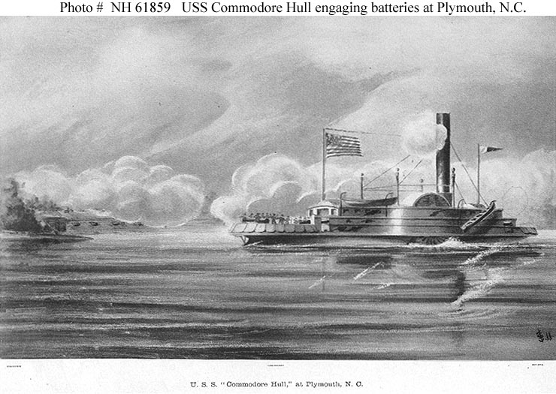

- 1897: published (book, Charles Scribner's Sons, New York)
- ?? Scribner's Magazine 21 (May 1894): 728-740

- COOK:
  - fat
  - bails the water out
  - argues with the Correspondent over “life-saving station” and “house of refuge”
  - wraps the cork lifebelt around himself for warmth
- CAPTAIN:
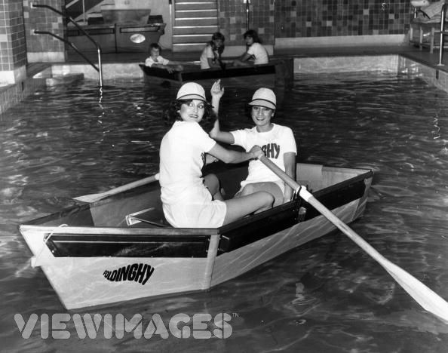
  - injured (arm)
  - gives directions (leads)
  - keeps them focused, calm
  - “this iron man”
  - “[t]he same steady voice”
  - holds water jug
  - paternal, father-figure
  - cool, calm, collected
  - in control, of emotions & men
- CORRESPONDENT:
  - rows & rows
  - trained as a cynic of humanity
  - BUT recognizes the brotherhood & best time of his life
- OILER:
  - rows
  - worked a double-shift the night before the wreck
  - no sleep
  - no food
- SEA:
  - 5th major character in the story
  - Antagonist
  - personification, anthropomorphism

I

- 1st line: "None of them knew the color of the sky."
  - that would be a luxury (PERSPECTIVE)
  - NO GOD; concerned with this world only, the Present
  - practicality, concerned only with the trouble they were in
  - looking up to the sky is a luxury they cannot afford; they are focused on the present, the here-&-now; no help from above
- dreariness: waves = slate, no sky
- *DANGER: precariousness of their situation: frought with peril:
  - waves = constant, like "rocks", with "jagged" edges
  - waves = "most wrongfully and barbarously abrupt and tall, and each froth-top was a problem in small-boat navigation"
  - boat = smaller than a bathtub
  - boat: only 6 inches of gunwale separated the men from the ocean
  - boat: water getting in the small boat, has tobe bailed out constantly
  - boat: "It was a thin little oar, and it seemed often ready to snap."

- COOK: squatted in the bottom of the boat, bailed out
- CAPTAIN: sat at the bow of the boat, injured, dejected & indifferent from the loss of his steamer
- CORRESPONDENT & OILER: at the stern, rowed
*BROTHERHOOD: each w/a job to do, unity, teamwork

mini-flashback: sinking of the Commodore:
- --the narrator mentions how the Captain was dejected, as part of himself died with the ship
- sinking = willy-nilly" (chance, fate, happenstance)
- sinking:
"7 turned faces" at the "grays of dawn" (turning questioningly towards the Captain, or away in disgust?), then later the ship going under with the topmast (w/white ball) last, slashed back & forth as it sank ---like them, cruelty of Nature

- "Billie" the Oiler, steering southward with an oar

- precariousness, cruelty: "bucking broncho"

- precariousness, no rest: "these problems in white water" AND "A singular disadvantage of the sea"

*MALIGNANT NATURE: "A singular disadvantage of the sea....terrible grace...snarling of the crests."

- 10-foot dinghy

PERSPECTIVE: "Viewed from a balcony....weirdly picturesque..."
- life as a play (see later)
- only GOD could have such perspective on them
- IRONY of their situation, that outside of such danger it would have looked wonderful, "weirdly picturesque" -- they cannot appreciate the beauty of the dawn (BEAUTY = a luxury)

- dreary #2: "the wan light" of dawn
- no sky #2: cannot see or appreciate the beauty of the dawn

*PLATO'S "ALLEGORY OF THE CAVE":
- they cannot see the sky (the Ideal, the Sun itself)
- they can only see its reflection upon the ocean: "The process of the breaking day..."

argument:
- Cook and the Correspondent
- semantic argument
- difference between a "life-saving station" & a "house of refuge"
  - HF: no rescue crews, only clothes & food
  - the Cook thought there was a HF north of the Mosquito Inlet Lighthouse
- reflects the class distinction: the education of the Correspondent over that of the rest of the boat
- reflects the tension, desperation in the boat, the fear for survival
- reflects the calming influence of the Oiler -- keeps them focused on the present "We're not there yet."

II

PERSPECTIVE: view from the top of the waves “was probably splendid...glorious”
- IRONY of their situation, in other circumstances, this = beautiful
- ZOO EFFECT: wild animal in cage, viewed from safety, from a safe distance the sea/animal = beautiful

- sea = wild animal #2: “this play of the free sea”

- Nature = (+) onshore wind blows them towards land, rather than away from it

- “humor, contempt, tragedy, all in one”

OPTIMISM = luxury they cannot afford, so the Captain & Oiler keep them focused on the tasks at hand
- (-) distraction, false hope
- not voiced, but thought, felt (superstition)
- "To express any particular optimism at this time they felt to be childish and stupid..."
- BUT they thought about it, felt it

- Captain = father-figure, "soothing his children"
- FORESHADOWING: "Yes! if we don't catch hell in the surf."

SEAGULLS:
- “sat comfortably,” floating easily on the waves
- envied by the men: "for the wrath of the sea was no more to them than it was to a covey of prairie chickens a thousand miles inland."
- stared with "black bead-like eyes", seemed "uncanny and sinister in their unblinking scrutiny"
- mocking them
- ** the men = out of their element
- ** evil temptation: 1 tried to sit on the captain's head, BUT the Captain was smart enough (CCC) not to b/c he would have capsized the boat (NATURE = MALIGNANT) ---see the shark later, tempting the Correspondent to swat at it, thereby capsize the boat & feed it
- superstition: "gruesome and ominous"

FORESHADOWING:
“In the meantime, the oiler and the correspondent rowed. And also they rowed....They rowed and they rowed.”

BROTHERHOOD: sat together on the same seat & each rowed an oar

PRECARIOUSNESS: changing seats in the dinghy, on the open sea, with the waves crashing, up & down
- teamwork

(+) hope
progress =
- slow and steady (as it is in life)
- marked by the seaweed
- Captain can see the Lighthouse at Mosquito Inlet
- "Think we'll make it, Captain? ... we can't do much else."

NATURE = MALIGNANT
- their helplessness to the sea
- (NATURALISM) MAN = AT THE MERCY OF EXTERNAL FORCES
- “The little boat, lifted .... swarmed into her.”

- Captain = CCC, no panic in his voice, calms the others, gives directions, order = security (the "illusion" of control? Since it seems as if someone is in charge, so all will be well)
- water comes in, the Captain orders the Cook, the Cook = "cheerful" (b/c of small hope ** even the smallest hope is good)

III

** “the subtle BROTHERHOOD of men...”
- felt, not said (superstition)
- not machismo, but something deeper, more natural
- men = from different parts of society, from different parts of the ship BUT working together doing their respective jobs
- ** more than survival instinct, more than working for the common good (which can be done impersonally, w/o liking the others)
- BUT these men liked each other, respected each other = friendship, "comradeship"
- (multiculturalism)
- * “nature vs. nurture”: Correspondent = “had been TAUGHT to be cynical of men”
  - education = a malignant force (see earlier fight??)
  - “natural” instinct in men = to help each other; compassion vs. competition (CIVILIZATION = bad??)

compassion & teamwork:
- makeshift SAIL so Oiler & Correspondent could rest together
- Captain donates his overcoat
- Cook & Correspondent held "mast"
- Oiler steered
(+) hope, moving forward
** men using Nature, wind power (as opposed to being simply the VICTIMS of Nature)

*** men using their intelligence to survive
- remain calm with the sea gull
- remain focused with the hope
- working together, carefully
- not arguing over something stupid
- makeshift sail out of coat & paddle (rest, wind power)
- not going in to the surf too soon, pulling back & trying again later
- remaining calm with the shark
- swimming slowly

(+) hope:
- makeshift sail = rest
- progress: lighthouse is getting closer/larger
- land = in sight

"Allegory of the Cave": "shadows" of lighthouse & land
- not the things themselves, only their imitations ????

(-)
- at New Smyrna, Cook realizes that the "life-saving station" was ABANDONED about a year ago
- who abandons a life-saving station? it's like a "for sale" sign on a church
- ** immediately the wind died down and they stopped making progress ("took the wind out of their sails" literally & figuratively)

FORESHADOWING:
- all 4: no sleep, no food 2 days b/4 the shipwreck
- Oiler worked a double shift the night before the wreck
- = tired, hungry, weak...cold, wet, afraid
- Captain: “Don't spend yourselves. If we have to run a surf you'll need all your strength, because we'll sure have to swim for it. Take your time.”

CRUEL FATE:
“Shipwrecks are apropos of nothing......”

PERSPECTIVE:
Correspondent on rowing: people thinking it was “amusing” while he thinks it's “a diabolical punishment” ......

(+) hope:
progress:
- can see the house of refuge
- can see land & trees & sand → so the lighthouse watcher should be able to see them
- can hear the roar of the surf (foreboding BUT hopeful)
- wind returned
- → guarded optimism: thought/felt BUT not said (superstition); cheerfulness; hoped to be safe in an hour, their "impending rescue"; Correspondent broke out CIGARS (4), somebody had 3 dry matches

FORESHADOWING:
- Oiler = rowing, his back = to the land (back to the goal, heaven)?
- CIGARS: 8 cigars, 4 survived (“scatheless”); only 3 dry matches → someone won't survive, like 4 cigars
  - 3 on a match = bad luck (from WWI)
  - the sheer luck (Providence?) of having 4 dry cigars and 3 dry matches soaked as they were (+)

* Sole Survivors: other life boats/survivors of the Commodore: none of them could have made it to shore (already?), or else they would have sent out help for them

IV

(-)
no signs of life at house of refuge (IRONY)
- loneliness of their situation
- abandoned by God AND man **
- ** self-reliance **

progress: now they are north of the lighthouse
CRUEL NATURE: forced off target by the "Tide, wind, and waves"

* Narrator knows what the men do not:
(-) no life-saving station within 20 miles in either direction

CURSES: cursed watchers at the lifesaving station
- disappointed hope → anger, frustration, rage, curses
- hope turns "bitter and bitter"
  - the sight of land was (+), now (-)
- hope = temporary, fragile, ephemeral, easily turns to its opposite
- they = incompetent, blind, cowards

**DISPLACEMENT, SCAPEGOATING:
- cannot blame God, themselves
- only Physical people to blame, lash out at = life-station people

** response = personality: reveals the cynicism of Correspondent previously alluded to...his “training” conditioning, education comes out when discouraged, afraid

* SELF-RELIANCE:
Captain: “I suppose we'll have to make a try for ourselves.”

ATTEMPT #1:
- -no help coming
- can't stay out too long, b/c will get too tired to swim (FORESHADOWING)

____________________________________________________________________________________________________________________________________________________________

DEATH OF THE OILER:
- hard worker
- rows more than his share
- thus, quite selfless (the most of the 4?)
- quite skillful at steering the boat
- had pulled a double-shift the night before the shipwreck
- had not eaten before the shipwreck
  - → completely exhausted
- swims too fast, goes out too hard
- does not help the others (selfish??)
- Was he selfish?
- Was he sacrificed to the “7 mad gods who rule the seas” so the others might be saved? (Shirley Jackson’s “The Lottery”)
- Was it just dumb luck that he was the one who died? (could have been any of the 4)
  - Cook = fat
  - Captain = injured arm
  - Correspondent = tired, cold, no food, no sleep
- Is there any significance to his being the only one named? Only one without a “C” name?
  - tribute to real Billy who drowned
- Ironic play on Darwin’s “survival of the fittest”: while under normal circumstances he would have been the fittest, he was not at this point: no food, little sleep, extra work,…
- Does his death illustrate Nature’s cold, callous indifference—tragic irony?

TITLE:
- “open” boat
- suggests vulnerability
- subtitle = autobiographical; fictionalized autobiography (“after the fact”)

SUPERSTITIONS:
- do not voice any hope—don’t jinx it
- sea gull = “ominous”, harbingers of death (albatross, Rime of the Ancient Mariner)
  - killing seagull = bad luck
  - 3 seagulls flying overhead = death soon
- matches???
  - 3 on a match (= WWI; here only 2 on a match)
- “3rd time’s the charm”// lucky #2 ???
  - gull (2x)
  - shark (2x)
  - attempts to shore (2x)
  - # of ships (2)
____________________________________________________________________________________________________________________________________________________________

CONFLICT:
- MAN VS. NATURE
- hostile environment
- NATURALISM THEME: humanity is besieged by its cruel, indifferent Nature, Universe

STYLE:
- REALISM:
  - vivid description, details
  - similes
- repetition of words & phrases for emphasis (how tired they were, how much they rowed)
  - “…the oiler and the correspondent rowed. And also they rowed.”
  - “… a man who had worked so hard, so hard”
- refrains (for theme)
- similes (animals: chickens, bronco, mountain cat)
- personification (esp. of the sea; of Nature, of sea creatures)
  - “the attribution of a personal nature or character to inanimate objects or abstract notions” (dictionary.com)
- anthropomorphism:
  - “Attribution of human motivation, characteristics, or behavior to inanimate objects, animals, or natural phenomena” (dictionary.com)
- narrator knows what they do not
- the men did not says things, but thought them → narrator relates them
- CONFLICT + SETTING + PLOT = THEME

STRUCTURE:
- 7 numbered parts
- chronologically
- daybreak, afternoon, nightfall, dark night, dawn-morning, night

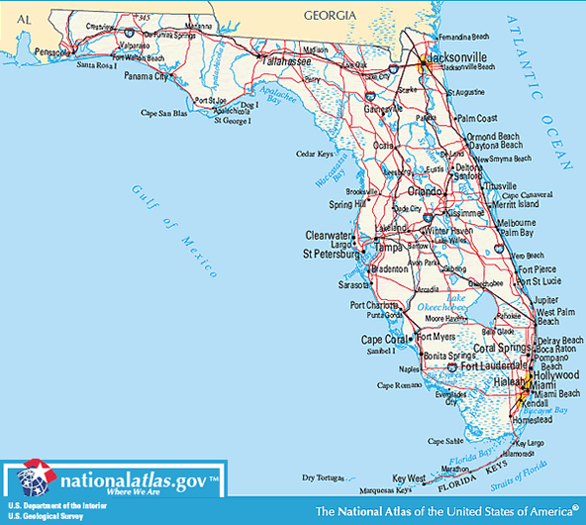
SETTING:
- January (1.2.1897)
- off the Atlantic coast of Florida, near Daytona Beach, Mosquito Inlet, New Smyrna
- atmosphere of hopelessness, of cruelty
- Setting → THEME: hostile environment, constant barrage of attacks
  - cannot change setting w/o changing the story
  - man vs. Nature conflict

POV:
- 3rd person, total omniscience
- Narrator knows what they know & do not know
- Narrator knows what they’re thinking, feeling, even without their having said it
- *from the Correspondent’s perspective the most: he can better articulate, verbalize what all of them are thinking and feeling, perhaps make better connections, put the situation into a perspective better (intelligence, schooling)
POV =
- their reactions, reflections to the situation
- not good or bad, just what they were
- like a scientist recording their thoughts/feelings during an experiment
- reveals their character (personality & strength)
- reveals their superstitions
- reveals their frustrations (argument, curses)
- reveals their vicissitudes between hope & hopelessness
- “grace under fire”
- POV = Realism, Naturalism (realistic portrayal of their reactions`)
- POV → THEME

SYMBOLISM:
- ** symbolized to the men during their ordeal VS. after the ordeal VS. to the reader
- dinghy =
  - HUMANITY, tossed helplessly, hopelessly, savagely upon the “sea of life” w/o gods, w/a cruel Fate torturing them with bitter tragic irony
    - Is this racist, sexist to assume that 4 white men can stand for all humanity?
  - Mankind out of its element, in the wild, no longer #1 on the food chain, not in control, prey instead of predator
  - danger, precariousness, vulnerability
  - “10-foot dinghy”
  - even its name suggests weakness, vulnerability
- sea:
  - Nature’s cruelty, indifference
    - personification in the moment of crisis → symbolized this to the men during their ordeal
    - What did it symbolize to the men afterwards???
    - What does it symbolize to the readers???
  - Life’s ups and downs, life’s vicissitudes
  - wild animal that we get too close to
  - danger
  - vulnerability, precariousness of the human situation
  - 5th major character in the story, antagonist
- wind:
  - like the sea
  - indifference
  - “took the wind out of their sails” (literally)
- “life-saving station” and “house of refuge”
  - refuge
  - “churches” or “temples” for this world (practical)
  - “brotherhood” –mankind helping mankind, compassion, empathy
- light house:
  - small hope, direction
  - distant God, watching?
  - men watching out for men, helping each other —“brotherhood”
- white flag, black coat/flag:
  - help, distress
  - acknowledgement
  - not death (town is not quarantined)
- windmill: Nature’s indifference (according to Correspondent)
- gulls, shark:
  - bemused indifference of Nature
  - danger, wild nature
  - angels watching over mankind???

FORESHADOWING:
- no sleep, no eat before the shipwreck
- double shift before shipwreck
- “row and row”
- exhaustion: instant sleep, sleep in the cold water
- 4 cigars, 3 matches??
- sea gull = “ominous”
- “Don't spend yourselves. If we have to run a surf you'll need all your strength, because we'll sure have to swim for it. Take your time.”
- freezing cold—teeth chattering, limbs shaking, huddled for warmth

IRONY:
- bitter, sad TRAGIC IRONY:
  - the hardest working dies
  - so close, but so far away
- “If I am going to be drowned -- if I am going to be drowned -- if I am going to be drowned, why, in the name of the seven mad gods who rule the sea, was I allowed to come thus far and contemplate sand and trees? Was I brought here merely to have my nose dragged away as I was about to nibble the sacred cheese of life? It is preposterous. If this old ninny-woman, Fate, cannot do better than this, she should be deprived of the management of men's fortunes. She is an old hen who knows not her intention. If she has decided to drown me, why did she not do it in the beginning and save me all this trouble. The whole affair is absurd. . . . But, no, she cannot mean to drown me. She dare not drown me. She cannot drown me. Not after all this work." Afterward the man might have had an impulse to shake his fist at the clouds: "Just you drown me, now, and then hear what I call you!”
  - absurdity of the fragile human condition
  - cruel fate to die so close, within sight of salvation, safety
  - impotence of our curses—shaking our fists to the sky
  - Oiler’s death: his face is pushed into the “sand”
- Author = naturalist, Story = naturalist, Characters not = naturalists
  - So “If I am to be drowned” = does not reflect Naturalism
  - b/c naturalists know that no matter how hard we work or progress, nothing we do will affect the universe
---------------------------------------------------------------------------------------------------------------------
THEMES:
- Leitmotif:
  - “lead motive” motif or theme throughout music or literature
  - melodic passage or phrase (Wagnerian opera)
  - HERE:
    - refrains (of rowing, exhaustion, Fate & “7 mad gods”)
    - Naturalism:
      - Mankind is always besieged by fate, the universe is indifferent to mankind’s plight, nothing mankind can do will affect fate or change nature’s/universe’s “mind”
    - Brotherhood →

- brotherhood
  - more than mere survival instinct
  - more than working for the common good
    - which is impersonal, no connection to the others,
    - just using each other to get by
  - “comradeship”
  - “friendship”
  - personal
  - respected, cared for others
  - selflessness, compassion:
    - make-shift sail to give both rowers a break
    - Cook steers while float to give both rowers a break
    - Correspondent share cigars
    - Correspondent & Oiler rotate shifts, take turns
    - Cook & Oiler huddle together for warmth
    - Captain captains: keeps them focused, no false hope, each w/a job, suggests they swim for it, directs them while they swim
    - Captain tells the man to help the Correspondent
    - Correspondent tells the man to help the Oiler
    - Someone lit a watch-fire in the night
    - Man jumps in the freezing morning January ocean naked to help save strangers
    - Men & Women come w/blankets and food to help the survivors
    - * see “Bingen on the Rhine” poem
  - *** humanity’s only chance for survival (die out), redemption ***

- self-reliance:
  - “if no help is coming”
  - do it yourself, save yourself
  - no God, gods, other men

- cursing/profanity =
  - refuge of those “bereft of sympathy” (to deal with the frustration)
  - release, catharsis
  - Correspondent, Cook
  - ** often wrong in the story (IRONY)
    - wrong impressions
    - Nature = cruel, (indifferent, no personification)
    - 7 gods of the sea = mad (no gods, no cruel Nature)
    - men = stupid, not paying attention (watch-fire, rescue)
    - God = dead/absent (God helps those who helps themselves?)
- Fate =
  - cruel: “the abominable injustice of it”
  - “If I am going to be drowned -- if I am going to be drowned -- if I am going to be drowned, why, in the name of the seven mad gods who rule the sea, was I allowed to come thus far and contemplate sand and trees? Was I brought here merely to have my nose dragged away as I was about to nibble the sacred cheese of life? It is preposterous. If this old ninny-woman, Fate, cannot do better than this, she should be deprived of the management of men's fortunes. She is an old hen who knows not her intention. If she has decided to drown me, why did she not do it in the beginning and save me all this trouble. The whole affair is absurd. . . . But, no, she cannot mean to drown me. She dare not drown me. She cannot drown me. Not after all this work." Afterward the man might have had an impulse to shake his fist at the clouds: "Just you drown me, now, and then hear what I call you!”
  - death of the OILER
- Nature =
  - cruel (personification)
  - indifferent to humanity’s suffering/plight
  - “When it occurs to a man that nature does not regard him as important, and that she feels she would not maim the universe by disposing of him, he at first wishes to throw bricks at the temple, and he hates deeply the fact that there are no bricks and no temples. Any visible expression of nature would surely be pelleted with his jeers.
--Then, if there be no tangible thing to hoot he feels, perhaps, the desire to confront a personification and indulge in pleas, bowed to one knee, and with hands supplicant, saying: "Yes, but I love myself."
-- A high cold star on a winter's night is the word he feels that she says to him. Thereafter he knows the pathos of his situation.”
  - even the sea creatures = indifferent, if not amused by their light (gulls, shark)
  - (windmill) “It represented in a degree, to the correspondent, the serenity of nature amid the struggles of the individual -- nature in the wind, and nature in the vision of men. She did not seem cruel to him, nor beneficent, nor treacherous, nor wise. But she was indifferent, flatly indifferent. It is, perhaps, plausible that a man in this situation, impressed with the unconcern of the universe, should see the innumerable flaws of his life and have them taste wickedly in his mind and wish for another chance. A distinction between right and wrong seems absurdly clear to him, then, in this new ignorance of the grave-edge, and he understands that if he were given another opportunity he would mend his conduct and his words, and be better and brighter during an introduction, or at a tea.”
  - *** LITERARY NATURALISM:
    - environmental (or hereditary) determinism
    - mankind = at the mercy of Nature, of the elements (nature over nurture)
    - conflict = man vs. nature
    - controlling force in our lives = nature
    - who we are = shaped by external forces (Nature, hereditary)

    - Mankind is always besieged by fate, the universe is indifferent to mankind’s plight, nothing mankind can do will affect fate or change nature’s/universe’s “mind”

- God = absent, dead:
  - opening line
  - no help coming
  - no benevolent god to “calm the sea” (walk on water)
  - atheism, God = “watchmaker God”—absentee landlord
- Bible:
  - walk on water/calm the seas (ye of little faith)
  - birds = angels?
  - New Smyrna? (Revelation 2:9-10)
    - I know thy works, and tribulation, and poverty, (but thou art rich) and I know the blasphemy of them which say they are Jews, and are not, but are the synagogue of Satan.
    - Fear none of those things which thou shalt suffer: behold, the devil shall cast some of you into prison, that ye may be tried; and ye shall have tribulation ten days: be thou faithful unto death, and I will give thee a crown of life.

- Literature:
  - to teach us humanity, compassion, empathy, to fight indifference
  - see schoolhouse-rhyme “Bingen on the Rhine” by Caroline Norton (1808-77)
  - more than @ rhymes, alliteration, …

- Responsibility:
  - personal responsibility for his fate
  - Oiler went out too fast, strong, selfish ???
- PERSPECTIVE:
  - their scene from the perspective of one on the beach, above, on a stage
  - the shark from the perspective of a picnicker

- PYSCHOLOGY:
  - Captain = EGO (or brain)
    - in control
    - calms them down, keeps them focused, warns them, makes suggestions, won’t let their hopes get too high, exchanges addresses (forethought)
  - displacement: curses, profanity:
    - can’t take it out on Nature, sea, so want to take it out on the men on the shore
- MICROCOSM:
  - boat = planet
  - sea = universe
  - BUT
  - 4 white men = all of humanity?
- MULTICULTURALISM:
  - Men = from different classes, walks of life
  - Cook, Oiler, Captain, Correspondent
  - All working together for (more than) the greater good
  - “brotherhood”
- SPANISH-AMERICAN WAR:
  - Is this an anti-war piece – brotherhood as a theme?
  - Is this a pro-insurgents piece—fight for the little guy, underdog?
  - Is this an unwittingly ironic piece—story @ brotherhood written during a war while the boat was carrying ammunition to be used in a war to kill other men
- WILD ANIMAL, WILD SIDE:
  - safe to dream about, fantasize about, watch from a distance
  - dangerous to touch, to get mixed up with (“WRUG?”)
____________________________________________________________________________________________________________________________________________________________
ALLUSIONS:

“Babes in the Woods” (p.250) J. M. MacGeahan
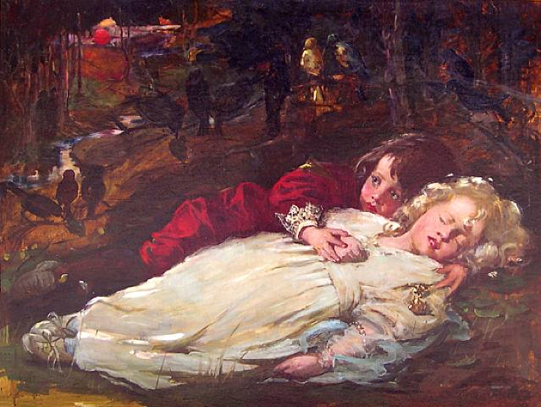

HAMLET: (3.1)
To be, or not to be: that is the question:
Whether 'tis nobler in the mind to suffer
The slings and arrows of outrageous fortune,
Or to take arms against a sea of troubles,
And by opposing end them? To die: to sleep;
No more; and by a sleep to say we end
The heart-ache and the thousand natural shocks
That flesh is heir to, 'tis a consummation
Devoutly to be wish'd. To die, to sleep;
To sleep: perchance to dream: ay, there's the rub;
For in that sleep of death what dreams may come
When we have shuffled off this mortal coil,
Must give us pause: there's the respect
That makes calamity of so long life;
For who would bear the whips and scorns of time,
The oppressor's wrong, the proud man's contumely,
The pangs of despised love, the law's delay,
The insolence of office and the spurns
That patient merit of the unworthy takes,
When he himself might his quietus make
With a bare bodkin? who would fardels bear,
To grunt and sweat under a weary life,
But that the dread of something after death,
The undiscover'd country from whose bourn
No traveller returns, puzzles the will
And makes us rather bear those ills we have
Than fly to others that we know not of?
Thus conscience does make cowards of us all;
And thus the native hue of resolution
Is sicklied o'er with the pale cast of thought,
And enterprises of great pith and moment
With this regard their currents turn awry,
And lose the name of action.--Soft you now!
The fair Ophelia! Nymph, in thy orisons
Be all my sins remember'd.

KING LEAR: (3.2.1-9)
Blow, winds, and crack your cheeks! rage! blow!
You cataracts and hurricanoes, spout
Till you have drench'd our steeples, drown'd the cocks!
You sulphurous and thought-executing fires,
Vaunt-couriers to oak-cleaving thunderbolts,
Singe my white head! And thou, all-shaking thunder,
Smite flat the thick rotundity o' the world!
Crack nature's moulds, an germens spill at once,
That make ingrateful man!

CREATURE-FEATURE: wild beasts (bronco, mountain cat) – see above under THEMES
- monster movies
- beast movies
- *when humans are taken out of their high place on the food chain
- when they are “out of their element”
- perspective: we admire the wild animals (here =sea) when it is safely at a distance or behind a zoo’s cage
  - here, though, they are at its mercy, on its home turf, in its natural habitat
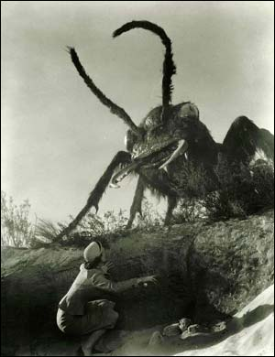

“zoo-effect”: (similar to “creature-feature”)
- humans like to look at wild beasts when they are caged
- we love to walk on the wild side (fantasy)
- BUT
- What happens when they are let loose & the humans are at their mercy, in their natural habitat, on their home turf?
- What happens we cannot get back from the “wild side”? –when the fantasy comes true?
- wild animals + wild sea + rock stars/movie stars (bad boys)
- “WRUG?” (bad boy)

Surf + rollers:
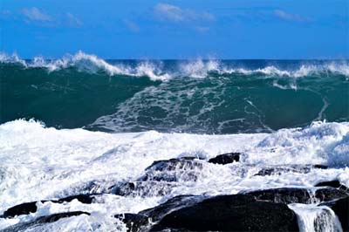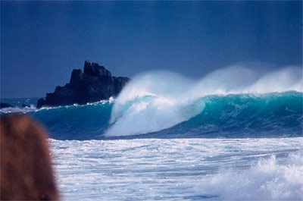

Dinghy:

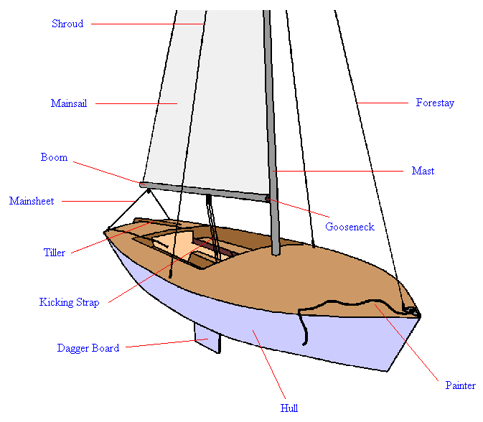
____________________________________________________________________________________________________________________________________________________________
QUESTIONS

- Why did the Oiler die?
  - Why did he have to die?
  - OR Was his just a senseless death? Evidence of a cruel, bitterly ironic Fate? Tragic irony?
- Is the Oiler selfish at the end, not helping the others, swimming ahead of them?
- Why is the Oiler the only one with a name (or nickname)? What does it suggest about his personality (outgoing)? What does it say about the regard with which the others hold him (warm, high regards)? Is this Crane’s homage to the person (“Billy”) who died during his real-life adventure?
- Is the story optimistic or pessimistic?
- Why did Crane tell this story? Fame? Pity? Money (via publishing)? Thematic @ the human condition?
- What is the message from/in the sea’s voice that the survivors can interpret? How is that related to the reasons Crane told this story?
- What is the power of art and literature that Crane may be suggesting through the reference to the “soldier who lay dying in Algiers”?
- Are the 4 men in the boat representative of humanity? Is their boat a microcosm of the world? What are the races and genders of these people? Is it racist or sexist to suggest that they represent the whole of society?

