PARABLE of the PRODIGAL SON
(Luke 15:11-32)

DEFINITIONS:
- “Prodigal”
  - wasteful, exceedingly & recklessly wasteful
    - spendthrift, wastrel
  - extremely generous
- “parable”
  - brief, concise story
  - anecdotal, on-point, from which a lesson is to be drawn
  - dictionary.com: “a short allegorical story designed to illustrate or teach some truth, religious principle, or moral lesson”
__________________________________________________________________________________________

CONTEXT:
- 1st century BC
- Pharisees & scribes
  - often opposed to Jesus b/c he found their traditions & teachings inadequate;
  - were “lovers of money” [16.14])
  - complained that Jesus was a man of loose morals:
    - “This man receives sinners and eats with them” (15.2)
      - tax collectors & sinners
  - against the conversion ( redemption) of Gentiles?
- Jesus’ response =
  - Parable of the Lost Sheep (15.3-7),
  - Parable of the Lost Coin (15.8-10), and
  - Parable of the Prodigal Son
  - followed by the Parable of the Dishonest Manager
    - 16.10 “One who is faithful in a very little is also faithful in much, and one who is dishonest in a very little is also dishonest in much. 11 If then you have not been faithful in the unrighteous wealth, who will entrust to you the true riches? 12 And if you have not been faithful in that which is another's, who will give you that which is your own? 13 No servant can serve two masters, for either he will hate the one and love the other, or he will be devoted to the one and despise the other. You cannot serve God and money.”
- LUKE:
  - Gospel of Luke, book of Acts of the Apostles (sequel) often called Luke-Acts, as 1 book
  - Greek (Lucanus?)
  - Gentile Christian (only one as writer in NT)
    - non-Christian, but familiar w/Jewish customs, OT Greek
  - companion of the Apostle Paul (witnessed Paul’s many arrests, beatings)
    - Christians tolerated as Jewish sect; AD 64 Rome fire, Nero blames Christians, Christianity & Judaism seen as 2 distinct religions, Christianity = new religion = illegal → persecutions, despised, seen as superstition (esp. in foreign lands)
    - 1st great Christian apologia = Gospel of Luke & Acts of the Apostles
      - a Defense of Christianity (legal defense)
  - historian , medical doctor by profession (maybe)
    - educated
    - → attention to detail, recording events & dates
      - scientific, orderly approach
      - carefully researched events
        - “eyewitnesses and servants of the word” (1:2)
        - interviews & preachings of the apostles
        - (close with Paul)
  - artist
    - “painter in words”
    - descriptive, visual
    - most literary of the Gospels
  - Book of Luke
    - @ AD 60 (written in Rome?)
    - 3rd Gospel
    - one of the 3 “Synoptic Gospels” (Matthew, Mark and Luke)
    - a defense of Christianity
      - apologia
      - supported by address to Roman official, Theophilus
      - only NT book meant for an audience outside the Christian community
    - style
      - styles – formal, classical prose; racy narrative in vernacular; semitic “Bible Greek”
      - logical, orderly
      - literary excellence, poetic, description, eye to detail
      - a human, sensitive, compassionate Jesus
      - interested in people over ideas/ideology
    - themes
      - humanity of Jesus
      - perfectness of Jesus (perfect man, perfect sacrifice, perfect savior)
      - Jesus’ love of people
      - Jesus’ compassion for the sinful, sick, poor
      - emphasis to prayer, angels, miracles
      - women have important place in the book
      - (1) universality, recognition of Gentiles as well as Jews in God’s plan (2:30–32);
      - (2) emphasis on prayer, especially Jesus’ praying before important occasions (see note on 3:21);
      - (3) joy at the announcement of the gospel or “good news”;
      - (4) special concern for the role of women (8:1–3);
      - (5) special interest in the poor;
      - (6) concern for sinners;
      - (7) stress on the family circle (Jesus’ activity included men, women and children, with the setting frequently in the home);
      - (8) repeated use of the Messianic title “Son of Man” (used 25 times);
      - (9) emphasis on the Holy Spirit;
      - (10) inclusion of more parables than any other Gospel;
      - (11) emphasis on praising God (1:64; 24:53).
    - written to
      - Theophilus (“one who loves God”)
        - a Roman who was interested in burgeoning Christianity movement
      - all those who are interested, who “love God”
      - Gentiles
      - (perhaps as defense of Paul who was on trial – defense of Christianity - see above)
    - 1) Birth, 2) Ministry, 3) Death & Resurrection of Jesus
    - stories NOT in other parts of the Bible (New to Luke)
      - Zachariah’s vision, angels & shepherds at Jesus’ birth, child Jesus in the temple
      - Parable of the Good Samaritan
      - Parable of the Prodigal Son
__________________________________________________________________________________________
Parable of the Prodigal Son

PLOT:
- premature inheritance
- far off land
  - “riotous living”
  - all spent → famine over land
  - desperation, starvation
    - takes job as pig feeder
    - pigs = fed better than he (husks of corn)
    - no one would help him
  - “came to himself”
    - realization
    - repentance
- goes home (to be a servant)
- welcomed
  - father’s “compassion” – already forgiven
  - given food, clothes
  - ring, shoes, fatted calf
- Elder Brother
  - working in field
  - hears music & dancing
  - jealous, angry
__________________________________________________________________________________________

LINES:
- 17 And when he came to himself,
- 18 Father, I have sinned against heaven, and before thee, 19 And am no more worthy to be called thy son: make me as one of thy hired servants.
- 23 And bring hither the fatted calf, and kill it; and let us eat, and be merry: 24 For this my son was dead, and is alive again; he was lost, and is found.
- 29 And he answering said to his father, Lo, these many years do I serve thee, neither transgressed I at any time thy commandment: and yet thou never gavest me a kid, that I might make merry with my friends: 30 But as soon as this thy son was come, which hath devoured thy living with harlots, thou hast killed for him the fatted calf.
- 31 And he said unto him, Son, thou art ever with me, and all that I have is thine. 32 It was meet that we should make merry, and be glad: for this thy brother was dead, and is alive again; and was lost, and is found.
__________________________________________________________________________________________

ARTISTRY:
- premature inheritance
- sparse narrative
  - details would get in the way
- comparison/contrast of sons:
  - Younger goes, Elder stays
  - Younger = physically & emotionally distant, Elder = physically near but emotionally/ spiritually distant
  - Younger repents, Elder does not “get it”
  - Both = spiritually lost
- open-ended ending:
  - Does the Prodigal “get it”?
  - Does the Elder Son “get it”?
- subtle:
  - “this thy son” vs. “this thy brother”
__________________________________________________________________________________________

PRODIGAL SON:
- symbolizes all of Fallen Mankind
- symbolizes each individual sinner
- demonstrates the path of repentance
- his request of premature inheritance =
  - mankind’s will (thoughts, desires), will to follow own will over God’s
- his fall = demonstrates
  - the natural state of unregenerate mankind =
    - toward lust, greed, wastefulness, extravagance
  - alienation from God
    - without God, we squander & become lost
    - grow hungry – cannot be sated by swinish pods (other gods/religions or materialism)
    - descend into futility, darkness, humiliation

__________________________________________________________________________________________

Elder Son:
- his sins =
  - self-righteousness
  - lack of forgiveness
  - hard-heartedness
  - lack of brotherly love, forgiveness
  - lack of compassion
- disowns brother
- symbolizes the Pharisees, scribes
  - envy
  - self-conceit, self-importance, pride, vanity, arrogance, snobbery, self-satisfaction
- justified?
  - blind to his father’s love, to imputed grace, to the gifts he has & has always had
  - misses the point
    - could have had a “party” w/ a fatted calf any time he wanted
    - should be happy for his brother’s return
    - should rejoice in his brother’s redemption/repentance
    - should forgive his brother’s transgressions
    - should realize it could have been him (“there but for the grace of God go I”)
- self-serving service:
  - does good to get noticed, appreciated
  - not virtue for virtue’s sake BUT for some reward
    - do good not b/c it’s the right thing to do but b/c it gets a reward, attention
  - attention-seeking behavior
  - actions, duty without heart
  - see “Say Yes”
- Father goes out to him, too
__________________________________________________________________________________________
FATHER:

positive | negative
- gives all he has  - gives inheritance prematurely (before it’s due)  - gives unconditional love  - accepts younger son  - without explanation, repentance, excuses, …  - celebrates the son’s return - homecoming  - Prodigal with his love  - goes out to Prodigal Son  - goes out to Elder Son  - complete, underserved forgiveness | - father = too prodigal with his love, money, property  - father gave the money prematurely (-)  - father accepted son back too easily  - son’s confession =  - rehearsed  - way of evading responsibility of his error/prodigality  - ending = father returning (ignorantly) to his original error  - father has learned nothing  - younger son has learned nothing (got away with it, will again)  - elder son has learned to be unrighteous, prodigal
________________________________________________________________________________________

INHERITANCE:
- God’s gifts to all humanity (mind, heart, grace)
- given prematurely
- son’s request = mankind’s will (thoughts, desires), will to follow own will over God’s

SWINE:
- Jews & Moslems do not eat pork
- vegetarians
- disgust – at his reduced to feeding pigs & his envy of the swine
  - farmer’s “bad joke”, contempt
  - reflects foreigners’ treatment of Christians (Chr. = superstition)
  - think of Abu Ghraib mistreatments (abuses targeting religious beliefs)
- PULP FICTION on pigs: < http://www.youtube.com/watch?v=u8UE4P8kB-c >
  - Vincent: Want some bacon?
  - Jules: No man, I don't eat pork.
  - Vincent: Are you Jewish?
  - Jules: Nah, I ain't Jewish, I just don't dig on swine, that's all.
  - Vincent: Why not?
  - Jules: Pigs are filthy animals. I don't eat filthy animals.
  - Vincent: Bacon tastes gooood. Pork chops taste gooood.
  - Jules: Hey, sewer rat may taste like pumpkin pie, but I'd never know 'cause I wouldn't eat the filthy motherf***er. Pigs sleep and root in sh*t. That's a filthy animal. I ain't eat nothin' that ain't got sense enough to disregard its own feces.
  - Vincent: How about a dog? Dogs eats its own feces.
  - Jules: I don't eat dog either.
  - Vincent: Yeah, but do you consider a dog to be a filthy animal?
  - Jules: I wouldn't go so far as to call a dog filthy but they're definitely dirty. But, a dog's got personality. Personality goes a long way.
  - Vincent: Ah, so by that rationale, if a pig had a better personality, he would cease to be a filthy animal. Is that true?
  - Jules: Well we'd have to be talkin' about one charming motherf***in' pig. I mean he'd have to be ten times more charmin' than that Arnold on Green Acres, you know what I'm sayin'?
__________________________________________________________________________________________

TITLE:
- Fine as is
  - BOTH sons = prodigal
  - external vs. internal
  - 2 parts of the story
    - younger son’s fall/edification
    - elder son’s fall/edification
    - (otherwise, story would stop after the younger son is welcomed home)
- alternate titles – (change title = change the way it’s read, interpreted)
  - of Lost Son
    - alienation from God
    - lost, can be found
    - lost, someone is waiting when he returns
    - not necessarily bad person, but took bad course
      - can be forgiven
    - can be found, redeemed
    - seems more of a temporary situation
  - of a Father’s Love (+)
    - gives all he has
    - gives inheritance prematurely (before it’s due)
    - gives unconditional love
      - accepts younger son
      - without explanation, repentance, excuses, …
      - celebrates the son’s return - homecoming
  - of Prodigal Father (-)
    - “waste not your heart on the unworthy, lest you lose the lose of the righteous”
    - father = too prodigal with his love, money, property
      - father gave the money prematurely (-)
      - father accepted son back too easily
      - son’s confession =
        - rehearsed
        - way of evading responsibility of his error/prodigality
      - ending = father returning (ignorantly) to his original error
        - father has learned nothing
        - younger son has learned nothing (got away with it, will again)
        - elder son has learned to be unrighteous, prodigal
  - of 2 Sons:
    - puts an emphasis on both sons
    - 2 halves of the story
    - both sons need to learn the father’s love/ways (God’s love/ways)
    - younger son = prodigal with gifts
    - elder son = envious, spoiled
    - both = blind to imputed grace, unconditional love
__________________________________________________________________________________________

EPILOGUE:
- What happens to the older brother?
  - Does he give up the righteous path?
    - Does he become prodigal?
      - Would it be worse if he did (worse than the younger’s wastefulness)?
  - Does he forgive & welcome his younger brother?
- What happens to the younger/prodigal son?
  - Does he learn his lesson?
  - Does he relapse?
  - Does he take advantage of the father’s love/money?
- What would happen if the father dies?
  - How the brothers behave?
    - Share? Fight over possessions? Squander money & property?

__________________________________________________________________________________________

QUESTIONS:
- Would this brief parable suffer if it had more details?
- How would the story be different from the Elder Son’s POV?
  - Does it change the story?
  - Change the message?
- Can this story be appreciated by non-Christians?
  - Does their religion change the message?
  - Does the fact that they do not accept the divinity of Jesus alter the story, their view of it?
  - Can they appreciate the moral lessons?
  - Can they appreciate the artistry of the writing?
- Does this message change with your age?
  - @ 20
  - @ 30
  - @ 40…
- How can this parable apply to Caretakers vs. other siblings
- How can this be the story of the Prodigal Father?
  - prodigal with his property
  - prodigal with his love
  - father = (-)
- What are some alternate titles for this parable?
  - How does each change the focus of the story?
  - of Lost Son
  - of Loving Father
  - of Prodigal Father
  - of 2 Sons
- How does this parable answer the Pharisees?
  - Pharisees = prodigal son
  - Jesus/God = father
- Are the Elder Son’s reservations justified?
  - Is the father prodigal with his love?
  - Does the son get the father’s point?
- Problem with this?
  - stay home, take care of everything, devoted, walk the narrow path, do what are supposed to, live a righteous life
  - the other lives as a wastrel, then repents when he’s lost everything, then all’s forgiven?
  - sin, murder, kill, …then repent on death bed?
  - make everyone else’s life miserable but as long as you repent at the end it’s ok?
- Did the Father know that the Prodigal Son would be prodigal?
  - When he gave him the inheritance
  - Did the Father realize that allowing his son to fail was the only to teach him, cure him?
  - self-sacrificing fathers
    - “Prodigal”
    - “Powder”
    - “Clod & Pebble”
- Is the Prodigal’s repentance true?
  - He practices, rehearses it?
  - like a speech
  - words without thoughts??
__________________________________________________________________________________________

ALLEGORY:
(possible??)
- Father = God
- Elder = Lucifer, angels
- Prodigal = humanity (with free will, fall & redemption)

(medieval allegorizations)
- Father = God
- Elder = Pharisees & teachers who resented the conversions of the Gentiles (sinners)
- Elder in field = Pharisees’ distance/remoteness from God’s grace
- Prodigal = Gentiles, wandered in illusions, served the devil, tended to demons
- Swine owners = Devil
- Swine = demons
- Husks (eaten by pigs) = vices (which cannot satisfy) & pagan literature (cannot satisfy)
- Father’s going to meet Prodigal = the Incarnation
- Father’s falling on Prodigal’s neck = the gentle yoke of Christ (Matthew 11.29-30)
- Music (heard by Elder) = praise of God
- Feast of fatted calf = Eucharist

TRAGEDY:
- Aristotle: “‘Tragedy, then, is an imitation of an action that is serious, complete, and of a certain magnitude; in language embellished with each kind of artistic ornament, the several kinds being found in separate parts of the play; in the form of action, not of narrative; with incidents arousing pity and fear, wherewith to accomplish its katharsis of such emotions.[ . . .] Every Tragedy, therefore, must have six parts, which parts determine its quality—namely, Plot, Characters, Diction, Thought, Spectacle, Melody.’”
- change in fortune, fall from grace, tragic flaw/error
  - (BUT tragic flaw = usually NOT a vice, as the Prodigal Son’s is)
- recognition, realization
- conflict, climax, complication (Elder?), resolution
- protagonist = high social standing (renowned, prosperous), reversal of fortune
- characters = true to life & believable, true to their character/consistent,
- tragic-comedy
  - fall
  - recognition
  - recovery/restoration, welcome
  - (happy ending)

__________________________________________________________________________________________

THEMES:
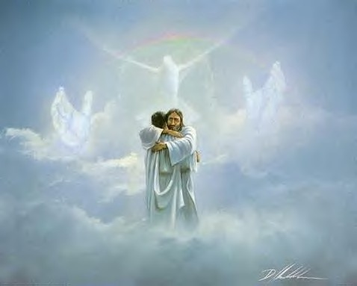
- Forgiveness
  - self
  - children
  - siblings
  - other humans
    - sinners, non-Christians
  - of sins
    - washes away all past sins
      - “POWDER”: new snow, covers old tracks/sins, fresh start
  - forgiveness = complete
    - not half-hearted, no resentments
    - total – fresh start
    - wash away/wipe out past sins
- Hope:
  - possibility for change
  - not stuck in hopeless situation
  - our will got us in to this mess, will to change/repent gets us out
  - God will forgive if we repent & return home
  - God is waiting for/watching for us “at home”
- Repentance
  - gradual, inner process
(1) consciousness of one’s fall
(2) sincere remorse
(3) humble turning to God
- HUMANITY
  - what it means to be human
  - these are humans acting human
  - each of us has the capability of
    - prodigality, wastefulness, materialism
    - unregenerate, fallen state
    - sin, sinning
    - fall from grace, disgrace
    - despair, isolation, alienation
    - compassion, forgiveness
    - envy, jealousy, self-righteousness, pride
    - inability to forgive
    - blindness to our gifts
- Unconditional love (imputed, undeserved grace)
- Fatherhood
- Fatherly love
- Brotherly love
- Fairness
- Loyalty
- Work
- Profligacy, prodigality, wastefulness, recklessness
- Wages of sin
__________________________________________________________________________________________

DECONSTRUCTIONISM:
- Because it’s a parable
  - sparse by its nature
  - doesn’t tell us how to interpret
  - doesn’t spell everything out
- readers can use its ambivalence it out to create alternate interpretations
  - fill in the gaps in the text
  - use the same words to create an alternate reading

FEMINISM:
- no women in the story
- no mother/wife, no sisters
- both sons = single
- only women referred to = “harlots”
- Jesus = sexist? Luke = sexist? Gospel writers, Church Fathers = sexist?
- refuted by Gospel of Luke
  - features prominent role of women, esp. in Jesus’ life as followers
    - Mary, Mary Magdalene, Martha, Mary of Bethany
  - only Gospel with the Annunciation story
- GOING TOO FAR:
  - allegorizations
  - tragedy
  - Deconstructionism
  - Feminism
  - Queer Theory (Elder Son as gay, b/c not married, at home)
OTHER STORIES:
- new starts:
  - “Prodigal”
  - “POWDER”: new snow, covers old tracks/sins, fresh start
- self-sacrificing fathers
  - “Prodigal”
  - “Powder”
  - “Clod & Pebble”
- Fake repentance?
  - “Say Yes”
  - “Parable”
- self-serving service:
  - does good to get noticed, appreciated
  - not virtue for virtue’s sake BUT for some reward
    - do good not b/c it’s the right thing to do but b/c it gets a reward, attention
  - attention-seeking behavior
  - actions, duty without heart
Shakespeare’s Sonnet XXIX
When in disgrace with fortune and men's eyes
I all alone beweep my outcast state,
And trouble deaf heaven with my bootless cries,
And look upon myself, and curse my fate,
Wishing me like to one more rich in hope,
Featured like him, like him with friends possessed,
Desiring this man's art, and that man's scope,
With what I most enjoy contented least;
Yet in these thoughts my self almost despising,
Haply I think on thee, and then my state,
Like to the lark at break of day arising
From sullen earth, sings hymns at heaven's gate;
For thy sweet love remembered such wealth brings
That then I scorn to change my state with kings.

    - see “Say Yes”
    - “Prodigal”
- fatherhood:
  - “Prodigal”
  - “Powder”
- forgiveness:
  - “Prodigal”
  - “Say Yes”

“Prodigal Son”: written by Reverend Robert Wilkins (a blues singer turned preacher) & recorded by the Rolling Stones on Beggars Banquet (1968).

Well a poor boy took his father's bread and started down the road  Started down the road  Took all he had and started down the road  Going out in this world, where God only knows  And that'll be the way to get along  Well poor boy spent all he had, famine come in the land  Famine come in the land  Spent all he had and famine come in the land  Said, "I believe I'll go and hire me to some man"  And that'll be the way I'll get along  Well, man said, "I'll give you a job for to feed my swine  For to feed my swine  I'll give you a job for to feed my swine"  Boy stood there and hung his head and cried  `Cause that is no way to get along | Said, "I believe I'll ride, believe I'll go back home  Believe I'll go back home  Believe I'll ride, believe I'll go back home  Or down the road as far as I can go"  And that'll be the way to get along  Well, father said, "See my son coming after me  Coming home to me"  Father ran and fell down on his knees  Said, "Sing and praise, Lord have mercy on me"  Mercy  Oh poor boy stood there, hung his head and cried  Hung his head and cried  Poor boy stood and hung his head and cried  Said, "Father will you look on me as a child?"  Yeah  Well father said, "Eldest son, kill the fatted calf,  Call the family round  Kill that calf and call the family round  My son was lost but now he is found  'Cause that's the way for us to get along"  < http://www.youtube.com/watch?v=Xle0kTH-cIA >

- How is the version of the Prodigal Son in the song different from that of the Bible? Are the differences or liberties in Wilkins’s song justifiable?

____________________________________________________________________________________________________________________________________________________________________________________

- the elder son reveals the theme of envy, self-conceit, legalism and the theme of the necessity for mutual, brotherly forgiveness.
- The younger, prodigal son is a symbol of all fallen mankind, and, at the same time, of each individual sinner. The portion of goods that falleth to him, that is, the younger son's share of the property - these are God's gifts, with which each man is endowed. According to the explanation of Bishop Ignatius Brianchaninov, these are "…the mind and heart, and especially the grace of the Holy Spirit, given to each Christian. The demand made of the father for the portion of goods falling to the son in order to use it arbitrarily is the striving of man to thrown off from himself submissiveness to God and to follow his own thoughts and desires. In the father's consent to hand over the property there is depicted the absolute authority with which God has honored man in the use of God's gifts".
- Repentance is the third theme. Nowhere better does the Gospel disclose to us what the essence of repentance is, than, namely, in the parable of the Prodigal Son. It reveals to us the gradual, inner process of the sinner's turnabout and the fullness of repentance, which consists of consciousness of one's fall, sincere remorse and turning humbly to the Heavenly Father. (http://www.stjohndc.org/Russian/parables/e_Par_2_11.htm)

The Parable of the Prodigal Son – The Meaning
- The parable of the prodigal son is one of the most well-known stories of Jesus. It is more commonly referred to as the story of the prodigal son, though the word prodigal is not found in Scripture. To characterize the son as “lost” emphasizes that sinners are alienated from God; to characterize the son as “prodigal” casts an emphasis on a wayward lifestyle. In truth, this particular parable has many points to bring out concerning the nature of man and God.
  - The word prodigal may be defined as “rashly or wastefully extravagant”; the son in the story exhibited this behavior with his handling of his share of his father’s estate. Having prematurely gotten hold of his inheritance from the father he “squandered his wealth in wild living” then, “began to be in need.” The natural state of unregenerate mankind is always toward lust and greed and extravagance of all kinds; without God we squander our resources and energies until we are void and empty. When the younger son found himself in this state, he remained in the far country working in a contemptible job and willing to eat the food he was feeding to the pigs which were under his care. When we remain in a place of alienation from God, we descend into futility, darkness, and humiliation.
  - The parable of the prodigal son indicates, however, that we do have the opportunity to make a change; we do not have to stay in our hopeless state; we can come to ourselves. The lost son realized that in his father’s house there was sustenance for him; he humbled himself, willing, if necessary, to be his father’s servant, and started back home. This turning in our lives is the first indication of God’s love for us. Even recognizing our sinful, hopeless state is initiated in us by God, Himself. “Or do you show contempt for the riches of his kindness, tolerance and patience, not realizing that God's kindness leads you toward repentance?” (Romans 2:4).
  - The parable of the prodigal son makes it obvious that God was at work. That he was able to see the younger son when he was still a long way off means that the father was watching for his son, waiting for him, longing for him. The father runs to him, embraces him, loves him and gives him gifts; he seems totally oblivious to the fact that his son has disrespected him, acted outrageously, and lost everything. The father lavishes upon him, celebrates over him. This is a wonderful picture of the great love of God towards us. He seeks after us, reaches out to us. When we come to Him, He washes away all our evil deeds of the past, not holding them against us. “You will again have compassion on us; you will tread our sins underfoot and hurl all our iniquities into the depths of the sea” (Micah 7:19).
  - The parable of the prodigal son also shows the attitude of the self-righteous sinner, pictured by the older son. He quarreled with his father that the younger son had messed up and yet the father had prepared for him the “fatted calf.” Because he considered himself better than the younger son, he could not share in the father’s joy. “My son,” the father said, “you are always with me, and everything I have is yours.” The older son’s hardness of heart made him unaware of the riches available to him in his father’s house. This son complained that he had “slaved all these years.” He had no more love for the father than the younger son; nor did he avail himself of all the good things the father freely provided for him at all times. Both sin and self-righteousness separate us from God. We all require God’s grace, His unearned, unmerited love for us. The father went out to the disgruntled older son. God is He who always continues to seek after us, regardless of the state we are in.

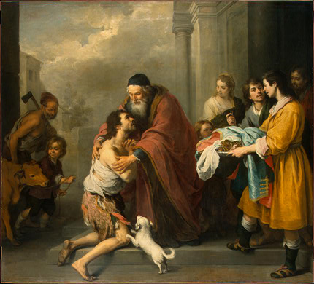
The Return of the Prodigal Son by Bartolomé Esteban Murillo (1667-1670)

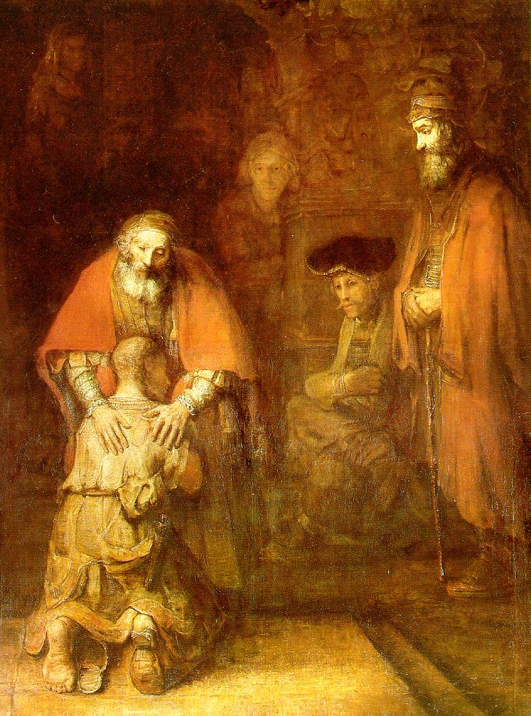
The Return of the Prodigal Son by Rembrandt (1668)


The Prodigal starring Lana Turner, Edmund Purdom (1955, dir. Richard Thorpe)
One critic has noted that The Prodigal was aptly titled, inasmuch as it was all too prodigal with the funds of the then-flagging MGM studios. In its retelling of the 22-verse Biblical story of the Prodigal Son, the film helpfully fills in the story details inconsiderately left out of the Old Testament [sic]. Edmond Purdon plays Micah, the wastrel son of Eli (Walter Hampden) who takes his share of his father's fortune and blows it all in wicked old Damascus. Micah's one redeeming feature is his unserving faithful in the Lord God Jehovah. Pagan princess Samarra (Lana Turner at her most giddily exotic) intends to seduce Micah into renouncing his faith, only to get stoned to death for her troubles. Nearly two hours pass before Micah returns home and the fatted calf is killed in his honor. If for nothing else, The Prodigal would be memorable for Lana Turner's pagan-ritual costume, which is little more than a glorified bikini. ~ Hal Erickson, All Movie Guide

_________________________________________________________________________________________
The Prodigal Daughter


