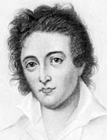
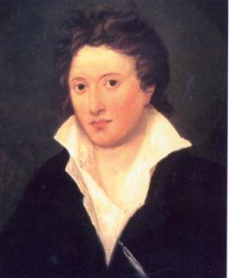
PERCY BYSSHE SHELLEY
(1792-1822) 29

*radical nonconformist*

- August 4, 1792, Field Place, near Horsham, Sussex
- *family = Sussex aristocrats* (since early 17thC)
- grandfather (Sir Bysshe Shelley) = richest man in Horsham
- father = Timothy: hard-headed, conventional, conservative, member of Parliament
- mother = Elizabeth
- 1 brother, 4 sisters
- PBS = eldest son
  - was to inherit grandfather's great estate *
  - (in line for a baronetcy)
  - was to inherit a seat in Parliament *
- 1804-10:
  - attended Eton College (began writing poetry)
  - fitted his station and future
  - *** PBS = bullied:
    - PBS = “slight of build, eccentric in manner, and unskilled in sports or fighting, and as a consequence was mercilessly baited by older and stronger boys. Even then he saw the petty tyranny of schoolmasters and schoolmates as representative of man’s general inhumanity to man, and dedicated his life to a war against injustice and oppression.” ***
    - “mad Shelley”: b/c of his moodiness, shyness, eccentricity, resentful of authority
    - later recounted these years in the dedication to Laon/Revolt:
    - “...‘I will be wise, / And just, and free, and mild, ... / ... for I grow weary to behold / The selfish and the strong still tyrannize / Without reproach or check.’...” (Norton p.1716)

1810: attended Oxford University
1810: published his 1st novel:
- Zastrozzi
  - Gothic novel
  - title villain = atheist & heretic
  - PBS used Zastrozzi to voice his own opinions
1810: published pamphlet of poetry
- “Posthumous Fragments of Margaret Nicholson”
  - collection of burlesque poetry
  - along with Thomas Jefferson Hogg:
    - another Oxford student
    - self-confident, self-centered
    - shared PBS's love of philosophy & scorn for orthodoxy
1810: published more poetry
- Original Poetry; by Victor and Cazire
- along with his sister Elizabeth
1811: more creative output, more pamphlets
- “The Necessity of Atheism”
- along with JT Hogg
- “claimed existence of God cannot be proved on empirical grounds” (Norton 1716)
- *got him expelled from Oxford University (after only 6 months)
- *could have been reinstated with his father's aide
- BUT Shelley refused to disavow the pamphlet, declare himself a Christian
    - → led to a complete break with his father
    - → $$$$$$ problems for the next 2 years, until he came of age (to inherit)
    - moved to London
1811: PBS = 19
- eloped to Scotland with Harriet Westbrook, 16
  - whom PBS took as a cause to fight injustice:
  - her father, a tavern keeper, had “persecuted her” (PBS) by forcing her to attend school (she = a cause for PBS to fight, not woman to love)
  - ???: PBS believed that marriage was tyrannical & degrading as a social institution (KATE CHOPIN), yet he still married her??
- moved frequently, lived off allowances from their families (given reluctantly)
1812: travelled to Ireland:
- to deliver his Address to the Irish People
- to join the Irish Catholic emancipation movement
- to help the oppressed & impoverished people
- (injustice, anti-establishment, socialism)
1812:
- settled in to England's Lake District, to study, to write
1813: published his 1st serious & long work
- Queen Mab: A Philosophical Poem
  - prophetic poem
  - the journey of a disembodied soul through space
  - Mab shows it visions of a woeful past, dreadful present, utopian future
  - * Mab: institutional religion (“there is no God!”) & codified morality = roots of social evil (* see BLAKE *)
  - * Mab: “humanity will follow goddess of Necessity, institutions will wither away, and humanity will return to its natural condition of goodness and felicity” (Romanticism*)
                - (Norton 1717)
  - reflects PBS’ friendship with & influence from William Godwin, radical freethinking Socialist philosopher
  - *began love affair with Godwin & Mary Wollstonecraft's daughter, Mary (Mary Wollstonecraft Godwin)

?? PBS’ convictions:
- marriage = tyrannical & degrading (but marries 2x),
- cohabitation w/o love = immoral (so abandoned Harriet)
- nonexclusive love (marries 2x) then invites Harriet to come & live with him & Mary in France, as a “sister”!
- Godwin = pissed, BUT PBS had taken over his debts even though he himself was in bad finances, BUT Godwin was against marriage & for free love (just not with his daughter!!)
- → PBS = an atheist, revolutionary, & immoralist in eyes of society, friends, family
- → when he eventually married Mary & moved to Italy, PBS saw himself in the role of ** ALIEN, OUTCAST, scorned & rejected by the very people (humanity) to whom he had dedicated his life with serving their welfare -- a Prometheus (Norton 1717)

1814: PBS and Mary eloped to Europe
- ran out of money $$$$
- returned to England
- November of 1814, Harriet gave birth to their son
1815:
- February, 4 months later, Mary gave birth prematurely to their son who died 2 weeks later
- ** PBS's grandfather died → PBS inherited $$$$$
  - wasted most of it helping William Godwin, Leigh Hunt , and others pay their debts
1816: January, Mary gave birth to another son, William, after her father
- PBS and Mary moved to Lake Geneva, Switzerland
- spent time with Lord Byron (George Gordon)
- ghost stories
- Byron's contest: each write a ghost story
  - Mary Shelley: Frankenstein
  - PBS: Alastor, or The Spirit of Solitude, a verse allegory
- December of 1816:
  - Harriet Shelley (pregnant by some unknown lover) apparently committed suicide, drowning herself in a fit of despair in a London park lake
  - PBS and Mary “officially” married 3 weeks later
  - PBS lost custody of the 2 children he had with Harriet, b/c of his "free love" ideas

** public scorn against PBS → his feelings as alien, exile

(1960s hippies: free love, swingers, elopement, anti-establishment, atheist, socialist)

1817: PBS wrote & published Laon and Cythna, a long narrative poem
- poem = pulled b/c of references to incest & attacks on religion
1818: Laon = edited, revised, republished as The Revolt of Islam
- PBS and Mary leave England for the last time

1818-19: within a 9-month period, 2 children died: Clara & William (children of PBS & Mary)
- → her into an apathetic & self-absorbed state, strained their marriage,
- not helped even by birth of another son (Percy Florence)

1818-1822:
- moved around Italian cities
- friends with Lord Byron, Leigh Hunt (English poet)
- ** period of PBS's greatest works
- in a period of financial & emotional strain ($$, kids) and without an audience
- 1819/20: Prometheus Unbound (masterpiece)
- 1819/20: The Cenci
  - numerous lyric poems (his best):
    - “Ode to the West Wind,”
    - “Ozymandias,”
    - “Ode to a Skylark,”
    - “The Cloud”
  - The Mask of Anarchy (call for proletarian revolution)
  - Peter Bell the Third (satire on WW)
  - A Philosophical View of Reform (political essay)
  - A Defense of Poetry
  - Epipsychidion (love as union beyond earthly limits)
    - see John Donne, American Transcendentalists
  - Hellas (lyrical drama evoked by the Greek war for liberation from the Turks, in which, like Mab, he prophesied a coming golden age)

**MATURE PBS:
*mature works = informed by his voracious reading, tragic deaths of children, outcast from society, constant philosophical thinking/considering...PBS = an erudite poet
*changed ideologies:
- turned from Gothic novels & radical optimists of late-18thC
  - to Greek tragedy, Milton's Paradise Lost, the Bible (!!)
  - millennialist; religious
- evils of society = humanity's own moral failures;
- radical social reform = now based on a prior reform of morality & imaginative faculties through the redeeming power of LOVE (BLAKE)
- Plato & Neo-Platonist: 2 worlds: (1) criterion world of perfect & eternal Forms, Ideal world; (2) ordinary world of change, mortality, evil, suffering; a world of sense experience that is but a distant & illusory reflection of the Ideal World
- David Hume & Empiricists: (tempered his Platonism) *limit of human knowledge, limited to valid reasoning based on sense experience only → Hume's radical skepticism
- skeptical idealist: Platonism + Empiricism + Hume's r.s. → imagination that transcends experience = ideal, but unlikely/rare, limits of human knowledge

→ ** “...the HOPE in the ultimate redemption of life by LOVE and imagination is not a certainty but a moral obligation. We must cling to hope b/c its contrary, despair about human possibility, is self-fulfilling, by ensuring the permanence of the conditions before which the mind has surrendered its aspirations. HOPE does not guarantee achievement, but it keeps open the possibility of achievement, and so releases the imaginative and creative powers that are its only available means.” (Norton 1718)
  - hope vs. despair, love & imagination/creativity
  - despair thwarts imagination, the only means of achieving, creating, improving; thus despair = self-fulfilling prophecy
  - despair → psychic paralysis (mental, spiritual, emotional), "can't change things, anything, the world, people...so nothing gets done
  - imagination/creativity = transcend experience, senses

PBS at Pisa: the “Pisan Circle” of friends = Lord Byron, Edward Trelawny, Edward Williams (whose wife, Jane, PBS carried on flirtations & to whom he addressed some of his lyrics)

DEATH: July 8, 1822, less than a month before his 30th birthday, drowned (along with Edward Williams) while trying to sail his schooner Don Juan in a storm from Leghorn to their summer house near Lerici, on the Gulf of Spezia, Tuscany, Italy
- violent squall swamped their boat ("Open Boat")
- washed ashore after several (10) days
- volume of Keats in one pocket
- volume of Sophocles in another pocket
- cremated, in pyre upon the beach (Shore of Via Reggio)
  - his heart refused to burn??
  - heart given to wife, Mary (found among her belongings when she died in 1851)
- Byron: friend, fellow exile, swam out to watch the flames; of PBS he said: "the best and least selfish man I ever knew. I never knew one who was not a beast in comparison." (EIL 397)
- ashes = (after stored in British Consul’s wine cellar) buried in Rome's Protestant cemetery, near the graves of William Shelley (his son) and John Keats
  - heart buried near Mary, in St Peter's Churchyard, Bournemouth
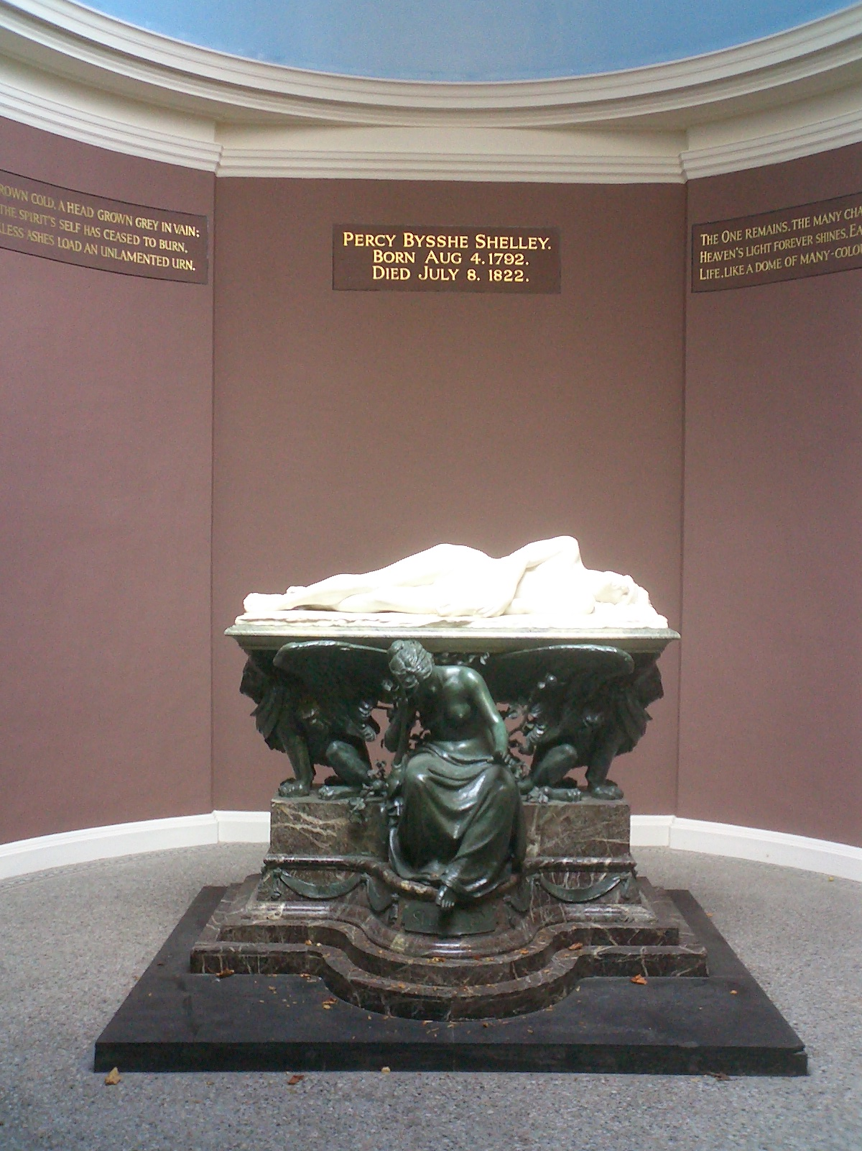
  - Shelley Memorial at University College, Oxford

---------------------------------------------------------------------------------------------------------------------
- radical nonconformist
- hippie, free love, anti-establishment
- restlessness: w/Harriet as newly weds, w/Mary in Italy
  - frequent moves (Poe, Hawthorne, Crane)
- freedom: Irish, Greek liberation movements
- millennialist: Mab, Hellas
  - ring: “Il buon tempo verra” (the good time will come)
- like BLAKE: power of imagination; redemptive power of love
- like BYRON: leaves England, feels like an outcast, alien
---------------------------------------------------------------------------------------------------------------------
(-):
- intellectual & emotional immaturity
- shoddy workmanship
- inconsistent/incoherent imagery

(+):
- multiple genres, no fixed mental position (ceaseless exploration); even his unfinished The Triumph of Life promised to move in a different direction
- structure to his symbolism
- expanded the “metrical & stanzaic resources of verse” (N 1719)
- range of voice: controlled passion of “West Wind,” heroic dignity of Prometheus, approximation of the inexpressible w/Asia's transfiguration, Adonis's visionary conclusion
- urbanity
- “effortless command of the tone & language of a cultivated man of the world” (N 1719)
- all w/o an audience
(Norton 1719)
---------------------------------------------------------------------------------------------------------------------
- against social injustice
- against institutions
- future = hopeful, utopic, millennial
- power of hope, love, imagination
---------------------------------------------------------------------------------------------------------------------
* “The Wall”
* “The Authority Song”
* Springsteen & the power of love as religion

** common theme of PBS poetry: nothing lasts:
- “Mutability”
- “Intellectual Beauty”
- “Ozymandias”

------------------------------------------------------------------------------------------------------------------------------------------------------------------------------------------------------------------------------------------
“To Wordsworth”
(1814-15)
- PBS calls WW “poet of nature” who weeps at the loss of childhood, youth, friendship, love
- PBS: grieves loss of WW, though WW does not die until 40 yrs. later → PBS = grieving WW's desertion from social radicalism

- WW = once a courageous spokesman for “truth and liberty” in literature & politics, a liberal, an activist, an example for others in the struggle for freedom & reform
- BUT = became in his later life a conservative, turning his back on his earlier causes, abandoned liberal causes & ideals
- PBS: felt betrayed by his hero, “deplores” WW's abandonment, his “deserting these” (truth & liberty) → “To Wordsworth”
---------------------------------------------------------------------------------------------------------------------
“Music, When soft Voices Die”
(1821)
- sense memory (“The Open Boat” & “The Grave”)
- music, scents, roses,...& love: live on
- immortality, in another form
- (see Christ's “Parable of the Mustard Seed,” changing form)
---------------------------------------------------------------------------------------------------------------------
“Mutability”
(1814-15)
- nature metaphors
- similes
- nothing lasts, nothing endures...BUT change
- the only constant = inconstancy, inconsistency
- thus, all = the same; joy, grief
- clouds in nights sky, musical notes, emotions
- “man's yesterday may ne'er be like his morrow”
---------------------------------------------------------------------------------------------------------------------
“Hymn to Intellectual Beauty”
(1816)
- “intellectual”= not of the senses (BLAKE)
- “beauty” = not physical beauty
- “beauty” = awareness, recognition, creativity (imagination)...(ST Coleridge, all creatures)
- “beauty” = God, ghosts, heaven: names given to beauty by religious philosophers
- “beauty” = INCONSTANT (see “Mutability”), we never know when it's going to strike; otherwise, we = immortal, omnipotent
- FALLEN WORLD: (SC)
  - “dim vast vale of tears, vacant and desolate”;
  - fear, dream, death, birth, gloom;
  - mutability
- beauty: gives grace & truth to experiences, to our moral consciousness ("love all human kind")--STC
- we never think we'll get old, past noon, in the autumn of life
____________________________________________________________________________________________________________________________________________________________
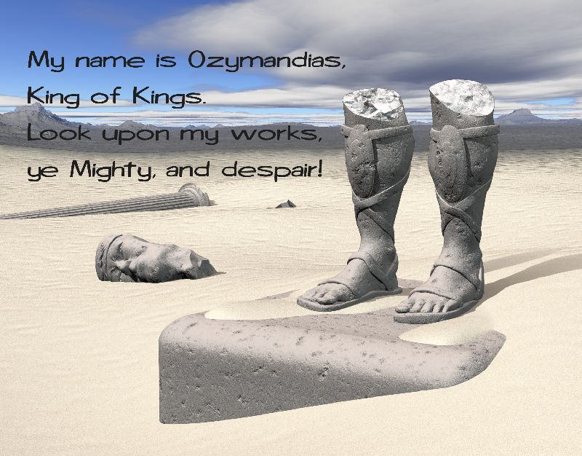
“OZYMANDIAS”
(1817)
TITLE:
- “Ozymandias” = Greek translation of Ramses II
  - Egyptian pharaoh 13thC BC
  - his funerary temple at Thebes;
  - inscription:
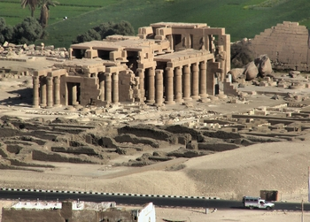
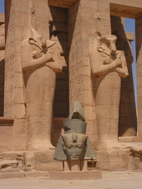
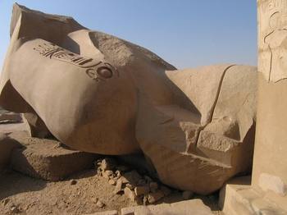
  - “I am Ozymandias, King of Kings; if anyone wishes to know what I am and where I lie, let him surpass me in some exploits.”

SOURCES:
- Shelley: visited to British Museum in 1817, with fellow poet Horace Smith,
  - PBS’s suggestion that they both compose a sonnet on the subject of the recent Egyptian finds
  - “Ozymandias” = Shelley's contribution
- Shelley: had a life-long hatred of tyranny
- Shelley: read book by ancient Greek historian Diodorus, in which he found an INSCRIPTION to an Egyptian monarch's monument quite similar to the one quoted in the poem
---------------------------------------------------------------------------------------------------------------------
- FORM = Petrarchan sonnet
  - sonnet (abaca, dedfe, hihi)
  - octave (abba, abba) & sestet (c d c d c d, c d d c d c, cdecde, cdeced, cdcedc)
- 3 speakers:
  - (1) speaker of entire poem ("I")
  - (2) traveler with the tale
  - (3) words on pedestal
- SUBJECT = “colossal wreck” of a statue
  - 2 legs (without trunk)
  - 1 shattered face
- TONE = ironic
- THEME = ironic comment on PRIDE; suggests the futility of all pride based on great works (works over faith??), anti-materialistic
  - line 8: suggests that this pride = ever-present, a human foible, past present & future
  - pride: arrogance of rulers (tyranny) & man (works)
- ALLITERATION = (reinforces) Meaning & Tone

Line 8:
- Ozymandias’ passions “mocked by” sculptor =
    - BUT
- sculptor “mocks” Ozy's passions:
  - imitated, copies them faithfully, exactly
  - derided, made fun of, them b/c he knew that Ozy won't last
  - derided b/c he knew that true immortality lies in ART, that he has true power of “king of kings” as artist
  - these passions REMAIN explicit, even in the ruined visage
    - passions survived both the sculptor & the pharaoh’s heart; artist & the model/inspiration
    - these passions = eternal, one of mankind’s foibles/sins
    - art = IMMORTAL (* “Shall I Compare Thee” *)
    - art has nothing to do with the artist or his/her subject; once created, art belongs to no one & everyone, now & always; has nothing to do with authorial intention (*No Biographical Criticism*)
    - Hamlet’s warning @ bad epitaphs:
      - “After your death you were better have a bad epitaph than their ill report while you live.” (Hamlet II, ii)

IRONY:
(1) sculptor lasts longer than Ozy
Ozy is only known through sculptor's work (not his own)
ART (ruins, sculptor) outlasts man (ruin, death)
(2) Ozy's boast: look on my works & despair BUT all that's left = sand
(3) Ozy is remembered not as he wanted (fear, awe) but as the artist (sculptor, poet) wanted (laughed at, mocked)
(4) lowly artist-servant-slave has power over “king of kings” through his medium; artist’s work will last longer than ruler's works
Ruling = destruction
ART = creation, therefore, as a positive force, it lasts longer, true immortality
(5) “despair” is true, just not in the sense Ozy meant – his vanity & ruin = instructive to others who follow – despair b/c this waste is what it all comes to
ART:
- has a power, responsibility over institutions (governments, rulers)
- link to immortality (truer than acquisition of material goods, lands, peoples, vanity)
- makes a comment: the poem, the sculpture --> is educational, immortality (teaches future generations)
- outlasts the artist, becomes the artist's immortality
- irony: the artist & the subject are joined forever in immortality (king & slave)
- subject, artist, traveler, poet, reader = linked -- *transgenerational
- sculptor = traveler = poet: convey through art
- art = more important than the artist, outlasts the artist →
- *art = god, life, world: outlasts pride & pompous man & his vain works (both art works, ruling works, all deeds), art is greater than the artist (perhaps sculptor = prideful too?)

Creativity vs. Tyranny
- art  - creation  - beauty  - eternal, immortal | - power  - destruction, subjugation, enslavement  - control  - ephemeral, mutable
* 9/11, our Twin Towers (and other skyscrapers, and other symbols of American superiority) = “pride,” great works....Ground Zero = “that colossal wreck” ?????????

* “Shall I Compare Thee to a Summer Day?” (art = immortal)
* “GCP” (no biographical criticism)

Arthur Guiterman -- “On the Vanity of Earthly Greatness”  The tusks which clashed in mighty brawls  Of mastodons, are billiard balls.  The sword of Charlemagne the Just  Is Ferric Oxide, known as rust.  The grizzly bear, whose potent hug,  Was feared by all, is now a rug.  Great Caesar's bust is on the shelf,  And I don't feel so well myself. | Shakespeare -- Hamlet (Act 5, scene 1)  HAMLET  To what base uses we may return, Horatio! Why may  not imagination trace the noble dust of Alexander,  till he find it stopping a bung-hole?  HORATIO  'Twere to consider too curiously, to consider so.  HAMLET  No, faith, not a jot; but to follow him thither with  modesty enough, and likelihood to lead it: as  thus: Alexander died, Alexander was buried,  Alexander returneth into dust; the dust is earth; of  earth we make loam; and why of that loam, whereto he  was converted, might they not stop a beer-barrel?  Imperious Caesar, dead and turn'd to clay,  Might stop a hole to keep the wind away:  O, that that earth, which kept the world in awe,  Should patch a wall to expel the winter flaw!

____________________________________________________________________________________________________________________________________________________________
“Stanzas Written in Dejection”
(1818)

- subtitle = “December 1818, near Naples”
- 1818:
  - Harriet drowns herself
  - Clara, baby daughter, just died
  - PBS = ill health, pain, $$ worries/problems, failure as a poet (self-doubt, not famous)

** ROMANTIC THEMES:
- sitting alone in nature
- beautiful day
- disconnect with nature & others (nature is not = inner self)
- joy in memory of the beautiful day
- alienation

NO: hope, health, calm, peace, contentment, fame, power, love
ALIENATION:
- from nature
- from others ("smiling they live and call life pleasure")
- from true self

regret:
- that he didn't enjoy that beautiful day
- that his “lost heart, too soon grown old”
- regret = lasting, will last longer than this day, linger like a joy still remembered --> (no end) no end to his pain

---------------------------------------------------------------------------------------------------------------------

“A Song: ‘Men of England’”
(1819)

1819:
- turbulent unrest
- return of troops from Napoleonic Wars
- economic depression

rich =
- lords who keep you down, tyrants
- ungrateful drones, stingless drones
- imposters, idles ("drink your blood")

working class =
- plough fields, weave robes
- save/make $$ or find (archeology??)
- forge arms

WHY?:
- the rich do not share with you (the products you make, the money they make from the products)
- you have the power & the skills

*proletarian revolution:
- labor movement
- do those things (sow, weave, forge) for yourself, not them,
- until England be your grave/tomb

Bees:
- drones (idle)
- worker bees (proletariat)

---------------------------------------------------------------------------------------------------------------------

"England in 1819"
(1819)

- king, princes, rulers, people, army, laws, religion, senate, Phantom

King George III =
- “An old, mad, blind, despised, and dying king”
- dead in 1820
princes =
- “dregs of their dull race” (worst of the worst)
- “mud from a muddy spring”
rulers =
- “"leechlike”
- far removed from what’s going on
- (do not see, feel, know, ...care)
aristocracy =
- parasites (live off others’ toils)
- (see “A Song: ‘Men of England’”)

people = "starved and stabbed"
- historical allusions to Peterloo Massacre:
  - 8/16/1819
  - St. Peter's Field near Manchester
  - cavalry stormed peaceful rally for parliamentary reform
  - “liberticide”

laws =
- favor the rich
- bought with gold
- lead to bloodshed
religion =
- “Christless, Godless”
religion & law =
- combined to keep “Time’s worst statute”:
  - unrepealed law imposing disabilities on Dissenters & Roman Catholics, restricted their civil liberties,
  - finally repealed 1829

- England = ripe for a revolution:
  - scary word in wake of French Revolution & its aftermath
    - 1789 = American and French revolutions
  - revolution = only hope for change, for survival of proletariat, ordinary people
  - revolution = “glorious phantom”
  - sheds light on dark, tempestuous day

GT:
- tyranny, cruelty, bloodshed on innocent
- religious persecution, Fallen Church
- “glorious phantom” = Second Coming of Christ, Christ’s return in glory to “illumine” or light the darkness

---------------------------------------------------------------------------------------------------------------------

"Ode to the West Wind"
(1819)

STYLE, FORM:
- 5 parts
- 14-line stanzas (each part with 14 lines)
- 3-line units, within each part, of terza rima (aba, bcb, cdc)
  - except last 2 lines = rhyming couplet
- 4 tercets + rhyming couplet (rhymes with middle line of previous)

5 parts
each part with its own topic:
(1) dead leaves driven away like ghosts; seeds buried like corpses;
(2) clouds like angels harkening Final Days, harbingers of coming storm; wind = dirge of dying year
(3) Mediterranean Sea and Atlantic Ocean = parted like the Red Sea, exposing the plant life beneath (sea = land)
(4) poet = West Wind, freedom of childhood, passed
(5) request to make poet WW's "lyre"; "Be thou me"; desires a new birth, a resurrection of his depressed spirt

BACKGROUND-INSPIRATION:
- inspired/conceived in a wood that skirts the Arno River, near Florence
- on a windy day, temperature = mild yet animated
- coming storm
- “This poem was conceived and chiefly written in a wood that skirts the Arno, near Florence, and on a day when the tempestuous wind, whose temperature is at once mild and animating, was collecting the vapors which pour down the autumnal rains. They began, as I foresaw, at sunset with a violent tempest of hail and rain, attended by that magnificent thunder and lightening peculiar to the .. .regions.” (PBS note)

WIND = BREATH = SPIRIT = INSPIRATION:
- identical or related in Hebrew, Latin, Greek, others

- WW's Prelude
- STC's “Dejection”
- PBS's “WW” and Adonais:
rising wind =
- linked with cycles of the seasons
- the outer correspondent to an inner change
- (like Biblical prophets)
- from apathy, imaginative sterility
- to spiritual vitality, burst of creative power

CYCLES:
- cycles of Death and Regeneration
  - vegetation-al
  - human
  - divine
- destroy in autumn to revivify in spring
- earth, sky, sea, nature, man (linked)

- LEAVES: dead leaves: blown to beds to seed until next spring
- CYCLE of nature: death & rebirth of leaves, plants, trees
- Cycle = “Destroyer and Preserver”
  - regenerative cycle of Nature
  - death → rebirth
- CYCLE of divine: Bacchus, Dionysus = vegetation god, dies in fall, resurrected in spring

- verbs = of movement (driven, moving, chariotest)
- CLOUDS = like dead leaves
- WATER:
  - wind stirs sleepy Mediterranean Sea
  - wind splits Atlantic Ocean to show plants
  - wind moves the waves

- sea vegetation dies along with land vegetation:
  - ground = sky = waters ** (linked)
- (leaves, clouds, seas/ocean)
- BUT
- paraphrase of 4: Even if I were leaf, cloud, wave, child, I couldn't move like you (wind), never be as FREE, “uncontrollable” as I was in childhood

Speaker = hurting:
- “I fall upon the thorns of life! I bleed!” (4. 54)
- “chained and bowed” with heavy weight of hours
- I was like the WW: tameless, swift, proud, free
- asking the WW for help: (request)
  - blow through me, be me
  - “Be thou me”
  - “Drive my dead thoughts over the universe / Like withered leaves to quicken new birth!”
  - (resurrection of his spirit)
  - → resurrection of nature = resurrection of spirit/mood = resurrection of soul/body
    - (nature = mind = soul)
- → CYCLE: nature = spiritual, creative

GT:
- leaves = yellow, black, pale, red
- leaves = 4 Horsemen of the Apocalypse
- plagues: "pestilence-stricken multitude"
- rapture: spring's “Clarion” resurrecting PBS’ multitude
- PS: purifying violence: “Destroyer and Preserver” (wicked and the good)
- Second Coming (on cloud), Apocalypse: “approaching storm”
- angels on 4 corners: clouds = “Angels,” harbingers of the storm
- Second Coming: clouds release “black rain and fire and hail”
- affects earth, sky, waters (all creation) (plagues, drought, storms, tempests)
- poem = to be a revelation, proclamation, gospel:
  - “trumpet of a prophecy”
- “If Winter [GT] comes, can Spring [Second Coming, MM, NJ] be far behind?”
- MM theme: "a deep, autumnal tone, Sweet though in sadness"
- → CYCLE: religious
  - nature = man = divine
- GT → New Jerusalem: new earth/sky, new man, new relationship between God and man

*poet = both “Destroyer” and Preserver”:
- Destroyer: destroys his old self?
- Preserver: preserves himself in art?
  - immortality in art, preserves the west wind in his lines
- HAMLET:
  - “scourge & minister”

*great lines:
- “Destroyer and Preserver” (1.14)
- “I fall upon the thorns of life! I bleed!” (4.54)
- “If Winter comes, can Spring be far behind?” (5. 70)

---------------------------------------------------------------------------------------------------------------------
"O World, O life, O Time"
(1822)

- on the last steps of life
- “glory of prime” and “delight” = to return “never more” (POE)

CHORUS FROM _Hellas_ (1821)
- Greece's war of independence from the Turks
- "choruses" sung by captive Greek women

(1) “Worlds on Worlds”
- about Christ entering the cycles of history (CYCLES in "Western Wind")

*** “Worlds on worlds are rolling ever / From creation to decay” ***
- SC
- downward spiral of history

- “they” = immortal “beings which inhabit the planets and... clothe themselves in matter” (PBS note)
  - new shapes, new laws, new gods
- Jesus =
  - one of “them”
  - “A Promethean Conqueror”:
    - over Death and Shame;
    - over Hell, Sin, Slavery;
    - over pagan gods (Apollo, Pan, Love, Jove)
    - gives gift of “fire” to mankind (not fire, creativity, but immortality, enlightenment, Truth)
  - from polytheism to monotheism:
    - chased away as swiftly as a dream passes when we awake
    - (so, ancient mythological gods = but a dream to be forgotten, not real)
  - “folding star of Bethlehem”: nighttime star, nighttime when sheep were driven to fold
  - wields a “killing truth” over pagan polytheism
  - nature w/o these gods weeps for a Golden Age:
    - b/c of bloodshed in the name of Christ?
    - b/c nature is no longer glorified?
    - b/c nature is ignored...see WW's “World is too much with Us”**

GT: (??)
- “The Powers of the earth and air”" = demons (see Apostle Paul)
- they flee from Christ at the Second Coming
- “waters turned to blood” = Apocalypse or Armageddon
- “dispeople” = Rapture
- “golden years” = years of “golden calf” and false gods, idols

(2) “The World's Great Age”
- “The golden years return”: return of a Golden Age, millennial peace, prosperity
- Prophecies:
  - Isaiah’s millennial prophecies: 25, 45 (lion & lamb)
  - Virgil's prediction of GA return: Ecologue 4
- Golden Age = 1st period of history, when Saturn rule
- rebirth = snake shedding skin, shedding mourning weeds, shedding dead vegetation
- PBS note: “‘Prophecies of wars, and rumours of wars, etc.’ may safely be made by poet or prophet in any age...” tougher and “more hazardous” to predict a “period of regeneration and happiness”

- poem = prophecy, not of doom, but of peace, prosperity, happiness, good times

BAD =
- institutional religions and governments (BLAKE):
- “Heaven smiles, faiths and empires gleam / Like wrecks of a dissolving dream.”
BETTER world =
- happy ending to old myths
- * “The world is weary with the past, / O might it die or rest at last!” *
- no more blood shed in the name of religion, no more blood sacrifices, no more golden cathedrals (man's vanity)
- Saturn and Love (Eros) = state of innocence and happiness
- better than gods of Greece, Asia, Egypt
- better than Jesus (indulgences, crusades, Catholic Church)
- better than idols of China, India, American Indians

---------------------------------------------------------------------------------------------------------------------
A DEFENSE OF POETRY
(1821) not published until 1840

- written in response to friend Thomas Love Peacock's satiric attack on Romantic's lofty poetic ambitions, goals, poetic inspiration...in his 1820 _The Four Ages of Poetry_:
- adopted same premise as WW:
  - poetry = in its origin was a primitive use of language and mind
- but took premise elsewhere:
  - poetry = has become a useless anachronism in this age of science & technology
- *ironic, satiric: joke = b/c Peacock was poet, too
- no joke to PBS: got Peacock's joke BUT also saw that others truly felt this way @ poetry
  - Utilitarian philosophers & material-minded laymen thought science = better than poetry, thus attacked or ignored poetry, as well as the entire imaginative faculty & its achievements

Defense:
- planned in 3 parts,
- BUT parts 2 and 3 = never written (PBS = dead within 2 years)

* “POET” =
- “all the creative minds that break out of the limitations of their age and place to approximate ... enduring and general forms of value” (N 1807)
- writers/poets, artists, legislators, prophets, founders of new organizations of society, morality, religion (N 1807)

PBS’ attack:
“…on our ACQUISITIVE society and its narrowly material concept of utility and progress. This bias has allowed the human race to make enormous progress in science and in material well being WITHOUT a proportionate development of our 'poetical faculty,' the moral imagination....” THE RESULT: “man, having enslaved the elements, remains himself a slave” *******
(* WW's “World is too much with us” *)
(* 21st century *)

PBS’ emphasis:
- “on the universal and permanent forms, qualities, and values that all great poems, as products of the imagination, possess in common” (N 1807)
- PBS = Blake

Reason vs. Imagination:
Reason = (“logizein”)  - calculating,  - reasoning,  - analyzing,  - logic,  - enumerating of qualities already known  - differences  - instrument, body, shadow | Imagination = (“poiein”)  - Greek for poet = "maker" - making, mind acting/coloring thoughts  - synthesizing (higher cognitive function)  - perception of the value of those qualities  - similitude  - agent, spirit, substance

**Metaphoric Language: (of Imagination)
- through synthesis & similitude
- marks the hitherto unapprehended relations of things
- makes LINKS, associations, beyond the Familiar World, see things anew/in a new way (an act of creation)

new language = poetry:
- imagination
- @ same subject
- everything is connected
→
reason & logic:
- reason
- comes later, after imagination/creativity/language
- lexicons, grammars, catalogues of poetic works

POET:
- sees what's True and Beautiful
- sees relation btw existence & perception, btw perception & expression
- legislator = poet: both see the present, affect the future (“sees the future in the present”)

story vs. poem:
- story = partial, @ certain period of time, combination of events that only hapens once
- poem = @ human nature, universal, affects future motives & actions

poetry = moral:
- writes about the crimes of our time
- *WONDER:
  - makes us see anew: "Poetry lifts the veil from the hidden beauty of the world, and makes familiar objects be as if they were not familiar; it reproduces all that it represents...." (1811)
- *EMPATHY:
  - “The great secret of morals is LOVE; or a going out of our nature, and identification of ourselves with the beautiful which exists in thought, action, or person, not our own. A man, to be greatly good...must put himself in the place of another and many others; the pains and pleasures of his species must become his own.” (1811)
  - Christian charity
  - thinking of others 1st, selflessness
  - “The Open Boat”
- *MORALITY:
  - power of morality = imagination
    - (empathy, see anew, see links/connections-interconnections),
  - see through, see anew;
  - link: connect the unconnected, all people = the same (SHK)
  - do unto others
  - multiculturalism
- ** Poetry = better than Science
  - b/c poetry fosters, requires METAPHORICAL THINKING, which is the key to making connections btw all of existence, all of humanity; once one sees that all is connected, interconnected, the same, then in time this will lead to reforms, then to a Golden Age, millennial age, when all are equal and none oppressed or tyrannized

- Poetry = of the Soul, Inspiration
- Science = of the Will, Conscience

age =
- technology/science, materialism, utilitarianism, selfishness, greed
- knowledge (technology) w/o morality: since Poetry is the basis for all knowledge & teacher of morality, any “advancement” outside of Poetry = false knowledge ----
- ** “we want the poetry of life”
- ** “we have eaten more than we can digest”
- we have sacrificed morality, imagination, empathy for science, knowledge, money, material gain, power, “progress”
- we act w/o conscience, w/o weighing the consequences of our actions (instant gratification)
- ** quotes MB (1.7.44) “But we let ‘I dare not wait upon I would, like the poor cat i' the adage.'” (1813)
- ** “we have added a weight to the curse imposed on Adam.”
** “the abuse of all invention”
DISPROPORTIONATE DEVELOPMENT:
- developed knowledge, technology, progress
- without proportionately development
- conscience, morality
  - (MB, Dr. Faustus, Adam & Eve)
  - (God vs. Mammon: (Mt. 6:24)
    - God = poetry, empathy, conscience, future, others, selflessness, altruism
    - Mammon = selfishness, materialism, gain, greed, money, profit, instant gratification, now
* modern world:
- period when “from an excess of the selfish and calculating principle, the accumulation of the materials of external life exceed the quantity of the power of assimilating them to the internal laws of human nature” (1814)
- see Blake, WW

*2008: (see “attack” above)
- poetry = anachronism in age of technology,
- acquisitive society
- w/advancement in science but not morality, disproportion,
- blame violence in society on violence on TV, movies, games

* Poetic Imagination:
- “when composition begins, inspiration is already on the decline”
  - see STC “Kubla Khan”
- above the Will, consciousness, Self -- what you want to write
- the divine within
- see the whole 1st
  - see STC “Kubla Khan”

* APOCALYPSE:
- metaphorical thinking = an apocalypse:
  - see anew
  - make a heaven of hell, hell of heaven
  - lift “the veil”
  - remove the "film of familiarity"
  - “annihilate” the old world
  - compels us to feel what we see: (see STC, WW)

PS:
- uses self as own example of following inspiration rather than formula

Poetry:
- heralds Social Reformation to awaken the mind
- Poets = hierophants (expositors of sacred mysteries)
- “unacknowledged legislators of the world”
- “mirrors” of the shadows of the future cast on today

____________________________________________________________________________________________________________________________________________________________

