GOLDEN CALF
- Egyptian mythology: Apis or Hapis (alternatively spelt Hapi-ankh), was a bull-deity worshipped in the Memphis region
- Greek Mythology: Heracles Labors with the Cretan bull; sacred (to Poseidon) white Bull loved by Pasiphae (daughter of Sun, twin of Europa, wife to King Minos) → Minotaur
- Idolatry: worshipping of graven images, idols

Exodus 32: The Golden Calf
1 When the people saw that Moses was so long in coming down from the mountain, they gathered around Aaron and said, "Come, make us gods ^{[a]} who will go before us. As for this fellow Moses who brought us up out of Egypt, we don't know what has happened to him."
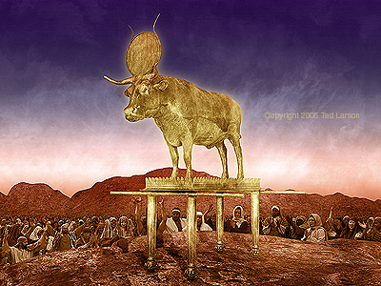
2 Aaron answered them, "Take off the gold earrings that your wives, your sons and your daughters are wearing, and bring them to me." 3 So all the people took off their earrings and brought them to Aaron. 4 He took what they handed him and made it into an idol cast in the shape of a calf, fashioning it with a tool. Then they said, "These are your gods, ^{[b]} O Israel, who brought you up out of Egypt."
5 When Aaron saw this, he built an altar in front of the calf and announced, "Tomorrow there will be a festival to the LORD." 6 So the next day the people rose early and sacrificed burnt offerings and presented fellowship offerings. ^{[c]} Afterward they sat down to eat and drink and got up to indulge in revelry.
7 Then the LORD said to Moses, "Go down, because your people, whom you brought up out of Egypt, have become corrupt. 8 They have been quick to turn away from what I commanded them and have made themselves an idol cast in the shape of a calf. They have bowed down to it and sacrificed to it and have said, 'These are your gods, O Israel, who brought you up out of Egypt.'
9 "I have seen these people," the LORD said to Moses, "and they are a stiff-necked people. 10 Now leave me alone so that my anger may burn against them and that I may destroy them. Then I will make you into a great nation."
11 But Moses sought the favor of the LORD his God. "O LORD," he said, "why should your anger burn against your people, whom you brought out of Egypt with great power and a mighty hand? 12 Why should the Egyptians say, 'It was with evil intent that he brought them out, to kill them in the mountains and to wipe them off the face of the earth'? Turn from your fierce anger; relent and do not bring disaster on your people. 13 Remember your servants Abraham, Isaac and Israel, to whom you swore by your own self: 'I will make your descendants as numerous as the stars in the sky and I will give your descendants all this land I promised them, and it will be their inheritance forever.' " 14 Then the LORD relented and did not bring on his people the disaster he had threatened.
15 Moses turned and went down the mountain with the two tablets of the Testimony in his hands. They were inscribed on both sides, front and back. 16 The tablets were the work of God; the writing was the writing of God, engraved on the tablets.
17 When Joshua heard the noise of the people shouting, he said to Moses, "There is the sound of war in the camp."
18 Moses replied:
"It is not the sound of victory,
it is not the sound of defeat;
it is the sound of singing that I hear."
19 When Moses approached the camp and saw the calf and the dancing, his anger burned and he threw the tablets out of his hands, breaking them to pieces at the foot of the mountain. 20 And he took the calf they had made and burned it in the fire; then he ground it to powder, scattered it on the water and made the Israelites drink it.
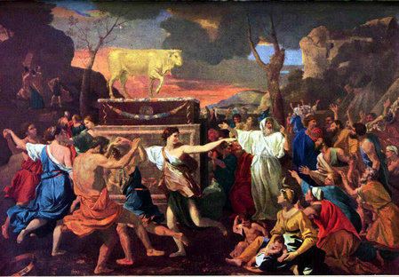
21 He said to Aaron, "What did these people do to you, that you led them into such great sin?"
22 "Do not be angry, my lord," Aaron answered. "You know how prone these people are to evil. 23 They said to me, 'Make us gods who will go before us. As for this fellow Moses who brought us up out of Egypt, we don't know what has happened to him.' 24 So I told them, 'Whoever has any gold jewelry, take it off.' Then they gave me the gold, and I threw it into the fire, and out came this calf!"
25 Moses saw that the people were running wild and that Aaron had let them get out of control and so become a laughingstock to their enemies. 26 So he stood at the entrance to the camp and said, "Whoever is for the LORD, come to me." And all the Levites rallied to him.
27 Then he said to them, "This is what the LORD, the God of Israel, says: 'Each man strap a sword to his side. Go back and forth through the camp from one end to the other, each killing his brother and friend and neighbor.' " 28 The Levites did as Moses commanded, and that day about three thousand of the people died. 29 Then Moses said, "You have been set apart to the LORD today, for you were against your own sons and brothers, and he has blessed you this day."
30 The next day Moses said to the people, "You have committed a great sin. But now I will go up to the LORD; perhaps I can make atonement for your sin."
31 So Moses went back to the LORD and said, "Oh, what a great sin these people have committed! They have made themselves gods of gold. 32 But now, please forgive their sin—but if not, then blot me out of the book you have written."
33 The LORD replied to Moses, "Whoever has sinned against me I will blot out of my book. 34 Now go, lead the people to the place I spoke of, and my angel will go before you. However, when the time comes for me to punish, I will punish them for their sin."
35 And the LORD struck the people with a plague because of what they did with the calf Aaron had made.
Footnotes:
- Exodus 32:1 Or a god ; also in verses 23 and 31
- Exodus 32:4 Or This is your god ; also in verse
- Exodus 32:6 Traditionally peace offerings

BibleGateway.com is © Copyright 1995-2007 Gospel Communications International

