Death AND THE MAIDEN:
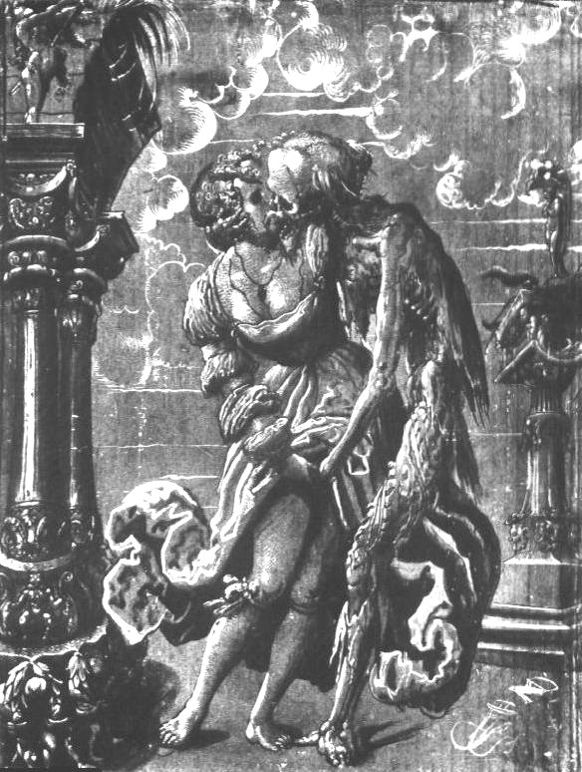
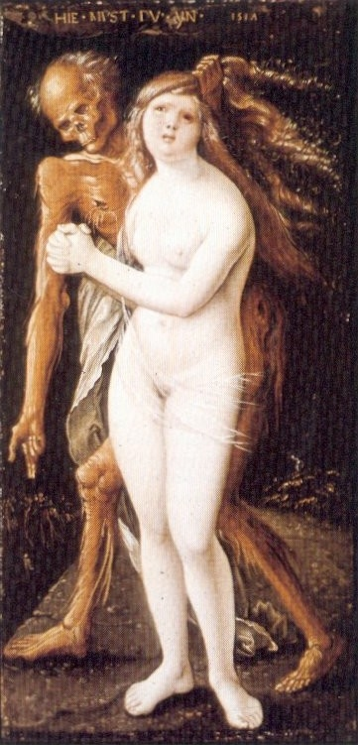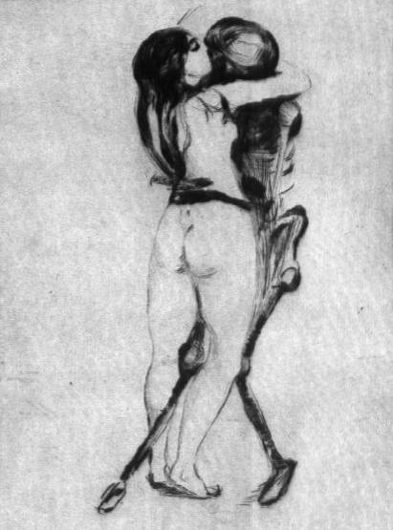
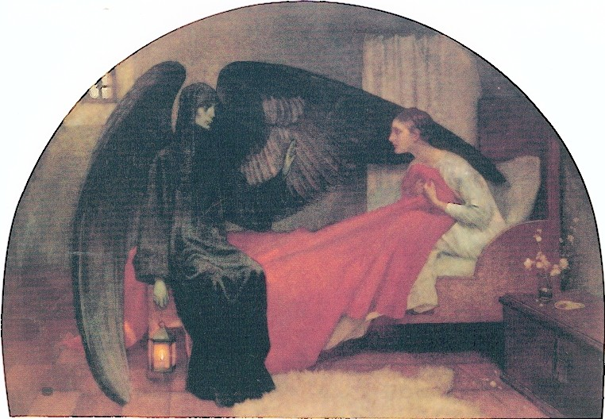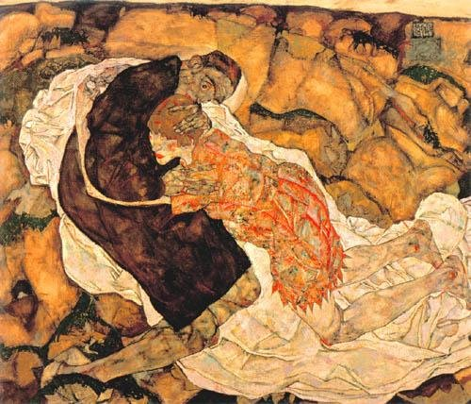
Death and the Maiden (http://www.lamortdanslart.com/fille/maiden.htm)
This theme has a multi-faceted past . It is rooted in very old mythological traditions: among the ancient Greeks, the abduction of Persephone (Proserpine among the Romans) by Hades (Pluto), god of Hell, is a clear prefiguration of the clash between Eros and Thanatos. The young goddess gathered flowers in company of carefree nymphs when she saw a pretty narcissus and plucked it. At that moment, the ground opened; Hades came out of the underworld and abducted Persephone.
This old vision will take a new form at the end of the 15th century and become the theme of Death and the maiden, which will culminate in Germany at the Renaissance. In many dances of Death already figured a representation of Death with a fine lady or with a beautiful virgin. The image of a young woman was also found in the three ages and Death. However in both cases, there was no trace of erotism. But with Death and the maiden theme, something new happened. People discovered a dark bound between sexuality and death. In this type of iconography, the young lady was not involved in a dance anymore, but in a sensual intercourse, which will become always more erotic as time went by. Unlike the dance of death, the Death and the maiden pictures dont have any verses to explain them. Due to that, this new kind of illustration lost somewhat of its dramatic intensity; its didactic role became less impotant. On the other hand, this form of art gained a kinf of intinacy. However in spite of the sensuality of this genre, it still had a moralistic goal; it kept on pointing out the fact that life is short as is the proud beauty of a woman. Her body, her face, her hair and her chest will someday feed the worms. The theme of Death and the maiden has sometimes been used pretexts to represent female nudity.

Death and the maiden
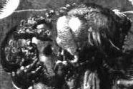This work of Niklaus Manuel Deutsch painted in 1517, shows well the transition between the dance of death and the theme of Death and the maiden. Here Death is a rotting corpse which does not caress the girl nicely, it take her by the hand; it grasps her by the neck and kisses her and puts its hands on her sex. The girl doesn't seem to resist the dreadful lover. Deutsch also created one of the few dances of death where Death and the maiden share an erotic relationship. In the frescoe of Berne, a skeleton kisses the virgin on her cheek and grabs her full breasts.
Death and the maiden
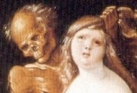In 1517, Hans Baldung Grien painted this painting in which Death seizes a girl by the hair and force her to go down in to the tomb dug to her feet. Death indicates with its right hand the grave. The girl, completely naked, does not try to resist. Her mouth is plaintive, her eyes are red and tears run down on her cheeks; she understands that it is the end.Grien painted several pictures like this one. As a matter of fact, the encounter of Death and the maiden may have served as an excuse to show a naked woman. Look at this engraving by Hans Sebald Beham (1548), where a winged skeleton holding a hour-glass moves towards a young girl, who fell asleep in a suggestive position. It's hard to believe she finds it relaxing!
Death and the maiden
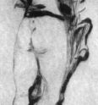Edvard Munch completed this engraving in 1894, one year after the original, an oil painting. Here, Death is a skeleton; no flesh covers it anymore. In this work, Munch does not conform to traditional representations. At the beginning of the Renaissance, Death was often represented in a sexually aggressive way. In this engraving, Munch suggests a victory of Love over Death: the girl is not dominated, by Death, she embraces it passiontely.Five years later, Munch created The Kiss of Death. In this work, the young girl looks exactly like the one previously shown in Death and the Maiden. Her long hair covers the neck and the shoulders of Death, who sweetly kisses her cheek. She, however, remains indifferent to him and looks away with forlorn eyes. Once again, the maiden seems to dominate her partner.
Death and the maiden
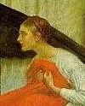Made by Marianne Stokes in 1900, this painting brings a new twist the well-known story of Death and the maiden. Here, Death is neither a decaying corpse nor a skeleton, but a winged woman dressed in black. The young girl lies in bed in her nightgown. Suddenly awaken, she pulls the bed linen to her breast, probably out of modesty. There is no physical contact between the two characters, but Death makes a soothing gesture with her left hand. Usually, the theme of Death and the maiden warns against vanity, but this isn't the case here. Instead, Marianne Stokes simply evokes, in this painting with a dreamlike quality, the sudden death of a girl during her sleep.
Death and the maiden
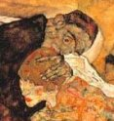When you first look at this oil painting by Egon Schiele (1915), it takes some time to understand its title: Death and the Maiden. A man and a woman sit on a white sheet, in a surreal landscape of rocks in which you can distinguish parts of human faces. The young girl wears a dress. She kneels down, hugging Death with her fleshless arms that strangely contrast with her strong legs. Death is represented as a man. With one hand, he presses the maiden's head on his chest, while he rests his other hand on her shoulder. The painting suggests more melancholy than fear or anger. As Marianne Stokes, Egon Schiele freed himself from the traditional allegory of Death and the maiden to sketch the parting of a couple. Did he find inspiration in his own life? As a matter of fact, the painter had once to break up with his lover (and model) to marry another woman. To learn more about Egon Schiele and this painting, click here.
Death and the maiden
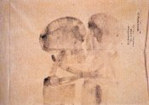Joseph Beuys drew this work in 1959 on an envelope bearing on its left corner the seal of an international organization of Auschwitz survivors. Both characters look like shadows on the verge of disappearing. Death has his right arm round the girl's shoulder and his head close to hers. Surprisingly, the young girl looks as fleshless as him and stands in the same position. Is she already dead? Or a survivor of the Holocaust, as the seal on the envelope seems to indicate? Be that as it may, Beuys pushed the theme of Death and the maiden as far as possible. It's hard to imagine an artist could propose a more extreme interpretation.

__________________________________________________________________________________________
PERSEPHONE & DEMETER:


