
JOHN UPDIKE
(1932-2009)

BIOGRAPHY:
- small town (Shillington, PA)
- only child
- father = junior-high math teacher
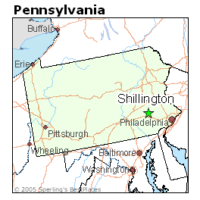
- mother = writer, ambitious
- schooling:
  - 8 y.o. = wrote first short story
  - honor student
  - editor of school paper
  - president of senior class
  - Harvard University (mother’s choice – thought it made good writers)
- 1954 =
  - editor of school paper (The Lampoon editor, writer, artist)

  - graduates Harvard (summa cum laude)
  - sold 1st short story to the New Yorker
  - year fellowship studying art in England (graphic artist, cartoonist = unrealized goal)
- 1955 =
  - staff writer @ New Yorker
    - 1950s-1960s: established his reputation as a writer of short fiction here
    - 1950s-death = regular contributor
    - poems, essays, sketches, short stories, & reviews
    - dubbed “The Brilliant Young Writer”
      - Did he fulfill this early promise?
- 1957 =
  - left New Yorker
  - moved to Ipswich, Mass
  - became independent writer
- 1958 =
  - 1st book The Carpentered Hen (poetry collection)
- 1959 =
  - 1st novel Poorhouse Fair
  - 1st short story collection The Same Door
- became “one of the most American writers in modern American literature”
  - novels, articles, reviews, opera libretto, play, memoirs (1980’s Self-Consciousness)
- 1963 =
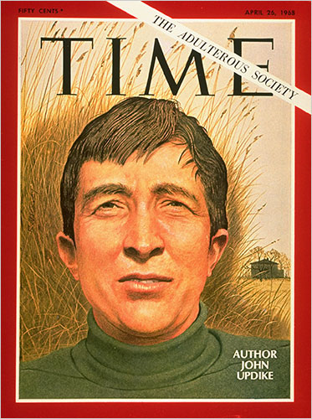
  - critical success w/ Centaur
    - highly allusive, symbolic novel
    - National Book Award
- 1968 =
  - 1st widespread recognition, commercial success/popularity, infamy (?) w/ Couples
    - salacious novel
    - compulsive adulteries
- 1978
- “Olinger stories”
  - fictitious Pennsylvania town
  - similar to Shillington
- “Rabbit novels”
  - Rabbit Run (1960)
  - Rabbit Redux (1971)
  - Rabbit Is Rich (1981)
  - Rabbit at Rest (1990)

- The Witches of Eastwick (1984)
- S (1988) = rework of Scarlet Letter

- UPDIKE’S AMERICA:
  - mundane world
  - of middle-class, lower-class materialism
  - land of sterile, empty, trivial lives
  - centered on TV, movies, fan mags for riff-raff
  - brand-name America
  - whose inhabitants are sunk in installment buying
  - whose stomachs are bloated w/franchised food
  - whose minds are dulled by soap operas & trashy newspapers
  - characters = searching for spirituality & religious meaning in life
  - BUT

  - find love = trap, deceit
  - happiness = brief
  - life = dull
    - (McMichael)

- STYLE:
  - “To transcribe middleness with all its grit, bumps, and anonymities, in its fullness of satisfaction and mystery” (Updike, memoir, The Dogwood Tree)

  - one’s spirit takes on its coloration from the material circumstances (houses, clothes, landscape, food, parents) one is bounded by (Norton)

  - (+)
    - elegant prose
    - balanced, rhythmic sentences
    - concern w/ “business of memory”
    - explorations of private feelings
    - portrays America in all its ugliness BUT still the best
  - (-)
    - strains for elegance
    - suffused w/nostalgia
      - mired in childhood
    - characters = predictably autobiographical
      - puzzled young man
      - devoted by dim girlfriend
      - strong older woman w/ misplaced enthusiasms

(McMichael)
- Interview (’08)
- Interviews & Readings
- Obid
- Prose Sampler
- Mapping America’s Mysteries

