“GCP”: PIX

- Pix by Scott Kolbo < http://www.newpantagruel.com/issues/1.4/tnp.php >

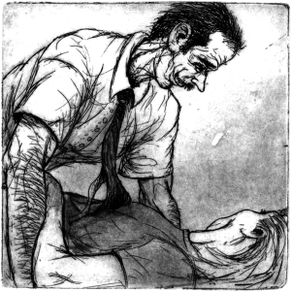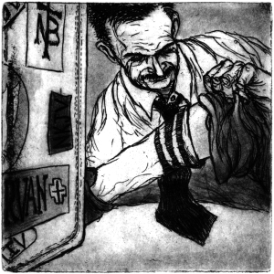
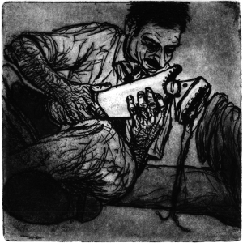

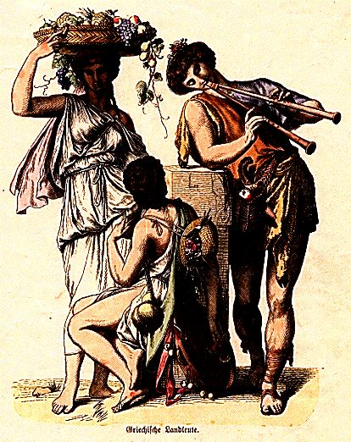
- 1960’s short film (10-minutes) on YouTube
< http://www.youtube.com/watch?v=3-vyUQx5Yss >
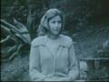

- Country People in Ancient Greece →

