“Hills like White Elephants”
1927, Ernest Hemingway, Men without Women


(Hills in the Zaragoza area)

PLOT:
  - 40-minute wait for express train, from Barcelona (east) to Madrid (central)
  - American & girlfriend sit outside in the heat at train station
  - order 2 large beers
  - she waxes philosophic by noticing the hills “look like white elephants”
    - white hot in the sun
    - field = brown & dry, arid
  - she insults him
    - says of course he’s never seen a white elephant
    - her snobbery
    - her worldliness or book smarts/education
  - order 2 Anis del Toro drinks (b/c she sees an ad on the curtain)
    - change of subject
  - she = bored, disappointed
    - ENNUI
    - “Everything tastes of licorice.”
    - “That’s all we do, isn’t it—look at things and try new drinks.”
  - another drink
  - out of the blue → “the operation”
    - it’s really simple
    - just let air in
    - perfectly natural
    - I’ll go with you
    - afterward, we’ll be happy, like before
    - it’s the only source of our displeasure
    - if you don’t want to, you don’t have to
    - it’s for the best
    - I love you
  - her response: I’ll do it b/c I don’t care about me
    - childish
    - selfless
    - selfish, controlling, manipulative (control drama)
    - self-loathing
  - she looks at NATURE 3x
    - 1 before operation
    - 1 “in the sun” & sees the fertility
    - 1 “in the shade” & sees the aridity
  - “It isn’t ours anymore….And once they take it away, you never get it back.”
  - another beer
  - she: stop talking…or I’ll scream
- train in 5 minutes
- he takes the bags to the other side of the station
- stops inside for a beer
  - others = “waiting reasonably” for the train
- goes back to finish his other beer
- final words:
  - “I feel fine. There’s nothing wrong with me. I feel fine.”
- PIX from
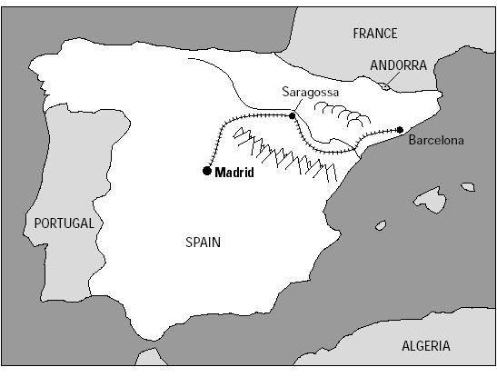
- http://vccslitonline.cc.va.us/copy_of_hills/split.htm
__________________________________________________________________________________________

SETTING:
  - Zaragoza, Saragossa
  - the valley of Ebro, in northeastern Spain
  - between Madrid & Barcelona
  - 1927
  - summer season
  - train station
  - 40 minutes ETA

__________________________________________________________________________________________
SYMBOLISM:
  - Setting = symbolic
  - valley bisected by train station
    - one side = fertile (motherhood, pregnancy)
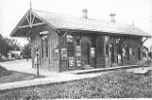
    - other = barren (abortion, consequence of abortion)
    - perhaps symbolic of the Choice
  - train station:
    - stop-over, pause, transition, movement
    - cuts the valley in half
    - foreigners; don’t belong; outsiders
      - physically outside the bar where the locals are
    - waiting
      - she’s waiting for him to grow up & settle down, marry her
      - he’s waiting for her make the decision (his way) so they can go on as before
      - they = waiting for the express from Barcelona to Madrid (40 minutes)
    - in-between
      - between 2 big cities
      - layover, pause, transition
      - purgatory
      - epochal moment
    - one of those “we have to talk” moments
    - 2 different directions
      - go forward or back
      - past, future

      - time moves in only 1 direction, can only go in 1 directions, can’t go back
      - the COUPLE, going in 2 different directions
      - can’t go back, can’t recapture the glory days, can’t “be like they were before”
  - train tracks:

    - 2 parallel lines = not converging, never crossing, connecting
    - together but separate = THE COUPLE
    - division, separation
  - hills:
    - white mounds of pregnancy, womb, expanded woman’s stomach; swollen, milk-filled breasts
    - fertility
  - white elephants:
    - woman’s pregnant stomach
    - she = poetic
    - her way of bringing up the conversation @ her pregnancy
    - her unconsciousness, revealing what’s on her mind
    - birth of Buddha (fertility symbol)
      - B’s mother dreams of white elephant coming to her the night before the birth & presenting her w/lotus
      - linked to fertile valley
    - white skin through trees
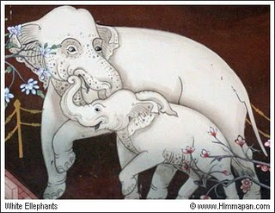
    - white skin = newborn’s skin
    - white =
      - purity
      - innocence
      - rarity (albino)
    - white elephants =
      - (1) basically useless object
        - takes up space
        - waste of money (to build, maintain)
        - expensive to maintain
        - empty arena, abandoned home
          - King of Siam’s practice of giving white elephant to courtier who’d fallen out of favor; since it couldn’t be put to work or slaughtered (venerated) & couldn’t be easily rid of, it proved to be financial burden, ruinous b/c of its upkeep& uselessness (Wordsmith)
          - What does this say @ a baby?? For/against abortion??
      - (2) similarly, object once prized
        - no longer holds value to owner
        - unwanted (& useless) property
      - (3) venerated object
        - in Indian culture
        - rare
    - 800-lb. gorilla in the room
      - obvious but avoided issue
  - Ebro River:
    - “originates in the Cantabrian Mountains and flows 565 miles to the Mediterranean” (link)
    - water = symbol of fertility, vitality
      - life-giving force
      - feminine
    - passage of time
    - Ebro = “embryo”
  - valley:
    - fertility, connected to hills
    - barrenness, across the tracks
    - reflects her choice
      - sterility
      - fertility

  - cloud:
    - cloud passes over as she’s looking while standing in the sun
    - she was noticing the fertile side
    - cloud =
      - the abortion
      - break from heat (of the sun, of the argument/problem)
  - bead curtain:
    - not a door
      - things still seep in/out
      - like their pesky problem
    - to keep out pests (flies)
      - like the booze, a distraction from the problem
      - avoidance of their problem
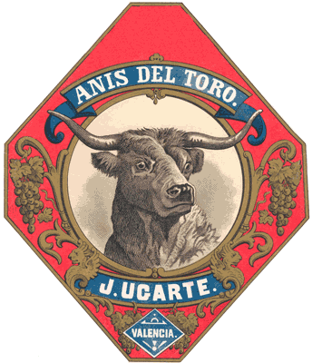
  - Anis del Toro:
    - seed of the bull
      - bull = virility
      - seed = sperm
        - she’s pregnant
    - hard, “stiff” drink
      - to numb
    - @ Jig
      - she’s adventuresome, daring, willing to try new things
      - she’s trying to get drunk
      - she doesn’t speak Spanish (but he does)
    - @ The American
      - he speaks Spanish, he’s been around
        - more educated than she?
      - ironically, his lack of “virility”
        - while he once thrilled her/she got a “charge” out of him
          - adventure, something new
        - he no longer gives her a thrill
        - ennui
      - he = BULL
        - impregnates her
        - keeps charging at her in the conversation @ “the operation”
    - watered down, diluted
      - “tastes like licorice”
      - numbing of life (through alcohol)
      - ignoring conversations
      - seen it all, boredom, ennui
    - she jokes @ absinthe
      - boredom, ennui
      - danger-seeker
  - Absinthe:
    - strong drink, highly alcoholic, highly addictive,, highly toxic
    - tastes like aniseed
    - from wormwood (poison, end of world)
    - her “joke”, zinger – her sarcasm
      - waiting for him to propose
    - her boredom, ennui
    - she = thrill-seeker

  - summer
    - time of fertility, planting
    - too hot, can scorch?
  - heat:
    - tension
      - about to boil over
      - (her “scream” later)
    - under a spotlight, being grilled
      - pressure to make a decision
      - combined with the Setting
        - 2 people alone outside
        - in the center of a valley
        - at a train station
  - booze:
    - denial, avoidance
    - numbing
      - to avoid each other
      - to avoid the problems within their relationship
        - problem = more than just the pregnancy
      - typical of their relationship
        - always avoiding it
        - when they try new drinks
    - final 2 drinks = separation, end of the relationship
      - like the train tracks
      - she drinks by herself at the table
      - he drinks by himself at the bar – identifying w/the people “reasonably” waiting for the train
  - the bartender/waitress:
    - speaks Spanish only
    - local, native – belongs
    - symbolic of something else, release, relief?
  - Jig:
    - lively dance –
      - full of life
        - lively, energetic
        - pregnant
        - once was lively, now = deadened, numb
          - numbed by the restlessness, constant moving
          - waiting, waiting, waiting
      - mercurial
        - can change her mind at any second
      - their relationship
        - they “dance” around the issue
    - pot shots, zingers
    - has traveled more than he? Or more educated than he
      - “No, you wouldn’t have.”
      - rich, upper class (slumming it w/worldly guy)
      - elitist, snobbish, condescending
    - lacks assertiveness
      - always in the form of a question
      - always asks his approval
      - to the point of screaming
      - total dependence upon him
    - doesn’t speak Spanish
      - her dependence upon him
      - her inability to express herself
    - creative, link to nature
      - she philosophizes on the hills
      - she pays attention to/observes the nature around them
      - he never does
  - The American:
    - no name
    - anonymous
    - symbolic of country, way of life
      - wandering, aimless – “lost”
      - numbing
      - manipulative
    - trying to manipulate through words
    - force his will upon her
    - wants to maintain his current lifestyle
      - roaming
      - traveling
      - drinking
      - not settled down
    - Hemingway-esque
      - rugged, worldly
      - knowledgeable
      - self-controlled (CCC)
      - controlling
      - feigned indifference
  - the number 2:
    - mentioned 10 times throughout the story
    - 2 to refer to the couple
      - (but there could be 3)
      - he wants to keep it at 2
      - she wants to try it at 3
  - baggage:
    - “labels from all the hotels where they had spent nights”
      - lots of traveling
      - nights = sex
    - heavy
      - no home → travel w/all possessions
    - nomadic existence
    - “baggage”
      - emotional baggage, the “problem”
      - that they drag/haul with them wherever they go
      - can’t get away from problems – even though ignore them
    - the past, “the way things were”
    - his moving them = his wanting to continue on as before
__________________________________________________________________________________________

THEMES:
  - ENNUI
    - boredom
    - Jig = tired of the nomadic, restless/rootless existence, always traveling
    - she wants to settle down, start a family
    - what better time than now as she’s pregnant
    - “That’s all we do, isn’t it—look at things and try new drinks?”
    - “Everything tastes of licorice.”
    - after a steady diet of junk food, we crave some “real” food
  - lack of communication
    - like the train tracks
    - they/re never on the same page
    - they speak in shadows
      - hints, intimations, euphemisms
      - the word “abortion” is never used
    - “talking” vs. “communicating”
  - verbal manipulation
    - he tries to sway her through his onslaught
    - downplays operation
    - euphemizes abortion
    - but if you don’t want to
    - it’s the sole cause of our unhappiness
  - men are from Mars (Taurus), women from Venus
    - differences between the sexes
    - he = like a Bull
    - she = like a rabbit
    - (elephant & bull = hard-charging animals)
    - Guy-thing
      - talk
        - keep talking
        - keep talking until she’s convinced
        - beat her in to submission w/words
        - barrage her w/words until she succumbs
        - force his will onto her (Shk’s will into her)
      - euphemisms
        - don’t come out & say it
        - beat @ the bush
        - “operation”
        - “it” w/several definitions
  - lack of resolution
    - PLOT = STYLE
      - unresolved “problem”
      - unresolved interpretation b/c of the style
  - avoidance
    - put off decisions until another time, some later date, not now
    - through alcohol
    - through not talking @ it
  - psychic numbing
    - through alcohol
  - layovers in life
    - those times we sit at the depot & wait
    - make decisions
    - epochal moments
    - “moment of truth,” “crossroads” (that never cross)
    - unresolved – missed opportunities to resolve problem
  - Present
    - he wants to live in the “now”
    - no past, no future, no ties
    - carpe diem, come what may, whatever happens
    - what kind of existence is it to have no past/future, only eternal present; no roots??
  - Past & Future
    - train tracks
    - past issues
    - future consequences
  - overindulgence
    - too much of a good thing
    - steady diet of junk food & crave “real” food
  - selfishness, irresponsibility
    - she = get drunk (while pregnant) & forget about it; take pot shots
    - he = get the abortion, forget about it, & go back to the way things were
__________________________________________________________________________________________

STYLE:
  - understatement
  - minimalism
    - bare bones, nuts & bolts, stripped-down (Iceberg Theory)
    - “The American and the girl with him”
    - “The operation”
    - his euphemistic tactic re: the operation
    - the explosive symbolism
    - the minimalistic conversation
    - sparse prose
      - short sentences
      - short paragraphs
      - lack of verbosity
      - journalistic
      - straightforward
      - subtextual, implicit, implied – clues, hints, suggestions
    - 3rd person POV, limited omniscience (only what they say/do, not what they think)
    - between the lines:
      - title line – hills like white elephants = her segue into conversation @ the pregnancy, and she is metaphoric, and she is connected to Nature
      - her retraction – “not really” = she wants to keep the baby or she is always changing her mind or she changes her mind to please him
      - his “the operation” downplaying, understatement
      - his “it” meaning abortion, baby, the decision,
      - the tension between them
        - his reaction to her put-down
        - his cut it out
        - her snarkiness
        - her I’ll scream
      - the symbolism
      - the euphemistic, subtextual style of their conversation

  - result of style
    - forces readers to analyze, interpret, think
      - Critical Thinking Skills
    - put self in characters’ shoes
    - dramatize, put on as a play
    - leaves unanswered questions
    - unresolved mysteries

__________________________________________________________________________________________
- She’s pregnant BUT
  - Argues about the abortion
  - Yet drinks hard & dangerous alcoholic beverages
  - mercurial part of her name

- “The American and the girl with him”
  - he has no name
  - he = outsider, foreigner
  - they = not married
  - they = not a couple
  - they = just together (like the train tracks)
__________________________________________________________________________________________

UNANSWERED QUESTIONS:
- Why are they sitting outside, in the heat?
  - Why not inside with the rest of the people?
  - Is it for privacy, to discuss “the operation”?
  - Is it because they don’t belong, because they’re foreingers?
- Is the pregnancy the sole cause of their unhappiness? What else could it be, esp. her?
- Does she really not care about herself?
  - Is this just some form of control, guilt-trip?
- Explain her: “It isn’t ours anymore….And once they take it away, you never get it back.”
  - Who are they?
  - What is it?
  - Why can’t they (and thematically us) get it back once they’ve taken it?
- If she aborts the fetus, will everything go back to the way they were?
  - Can they? Does either of them have a thought about this?
  - Can they just pretend that the “problem” never existed, that the “operation” never happened?
- Do you think he used the same line of reasoning to win her over in the 1st place?
  - Got her to sleep w/him
  - By downplaying the severity, seriousness, consequences
  - “It’s just sex”
  - Do you think she’s buying it now, the 2nd time around?

- Why does she want to stop talking?
  - Why is she on the verge of screaming?
  - Is she just some emotional female?
  - Or has she “realized” something? What is that something?
  - Is he really “talking”? Talking to or at her?
- What happens at the end?
- Explain her/story’s final words:
  - “I feel fine. There’s nothing wrong with me. I feel fine.”
  - Is she drunk, numb?
  - Sarcastic
  - Denial/avoidance
  - Mocking his insistence about her “feelings” when she already “know[s] things”
  - Made up her mind
- Do you think she’s made up her mind?
  - Do you think she’s going to Madrid with him, will have the abortion, but then go off on her own?
  - Will she get him drunk & leave him on the train…and keep the baby?
  - Will she keep the baby & raise it on her own?
  - Will she go back to wherever she comes from w/the baby, back to her rich family?
- What is your final analysis of the woman?
  - pushover, submissive
    - relies on him for everything (her questions)
  - emotional
  - dramatic, passive-aggressive
  - snobby, condescending
  - confused, indecisive, waffling
  - mercurial, changing, shifting
  - is she the same at the end as she was at the start
- What is your final analysis of the man?
  - selfish, domineering, controlling, manipulative
  - free-spirited
  - loving, caring
  - wants an answer
  - pushy
  - patronizing
    - women = emotional, “feelings”
    - men = reasonable
  - is her waffling, indecisiveness, dependence upon him
    - force him to be pushy
    - force him to make the decisions
    - force him to be all the negative traits above
- Setting revisited:
  - Scene = proleptic moment
    - as the station looks back & forward
    - so too does the entire seen
    - the bedroom before the pregnancy, at the start of their relationship
    - the train station in the middle of the pregnancy
    - the operating room at the end of the pregnancy
    - the bedroom or platform at the end of their relationship
  - Bedroom, bar
    - Before the pregnancy
    - he is trying to convince her to have sex
    - minimize the sin/shame
    - minimize the pain in the loss of her virginity
  - Abortion room
    - End of the pregnancy
    - he = doctor probing, prodding her
      - his talk = instruments
      - her ears = womb
    - she tries to escape (?)
    - waitress = nurse
    - alcohol = antiseptic, anesthetic
    - pads = pads, towels, bandages
    - table = operating table
    - platform = back-alley, back room, private room
  - Bedroom, platform, bar
    - End of the relationship
    - she turns the “table” on him
    - says the operation – the excising of him – the ending of the relationship
    - is painless, natural, simple
__________________________________________________________________________________________

CONNECTIONS:
- The Eagles’ “Life in the Fast Lane”
- The Eagles’ “The Thrill Is Gone”
- The Twilight saga
- The Death & the Maiden motif
- JCO’s “WRUG?”
- Eddie Money’s “I Want to Go Back”
- Macbeth: 1 thing = cause off all problems, or cure-all

LINKS:
http://www.cummingsstudyguides.net/Guides4/Hills.html
http://www.gummyprint.com/blog/hills-like-white-elephants-literary-analysis/
http://www.sparknotes.com/short-stories/hills-like-white-elephants/
http://vccslitonline.cc.va.us/copy_of_hills/criticism.htm
http://www.answers.com/topic/white-elephant

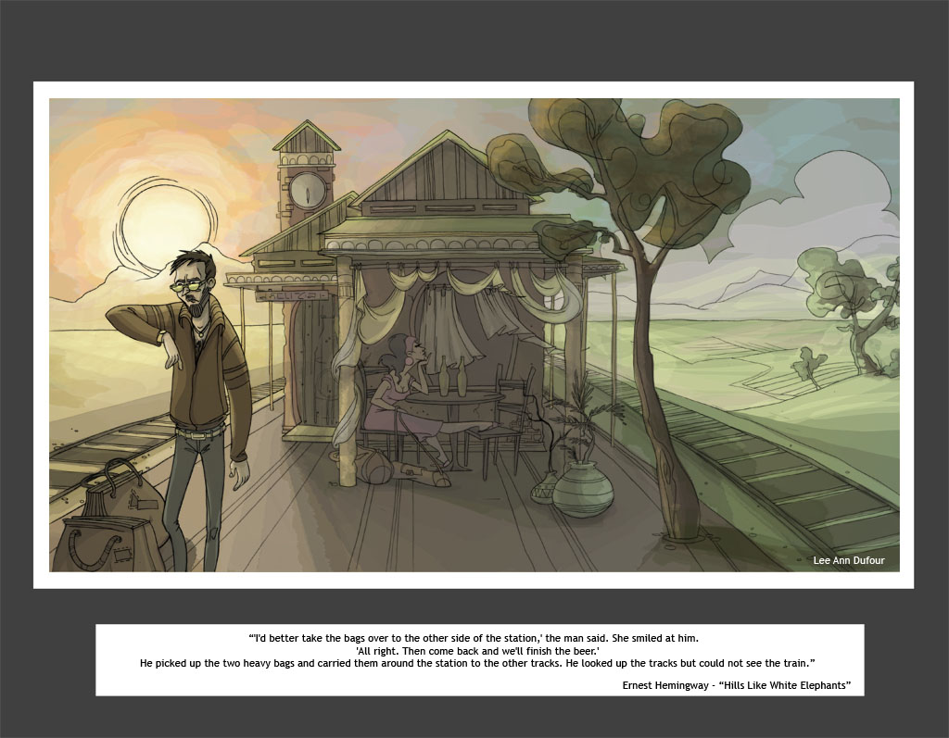
< http://leeanndufour.blogspot.com/2008/11/hills-like-white-elephants.html >
Zaragoza town map: http://oiyangnacho.com/gifs/mapa.jpg

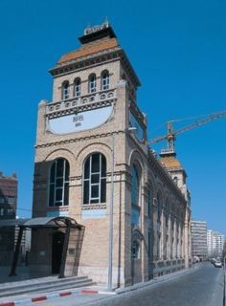
Hotel near train station:

Modern Zaragoza & Ebro River:
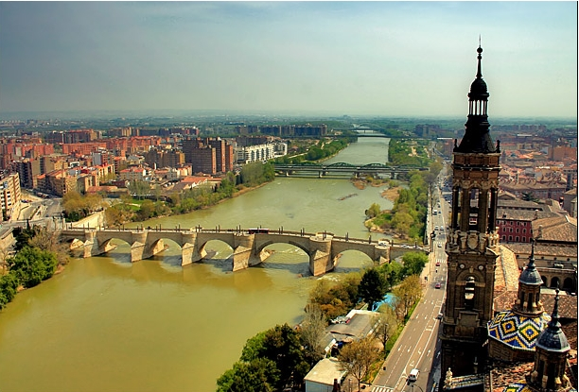

Spanish Osborne Bull (Zaragoza): 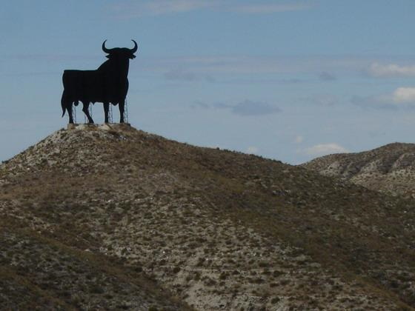

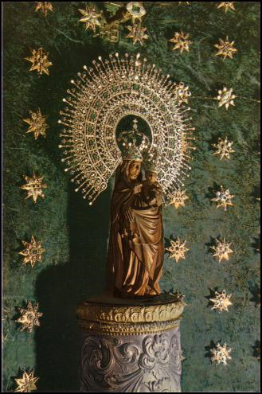
Basilica del Pilar (Cathedral of our lady of the Pillar)
- dedicated to Mary, mother of Jesus
- her 1st appearance to the Spanish people



