Ernest Hemingway’s “The Killers”
(1926)

PLOT:
- small-town diner
  - Henry’s
  - made over from a saloon (long mirror behind bar/lunch counter)
- George = owner
- Nick Adams = local, witness
- Sam, the cook (black, N-word)
- 2 well-dressed men enter (“killers”)
  - Al
  - Max (“talks too much”)
  - dressed alike (like uniforms, like Reservoir Dogs)
  - derby
  - tight overcoat, buttoned across the chest
  - silk muffler
  - gloves
- mild comedy –
  - want dinner, BUT dinner’s not until 6PM
  - clock reads 5:20 BUT 20 minutes fast
- eat sandwiches….
  - with gloves on (no fingerprints!)
- Ole Anderson
  - local, regular
    - 6 PM
    - (killers have done their homework)
  - to-be victim
    - “We’re killing him for a friend.” (mystery)
  - Swede
  - former boxer
  - described as kind-hearted
  - face of boxer
  - waits to die
- sawed-off shotgun
- Nick & Sam = tied to backs in kitchen while they await Ole
  - until 7PM
- Nick goes to warn Ole
  - lying on bed
  - in his clothes
  - waits to die
  - doesn’t show emotion
    - “flat voice”
    - “There isn’t anything I can do about it.”
  - stoic in the face of death
    - theme?
      - not afraid to die, of Death?
      - machismo?
  - deserved killing?
  - just desserts?
- Nick back to Henry’s
  - explains Ole’s indifference
  - guesses @ cause of “hit”
    - “he must have got mixed up with something in Chicago” (fixed fights)
    - “Double-crossed somebody” (see Pulp Fiction)
  - Ole’s indifference bothers Nick
    - Nick = macho
      - Hemingway way: would want to fight it out, go down swinging
---------------------------------------------------------------------------------------------------------------------------------------
STYLE:
- mystery
- comedy
- macho talk
  - short, curt dialogue
  - language
  - tied up like girlfriends
  - bright boy
- Pulp Fiction
  - comedy
  - mystery (some unresolved)
  - dialogue
  - clothing
  - machismo
---------------------------------------------------------------------------------------------------------------------------------------
THEMES:
- Ole, stoic in the threat of death
  - not afraid to die, of Death
  - machismo
- Zen-like attitude??
  - acceptance
  - indifference
  - complacency
  - surrender
  - echoed by George: if it bothers you, then “you better not think about it” (last words)
- against Ole’s attitude
  - like Nick = macho
  - Hemingway way:
    - would want to fight it out
    - go out in a blaze of glory
    - go down swinging

- Waiting motif:
  - waiting
  - waiting for dinner, the Swede, Swede waiting to die, our waiting to discover the mystery
  - “The Waiting Is the Hardest Part” – Tom Petty
- http://www.novelguide.com/a/discover/ssfs_17/ssfs_17_00021.html
- “The Matadors”:
  - the original title
  - the Swede = the bull, but doesn't act like the bull, suicidal bull? taken little by little
---------------------------------------------------------------------------------------------------------------------------------------

MOVIE:

- Edmond O’Brien, Ava Gardner, Burt Lancaster (1st movie)
- film noir
- “based” on the short story
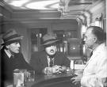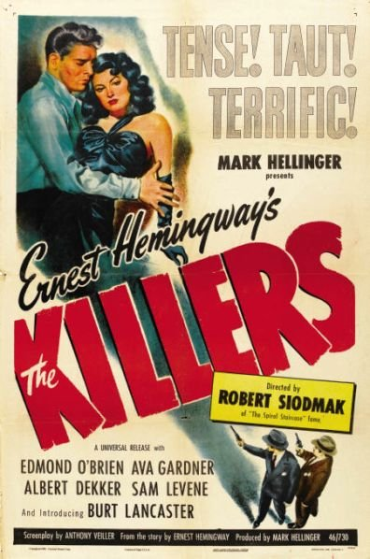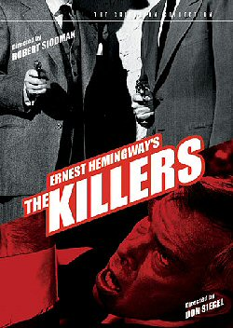
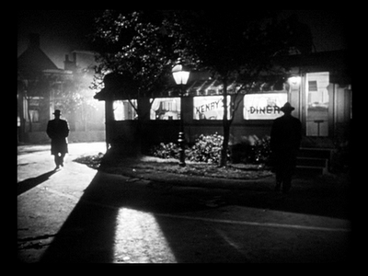

More < http://thelongvoyagehome.blogspot.com/2009/09/killers.html >

