What’s the Story of Your Writing?
Posted in Turnitin Community North America
http://turnitin.com/en_us/community/north-america/blog/2550-what-s-the-story-of-your-writing 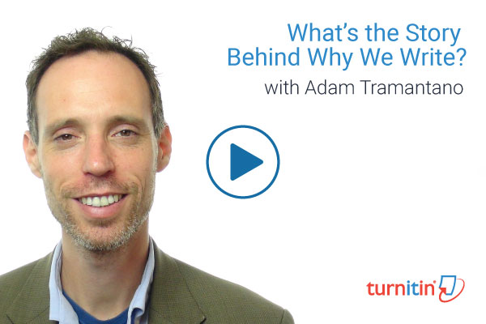
For most people, the word “story” is a simple noun used to describe the plot or narrative of a work. However, for Adam Tramantano, story is also a verb, one used to describe the process of writing and the point of view of the author.
Tramantano, an English teacher at the Bronx High School of Science, is also a doctoral student in English Education and an adjunct instructor at Teacher’s College, Columbia University. He recently sat down with Jason Chu for a webcast entitled “What’s the Story Behind Why We Write?” that delved into how we can make writing a more conscious and deliberate process for students.
According to Tramantano, by “storying” their writing, authors can not only introduce elements of themselves into their work but can also drastically change the way the work is read and can provide new context for the ideas, images and events in the piece.
One example Tramantano provides of this is Jon Krakauer’s Into the Wild, which is a fictionalized account of a young man who graduates university and treks around the country, eventually ending up in the Alaskan wilderness.
In that book, the author’s note directly tells the reader that the protagonist’s narrative will be interrupted by stories and moments from Krakauer’s own life. Krakauer says he hopes, “That my experience will throw some oblique light on the enigma.”
Elsewhere in the book, Krakauer writes, “So, as a youth I am told I was willful, self-absorbed, intermittently reckless, moody.” According to Tramantano, this provides a sense of self-reflection on the narrator/author and creates a kind of dramatic irony, one where the audience knows that the character is reckless but the character, who is recalling the events from the future, does not currently.
In another example, Tramantano cites James Baldwin’s book of essays Notes of a Native Son. In one of the essays, Baldwin told the story of his father dying but contrasted it with other elements going on at the same time including race riots happening elsewhere in the city and the fact the funeral took place on his birthday.
According to Tramantano, this was a way of viewing the story Baldwin wanted to tell as a closeup of a much larger story, like a camera zooming in on a detail. It puts the story in a larger context, one that adds to the tale but also changes the way the audience views it.
Tramantano believes that studying these kinds of techniques are important for students as they can help new writers improve their work in not just English class, but all of their subjects. Teaching students how to be more active in their writing and more deliberate with the message they are sending to the reader.
Along those lines, Tramantano says that teachers and students alike should stop thinking about a work as being “complete”. Though it might be done for a particular class or assignment, works are constantly revisited, changed and improved upon over time, meaning that even a “final” draft might just be a new beginning.
All in all, Tramantano wants instructors to teach students not just how to write, but also how to think about their writing so the decisions they make about framing and narrative are conscious rather than accidental.
By “storying” their writing, students have a chance to create much more powerful writing that delivers a message on more levels.
Watch the webcast, “What’s the Story Behind Why We Write?”

Related
Color Me Bad?”: Fostering Plagiarism Awareness
Aligning STEM and the Humanities: Standards, Writing, and Workforce Preparation

Blog

Promptastic: Analyzing Tweets and Texts
Written on July 06 2016
http://turnitin.com/en_us/resources/blog/421-general/2551-promptastic-analyzing-tweets-and-texts
Your students are actually always thinking about voice and audience -- they just may not be aware of it! One way to teach rhetorical analysis is to have students analyze their own texts and tweets for audience, tone, and voice.
See Kristen Hawley Turner’s article on Digitalk for more context and ideas.
As she writes in her free-access article, “Asking students to include out-of-school writing, such as text messages, IMs, and social network posts, as part of their portfolio in school would value these discourse practices and the language that is associated with them. Adolescents could begin to see their communications as real writing and appreciate their individual competencies” (Kristen Hawley Turner, Digitalk as Community 40).
To bring this discussion and practice into classroom writing, try a great exercise in voice with our argumentative prompts on social media and school uniforms. Ask students to first write the editorial or letter to a formal, more authoritative audience, like their principal or their community leaders. Then, in subsequent revisions, ask students to direct their arguments to various audiences, including parents, friends, classmates, or an audience who strongly disagrees. Ask students to carefully analyze their word choice, sentence structure and tone in each of these revisions. When they are happy with a final product, ask them to write a memo to you letting you know which audience their final draft is written toward and how that audience has affected their writing.
These activities will help students see that they are already rhetoricians: they take into account their audience and the persona they hope to create in all kinds of everyday rhetorical situations. Now they may be ready to do more advanced rhetorical work like that demanded in Last Child and Big Data.
All of these Revision Assistant prompts offer students an opportunity to receive custom holistic and targeted feedback, helping them improve as writers and critical thinkers.

Related:
Summer Promptastic: Learning in Unexpected Ways
Promptastic: Promoting More Thoughtful and Polished Drafts

AP English Language and Composition— Last Child
Grades 11-12 | Informative
Learning Standards
The passage below is from Last Child in the Woods (2008) by Richard Louv. Read the passage carefully. Then, in a well-developed essay, analyze the rhetorical strategies Louv uses to develop his argument about the separation between people and nature. Support your analysis with specific references to the text.
from Last Child in the Woods (2008) by Richard Louv
Researchers at the State University of New York at Buffalo are experimenting with a genetic technology through which they can choose the colors that appear on butterfly wings. The announcement of this in 2002 led writer Matt Richtel to conjure a brave new advertising medium: "There are countless possibilities for moving ads out of the virtual world and into the real one. Sponsorship-wise, it's time for nature to carry its weight." Advertisers already stamp their messages into the wet sands of public beaches. Cashstrapped municipalities hope corporations agree to affix their company logo on parks in exchange for dollars to keep the public spaces maintained. "The sheer popularity" of simulating nature or using nature as ad space "demands that we acknowledge, even respect, their cultural importance," suggests Richtel. Culturally important, yes. But the logical extension of synthetic nature is the irrelevance of "true" nature— the certainty that it's not even worth looking at.
True, our experience of natural landscape "often occurs within an automobile looking out," as Elaine Brooks said. But now even that visual connection is optional. A friend of mine was shopping for a new luxury car to celebrate her half-century of survival in the material world. She settled on a Mercedes SUV, with a Global Positioning System: just tap in your destination and the vehicle not only provides a map on the dashboard screen, but talks you there. But she knew where to draw the line. "The salesman's jaw dropped when I said I didn't want a backseat television monitor for my daughter," she told me. "He almost refused to let me leave the dealership until he could understand why." Rear-seat and in-dash "multimedia entertainment products," as they are called, are quickly becoming the hottest add-on since rearview mirror fuzzy dice. The target market: parents who will pay a premium for a little backseat peace. Sales are brisk; the prices are falling. Some systems include wireless, infrared-connected headsets. The children can watch Sesame Street or play Grand Theft Auto on their PlayStation without bothering the driver.
Why do so many Americans say they want their children to watch less TV, yet continue to expand the opportunities for them to watch it? More important, why do so many people no longer consider the physical world worth watching? The highway's edges may not be postcard perfect. But for a century, children's early understanding of how cities and nature fit together was gained from the backseat: the empty farmhouse at the edge of the subdivision; the variety of architecture, here and there; the woods and fields and water beyond the seamy edges—all that was and is still available to the eye. This was the landscape that we watched as children. It was our drive-by movie.
Perhaps we'll someday tell our grandchildren stories about our version of the nineteenth-century Conestoga wagon.
"You did what?" they'll ask.
"Yes," we'll say, "it's true. We actually looked out the car window." In our useful boredom, we used our fingers to draw pictures on fogged glass as we watched telephone poles tick by. We saw birds on the wires and combines in the fields. We were fascinated with roadkill, and we counted cows and horses and coyotes and shaving-cream signs. We stared with a kind of reverence at the horizon, as thunderheads and dancing rain moved with us. We held our little plastic cars against the glass and pretended that they, too, were racing toward some unknown destination. We considered the past and dreamed of the future, and watched it all go by in the blink of an eye.

Rubric:

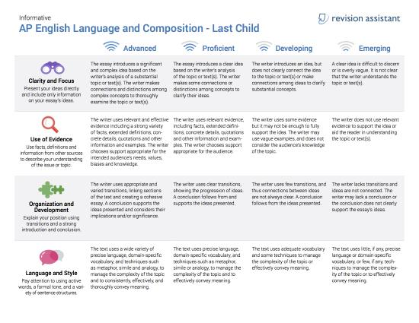

Big Data
Grades 11-12 | Argumentative | Text-Dependent
Learning Standards
Read the following articles about whether governments and banks should have the right to collect and sell people's data. Then, analyze how each author presents his or her argument, considering the use of ethos, pathos, and/or logos; style, word choice and tone; and the author's purpose. Then determine which author presents the most convincing argument. Use evidence from the articles in your essay to support your position.

Private License Plate Scanners Amassing Vast Databases Open to Highest Bidders
Automated license plate readers used by car repo companies, for example, collect billions of personal records per year, which contribute to vast databases that can be used by law enforcement, insurance companies, banks, and the like, with few limits.
BetaBoston, working with the Boston Globe, detailed one Boston repo company's data collection abilities, reporting that New England Associates Inc. can collect $200 to $400 for each vehicle found by an automated reader attached to an unmarked car. The company says it can typically add 8,000 license plate scans to its database in Texas each day.
Digital Recognition Network, which works with New England Associates, says it collects plate scans of 40 percent of all US vehicles per year.
According to the company's own disclosures, Digital Recognition Network operates in conjunction with around 400 repossession outfits across the US, has increased tenfold its plate scans since September 2010, and adds 70 million scans a month.
The scanners use high-speed cameras and optical character recognition technology to scoop up 1,800 plates a minute, no matter the speed or driving conditions. The scanner also collects the date, time, and GPS location of each read, punctuating the privacy threats associated with plate scanning.
The legal scanners, which usually cost anywhere from $10,000 to $17,000, have few legal limits. For example, law enforcement— which have used the scanners for years— often have prohibitions on how long they can maintain the information gleaned, but private use is open season for those willing to subscribe for the information.
The top commercial use of the devices falls into the auto finance and auto repossession industries, which both work closely with major banks to track down those who default on loans. Digital Recognition claims its clients include Bank of America Corp., JPMorgan Chase & Co., HSBC Holdings, and Citibank.
Banks strongly encourage its repo contractors to use plate scanners, based on their efficiency in tracking down loan defaulters.
"The banks want it," said Liran Cohen, owner of repo company Massachusetts Recovery Bureau. "All of them make a big deal out of it, since it gives them so much value."
Yet with few limits, there is little, if any, accountability regarding where and how repossession companies use the scanners. Many companies that spoke to the Globe said they send spotter cars to commercial lots based on the amount of vehicles open for scanning.
Digital Recognition's website lists "target environments" for repo agents, including "malls, movie theaters, sporting events, and numerous other locations." The company also suggests repo agents trawl workplaces and commercial lots during the day and apartment complexes and residential areas at night.
Some commercial property owners call this practice trespassing.
"We're unaware that this is happening, and we're reaching out to our security teams and law enforcement contacts to get a better handle on it,"" said Les Morris, spokesman for Simon Property Group, which owns at least one mall in the Boston area.
"If we saw scanning like this being done, we would throw them out," said Issie Shait of New England Development, which owns the CambridgeSide Galleria and Bunker Hill Mall District.
Two repo companies said they target low-income housing areas, given the amount of yields collected in the past.
"This is just another example of stereotyping," said Cambridge Housing Authority deputy executive director Michael Johnston. "But our lots are open, and we don't have any gated communities in our system, so I don't know how to prevent it."
For its part, Digital Recognition said it cannot be blamed for how the scanners are used.
"We have nothing to do with the actual data collection process," said Chris Metaxas, chief executive of Digital Recognition. "We provide technology to repossession professionals."
Over 60 Massachusetts police departments have adopted scanners since 2008. In December, the Boston police suspended plate scanner use after a Globe investigation found questionable data management— including the inadvertent public release of over 69,000 license plate numbers.
The private databases are of use to law enforcement. Digital Recognition offers its data to over 3,000 law enforcement agencies across the country, including the Massachusetts State Police.
This week, a Massachusetts state legislative committee held a hearing on a bill that seeks to ban license plate readers completely, with exceptions for law enforcement, toll collection, and parking regulation.
"We have technology rapidly moving ahead in terms of its ability to gather information about people," said state Representative Jonathan Hecht, a co-sponsor of the bill. "We need to have a conversation about how to balance legitimate uses of this technology with protecting people's legitimate expectation of privacy."
The bill would require law enforcement agencies to scrub their plate data after 48 hours.
Citing the First Amendment, data brokers argue that the scanning pertains to license plates in public, which are available for anyone to record. In their opposition to the bill, they also say they do not disclose the plate's owner, though their banking, insurance, and other clients can access the information.
The private companies also claim that inhibiting scanners would damage police efforts.
"I fear that the proposed legislation would essentially create a safe haven in the Commonwealth for certain types of criminals, it would reduce the safety of our officers, and it could ultimately result in lives lost," said Brian Shockley, vice president of marketing at Vigilant, the corporate parent of Digital Recognition.
Privacy advocates say the data points gleaned by the scanners pose a highly intrusive risk to the public. For example, data brokers can translate plate numbers simply by accessing information from a state's motor vehicle registry.
"Right now, it's the wild West in terms of how companies can collect, process, and sell this kind of data," said Kade Crockford of the American Civil Liberties Union of Massachusetts. "The best legal minds, best public policy thinkers, and ordinary people whose lives are affected need to sit down and think of meaningful ways we can regulate it."
https://www.license-scanners/

Who Has the Right to Track You? As states begin to rein in mass surveillance, corporations argue that they have a right to collect data.
Do corporations have a legal right to track your car? If you think that is a purely academic question, think again. Working with groups like the American Civil Liberties Union, states are considering laws to prevent private companies from continuing to mass photograph license plates.
This is one of the backlashes to the news about mass surveillance. However, this backlash is now facing legal pushback from the corporations who take the photographs and then sell the data gleaned from the images.
In a lawsuit against the state of Utah, Digital Recognition Network, Inc. and Vigilant Solutions are attempting to appropriate the ACLU's own pro-free speech arguments for themselves. They argue that a recent Utah law banning them from using automated cameras to collect images, locations and times of license plates is a violation of their own free speech rights. Indeed, in an interview, DRN's counsel Michael Carvin defends this practice by noting, "Everyone has a First Amendment right to take these photographs and disseminate this information."
He argues that a license plate is an inherently public piece of information.
"The only purpose of license plate information is to identify a vehicle to members of the public," he says. "The government has no problem with people taking pictures of license plates in a particular location. But for some irrational reason it has a problem with people taking high speed photographs of those license plates."
The analogy to an individual's right to take photos only goes so far, though. Vigilant's website notes that "DRN fuels a national network of more than 550 affiliates," its tracking "technology is used in every major metropolitan area" and it "captures data on over 50 million vehicles each month."
"This is a complicated area where we are going to need to carefully balance First Amendment rights of corporations versus individuals privacy rights," says ACLU attorney Catherine Crump. "The mere fact that an individual has a First Amendment right doesn't mean that right is unlimited. There are circumstances under which the government is free to regulate speech."
Crump cited the Fair Credit Reporting Act and laws regulating the dissemination of health information as examples of legal privacy-related restrictions of speech rights.
"One could argue that the privacy implications of a private individual taking a picture of a public place is sufficiently less than a company collecting millions of license plate images," Crump says. "Especially with technology becoming more widespread and databases going back in time, there may be justification for regulation."
The Wall Street Journal reports that DRN's own website boasted to its corporate clients that it can "combine automotive data such as where millions of people drive their cars ... with household income and other valuable information" so companies can "pinpoint consumers more effectively." Yet, in announcing its lawsuit, DRN and Vigilant argue that their methods do not violate individual privacy because the "data collected, stored or provided to private companies (and) to law enforcement ... is anonymous, in the sense that it does not contain personally identifiable information."
In response, Crump says: "This is the same argument that the NSA made in the face of public outcry about its collection of telephone metadata, The argument was essentially, we're not collecting information about people, we are collecting info about telephone numbers. But every telephone number is associated with an individual, just like a license plate is."
The courts could follow corporate personhood precedents and strengthen First Amendment protections for private firms. Alternately, the courts could more narrowly rule on whether individuals' license plate information is entitled to any minimal privacy protections.
Either way, the spat epitomizes how the collision of free speech rights, the desire for private and the expansion of data-collecting technology is raising huge questions about what is— and is not— public.
http://www.inthesetimes.com

Rubric:

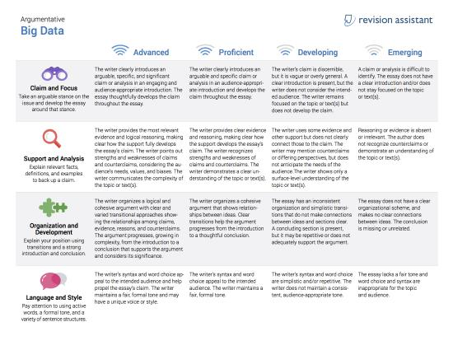

Letter to the Editor: Social Media
Grades 9-12 | Argumentative
Learning Standards
Many people use social networks on a daily basis, including Facebook, Instagram, and Twitter, but not everyone thinks that using them is a good idea. Some people think that social media is distracting, while others think that social networks connect users to new people and ideas.
Write an argumentative essay for your school newspaper in which you state your opinion on the benefits or drawbacks of social networks. Convince your audience, which may include other students, teachers, and parents, to agree with your position.
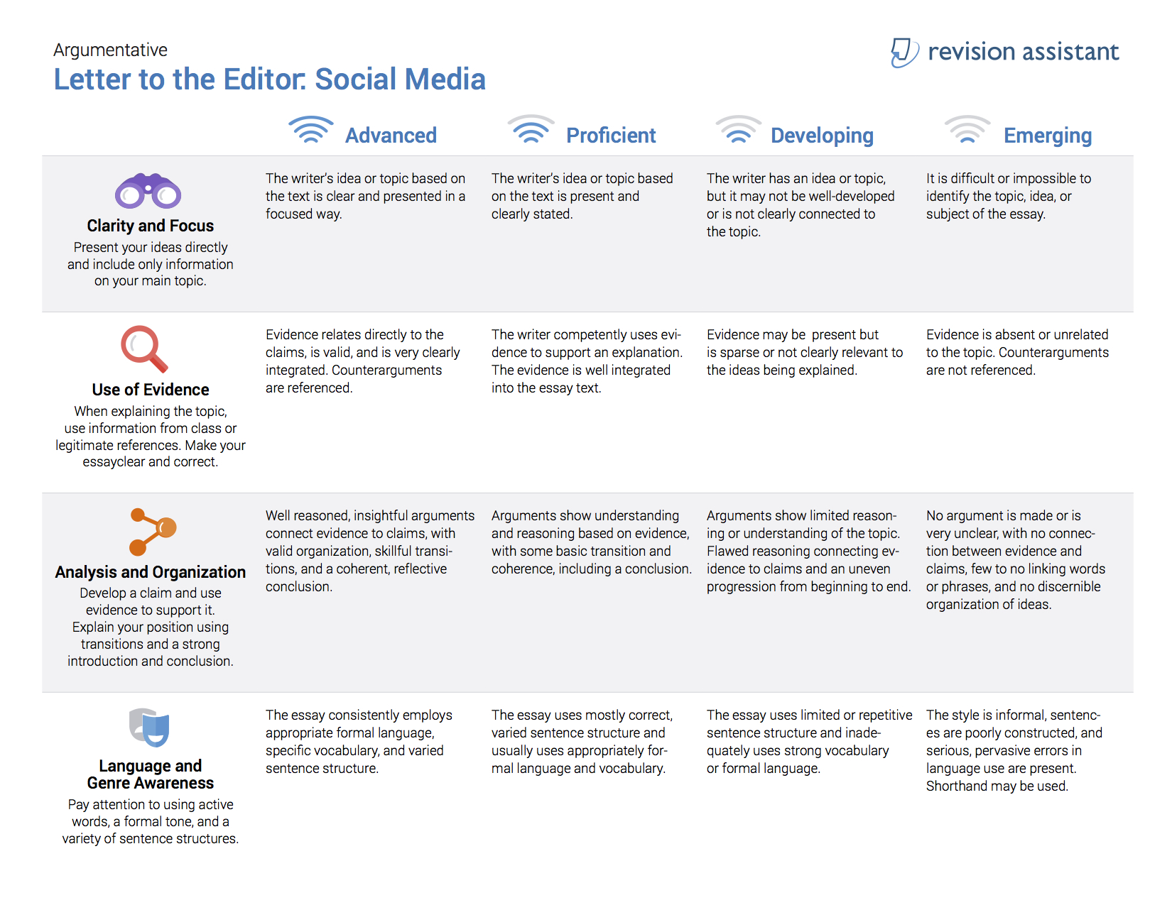

Letter To Your Principal: School Uniforms
Grades 6-8 | Argumentative
Learning Standards
Imagine that the schools in your town or city are considering making uniforms mandatory for all students in every grade.
Some people say that having uniforms prevent bullying, create safer schools, and help students stay focused on learning. Others think that uniforms mean you can't express yourself, don't prevent cliques, and are too expensive.
Write a letter to your principal stating your opinion on school uniforms. Convince your reader to agree with your position, using examples.


