SUBTEXT
Of course, I shouldn’t have to say it, but I will: Collecting these images does not mean endorsing the messages behind them.

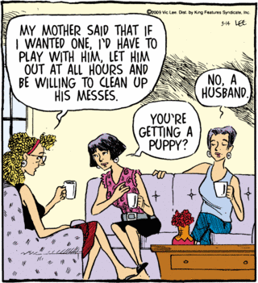
Pardon My Planet <http://www.seattlepi.com/fun/ineedhelp.asp?date=20090314>

AUDIENCE:
- children (cartoons), mothers reading to children
TARGET:
- women, wives (unhappily married), divorced women
SUBJECTS:
- women, Caucasian women, middle-upper class, nice clothes, not working, nice home & clothes
IRONY:
- no rings on their fingers, nice home & clothes

SUBTEXT:
- men = dogs
- lesbian is a man-hater,
- women = philogynists,
- women = sit around all day (in nice clothes, in a nice home) drinking coffee & gossiping while the “puppy” works like a dog

TOULMIN:
- Claim: men = puppies
- Grounds: none – stereotyping/overgeneralizing, male-bashing (philogyny), sexism
- Warrant: not warranted at all

RACIST SUBTEXT?

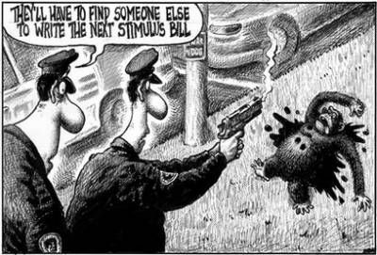
- New York Post 2/17/09 cartoon
- by Sean Delonas
- Contemporary allusion =
  - 200-pound celebrity chimpanzee (Travis) viciously attacked and critically wounded its Stamford, Connecticut owner (Charla Nash);
  - police mortally shot it when it attacked an officer
- Implication = the stimulus bill is so bad, a monkey wrote it
- Racist implications?
  - BO = is responsible for the stimulus bill
  - BO = black
  - Blacks = monkeys, BO = monkey
  - BO should be “assassinated”
- Historical Subtext:
  - Blacks were often depicted as simian creatures (monkeys, apes, chimps) in cartoons.

RACIST CARTOONS:
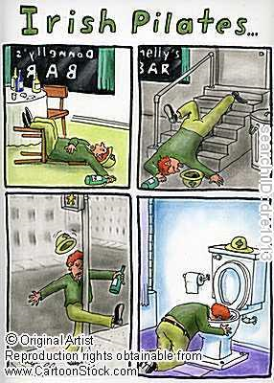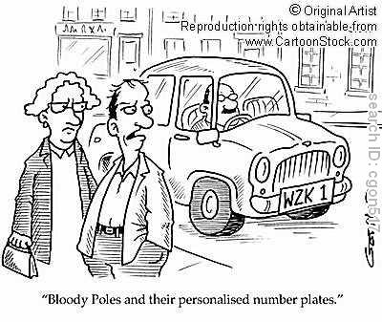

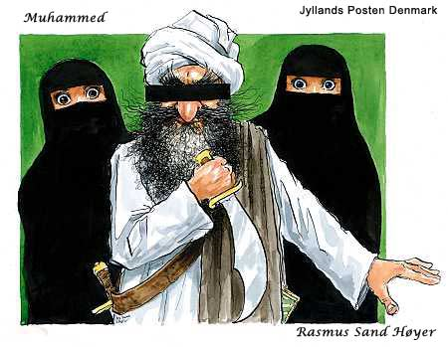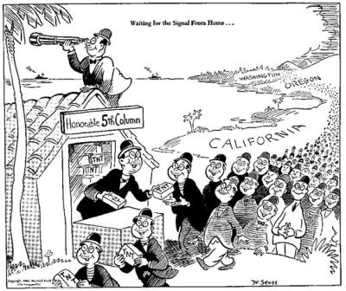

Racist “Jim Crow” cartoons @ Ferris State University :
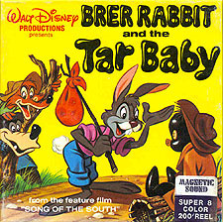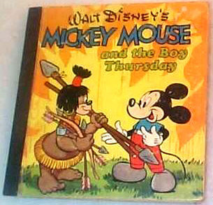

<http://www.ferris.edu/news/jimcrow/cartoons/homepage.htm >

Banned cartoon archives (videos mostly from the 1940s):
<http://www.angelfire.com/comics/mov/banned.html >

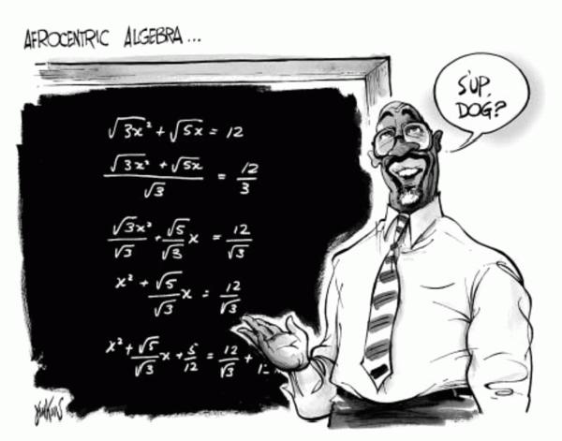2/18/08
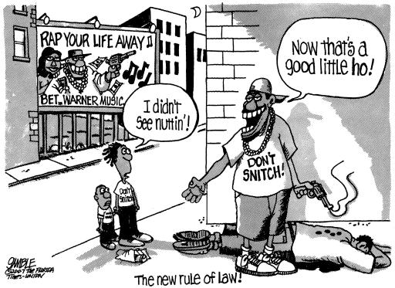8/21/07

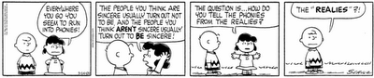
Lucy:
- Everywhere you go you seem to run into phonies!
- The people you think are sincere usually turn out not to be, and the people you think aren't sincere usually turn out to be sincere!
- The question is … How do you tell the phonies from the realies?
Charlie Brown: The “Realies”?!
Classic Peanuts <http://theworldsamess.blogspot.com/2009/03/phonies-vs-realies.html>

