DISNEY

10 Disney Characters Who Stirred Up Controversy

http://graphicdesigndegrees.org/10-disney-characters-who-stirred-up-controversy/

Media juggernaut Disney always seems to dredge up a wake of controversy whenever it releases one of their world-renowned animated films. Few will slam their merit from an artistic perspective, but for many people their characterization and storytelling leave plenty to be desired. Blinded by the lens of nostalgia, scads of fans fail to realize that many beloved Disney movies actually entail some pretty blatant racist and sexist overtones. Such lazy adherence to stereotypes, however, does not go entirely unnoticed by the communities they insult. As a result, waves of criticism roll up with the introduction of any new animated film – almost always backed by reasonable evidence, too. Sometimes Disney and media experts counter with interesting perspectives of their own, sometimes not. Far more than 10 examples of controversial characters and characterization devices have cropped up since the studio’s creation in 1939, but the following provides a summary of a few of their more visible offenses.
1. Sunflower from Fantasia (1940)
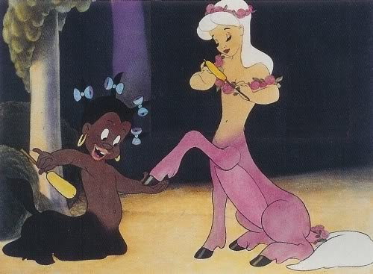In a move that would make even Al Jolson blush, Disney’s 1940 animated ode to Beethoven’s “Symphony No. 6” – titled The Pastoral Symphony – originally included a horrifyingly offensive African-American “pickaninny” caricature by the name of Sunflower. Subsequent releases rightfully edited out the big-lipped, half-donkey centaur handmaid capitulating to the aesthetic whims of her hedonistic Caucasoid brethren, but Disney faces quite a bit of criticism for the decision. Many find Sunflower’s later exclusions from the film offensive for a number of different reasons, chief among them the fact that for years the studio refused to acknowledge that the character ever even traipsed across the big screen in the first place. Such a denial reeks of an inability to admit mistakes and make earnest efforts to move forward when it comes to racial sensitivity in the media. Others believe that Disney should include Sunflower in any future theatrical or home releases of Fantasia as a means of illustrating the bleak history of racism. After all, if people do not learn from the problematic perspectives of the past, they face the risk of repeating them in the future. Just about the only thing most people can agree upon when it comes to the little centaur is that her depiction stands as a deplorably reductionist portrayal of African-American culture and behavior – unfortunately, one that also reflected common attitudes of the time period. Whether or not she should continue to exist only in the hidden corners of Disney history remains an extremely controversial debate that raises a number of interesting philosophical and ethical questions with solutions in varying shades of grey.
2. The Crows from Dumbo (1941)
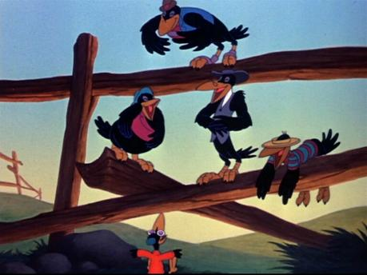One of Disney’s most beloved films, Dumbo’s cast sports a murder of crows mostly voiced by African-American actors – and their leader (the only one voiced by a white man) is saddled with the extremely unfortunate moniker of “Jim.” Reactions to the birds come extremely mixed. On one hand, they are lazy, poor, uneducated, cigar-chomping, jive-talkers with a love of jazz music. The crows voiced by African-American actors submit to the leadership of Jim, whose words and singing come courtesy of the only Caucasian in the bunch. On the other, however, they are also some of the only characters in the entire movie to ever offer the eponymous elephant any ounce of compassion or understanding. They accept him for him and ask for no compromises. In spite of their hierarchy, they never once capitulate towards the will of anyone else – they collectively sport much freer spirits than the subservient Sunflower. In reality, the crows’ actions support both positive and negative interpretations, and scans all over the internet reveal that writers of all races are equally capable of taking both stances. However, the film’s “Song of the Roustabouts” leaves far, far less room for open debate than the behavior of the crows. Sung by literally faceless African-American laborers, the lyrics praise the virtues of painstaking work with little to no reward. It doesn’t take a sociologist to figure out the extremely unfortunate overarching message.
3. Uncle Remus from Song of the South (1946)
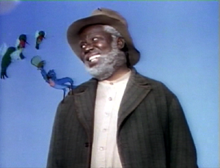Like Sunflower, the portrayal of African-American literary figure Uncle Remus in Disney’s hybrid of live action and animation, Song of the South, offers up plenty of fodder for debate over censorship and stereotypes. James Baskett (the first live actor ever hired by Disney) played the controversial role in 1946, and even at the time the studio wrung its hands over any potential offenses. Fearing further accusations of racial insensitivity, they have yet to release it for home viewing even to this day. But unlike Sunflower, the ire directed at the movie had less to do about Uncle Remus himself – the hero of the story – and more with his surrounding situation. The NAACP actually recognized the artistry of the film while simultaneously finding its sanitization, perhaps glorification, of slave life on a plantation abhorrent. Though Uncle Remus stands as a thoroughly pleasant and moral man devoid of the physically degrading traits present in the animated Sunflower, he and the other African-American character Toby still happily submit to the will of whites. People of all racial backgrounds remain divided over whether or not Disney should leave Song of the South in its vaults forever or finally release it for home viewing. As with the Fantasia example above, no one definitive solution emerges – the issue swirls with so many different and equally weighted arguments that none of them stand out as the absolute right thing to do.
4. The Native Americans from Peter Pan (1953)
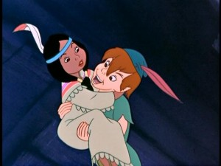Absolutely no alternate, potentially viable interpretations for the appalling depiction of Native Americans in Peter Pan exists to explain or otherwise temper the blatant racism. Lifting the portrayal almost directly from J.M. Barrie’s children’s books, almost any stereotype of the cultures (save for alcoholism and gambling) imaginable pops up in the movie. The sequence for the song “What Makes the Red Man Red?” alone involves a peace pipe, use of the words “paleface,” “Injun,” “squaw,” and “how,” stereotypic accents, clapping of hands to mouths, the reduction of a female value to appearances and servitude, glorification of an underage Native American woman as sexy and exotic, and what sounds like almost an apology for having nonwhite skin. Their characterization pulls entirely from popular perspectives with the reality of the cultures wholly sacrificed in favor of a reductionist song-and-dance of primitivism that perpetuates misconception. Both Native American and white men objectify Princess Tigerlily, who decides to put on a little show of her own in order to arouse her masculine audience – adding an extra, extremely uncomfortable dimension of misogyny into the mix. Note that the older, “ugly,” or white females never partake of the festivities, implying that only a young, conventionally attractive ethnic woman can satiate man’s lust.
5. Si and Am from Lady and the Tramp (1955)
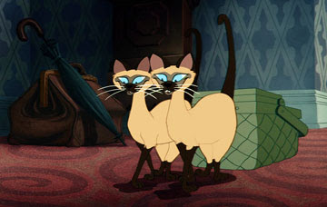Two of Lady and the Tramp’s most destructive villains, the twin Siamese cats oh-so-cleverly dubbed “Si” and “Am,” never prompted Disney to exercise any level of censorship; their embarrassing throwback to the racist concept of “yellow peril” can still be visually ingested by kids even today. Introduced in a sequence where the pair gleefully inflicts grievous property damage, they slink about the house with exaggerated, slanted eyes, gnarly buck teeth, and sporting a ghastly shade of pale. Si and Am’s very first song only solidifies their status as highly offensive Asian caricatures as they spit and slur through poor grammar and frequent switching of the “R” and “L” sounds. At no point does the film imbue them with any sort of redeeming qualities – until the end, the felines remain entirely remorseless, depraved, and manipulative. Most disconcertingly, Disney actually markets products featuring their likenesses, never making any sort of effort to downplay the obviously racist overtones. Young audiences unfamiliar with American history’s attitude towards Asians may perceive Si and Aim’s domestic terrorism and exaggerated physical attributes as simply the popular perception of cats as decidedly odd and cheeky. But older crowds with even a passing knowledge of World War II propaganda will squirm upon viewing the obvious implications.
6. The Apes from The Jungle Book (1967)
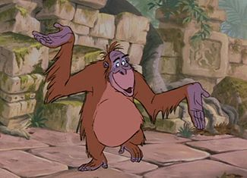Though he was no stranger to racial insensitivity and cultural relativism himself, Rudyard Kipling’s original novel The Jungle Book made no explicit parallels between African-Americans and apes; the character of King Louie didn’t even exist in print, instead tossed into the movie as a purely Disney creation. He scats and talks jive with a rather obvious cadence, singing about he wants to be more like the human (and generically American-accented in spite of his Indian heritage) Mowgli. On the surface, this characterization certainly carries the racist overtones of the era that the studio often reflected with insensitivity. Beneath that, however, their intentions for what social beliefs the movie did and did not intend to draw from occupy begin to occupy rather nebulous territory. Many assume that King Louie’s mannerisms drew their inspiration from Louis Armstrong, but the animators actually took cues from the man who lent his speaking and singing voice to the chubby orangutan – Louis Prima, a very white jazz musician and band leader from New Orleans. He did not record his lines or songs mimicking African-American speech patterns of the time; the voice used was actually how the man spoke. As with the crows from Dumbo, compelling evidence both for and against the apes’ intended status as negative African-American caricatures exists. “A little from column A, a little from column B” situation seems to be the most likely case, as the juxtaposition of jazz music and singularly simian behavior during the last heated years of the Civil Rights Movement strikes an exceedingly discordant note that seriously could not have gone unnoticed.
7. The Minister from The Little Mermaid (1989)
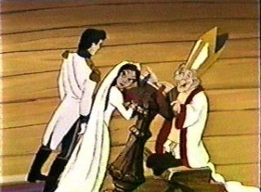Jokes about the unnamed minister from The Little Mermaid abound, with many people believing he sports a rather generous erection during the wedding scene between Prince Eric and the enchanted, disguised antagonist Ursula. Unlike the accusations of racism and misogyny backed by extremely reasonable and well-founded evidence, the diminutive officiate who stirred so much controversy that a lawsuit actually cropped up honestly didn’t enjoy the proceedings as much as people believe. In this case, a design flaw is the real culprit. Drawn with skinny, knobby knees that stick out, the little man’s robes bob up and down with his natural movements and blow about in the wind. Occasionally, his clothing obscures his bare legs and certainly gives the appearance of an erection. Whether or not this visual trick exists as an intentional bit of visual trickery on the part of the animators remains completely up for debate, of course, but no solid evidence exists either way. It is hard to believe that the famously thorough Disney animators would completely miss such a glaringly obvious visual, though. At least this incident does no damage to perceptions of race and gender, though, and the possibility elicits far more laughs than rages. Some Christian groups lashed out, but no religious officials appear to have taken any outspoken offense to the situation.
Oh, and that lawsuit? Eventually dropped.
8. The Merchant from Aladdin (1992)
There is obviously something wrong when portrayal by Robin Williams is actually the least offensive aspect of a character. Disney angered Arab-American groups when his introductory song to Aladdin spouted off the lyrics, “Where they cut off your ear if they don’t like your face./It’s barbaric, but hey./It’s home.” in reference to Middle Eastern culture. People of all political affiliations know that human rights atrocities occur in that corner of the globe – as they do EVERYWHERE. But to include them in a song as one of the defining characteristics of the cultures in the region understandably provokes ire, especially when one considers the history-altering contributions that Arabs have made to mathematics and surgical procedures in the past! Home video releases wisely replaced the offending lyrics with a benign discussion of geography and lamentation of the heat instead. Even beyond the merchant who sets up the story, Aladdin’s cast garners a hefty amount of controversy for portraying the features and accents of the protagonists as heavily Americanized, leaving the villains to lean more on exaggerated racial characteristics and Arab accents. Regardless of the one little change Disney made to the original film, it still continues to sport some extremely disconcerting depictions of race and gender that even the infamously politically correct 1990s could not squelch.
9. Pocahontas from Pocahontas (1995)
More than 40 years after chipping away at Native American cultural identity with the cringe-worthy scenes from Peter Pan, Disney caused more than a little outrage by taking considerable liberties with the true story of an adolescent – if not preadolescent – Powhatan girl by the name of Matoaka (Pocahontas was actually her nickname). “Considerable,” of course, meaning that almost no bit of historical veracity remained, save for names and locations. Though touted as a princess, Matoaka’s status as the daughter of a chief did not equate to such a title, nor did it mean she earned any sort of favoritism. However, increasing her age from 10-13 from the historical tale to around 18 and romantically pairing her off with John Smith when no such relationship actually occurred provoked the most controversy. Once again, Disney ignored the cultural reality in favor of lazily falling back on racial stereotypes and female exploitation to tell a story. Although they thankfully dismissed the earlier images of red-faced “savages,” the comparatively more contemporary stereotype of the Magical Native American communing intimately with nature flooded the film. The titular character may have palled around with animals in the same manner of other Disney princesses, but unlike her Caucasian counterparts she also talked and sang to the trees, rocks, and wind. Many take this depiction of Native Americans as more positive and acceptable. While a step in the right direction, adhering to such stereotypes still stands as reductionist and displays an unwillingness to actually put forth any research to whip up an accurate portrayal of the societies represented.
But this story unsurprisingly has 2 sides, and Native American political leader Russell Means – who actually lent his voice to Chief Powhatan – praised the film for its positive spin on the cultural heritage. He supported Disney’s decision to show how Europeans wrongly accused the tribe of savagery, glad to see that some veracity in the attitudes of the time did not receive the expected glossing over. Shockingly enough, a couple of white Americans actually got offended for reasons other than the questionable portrayal of Native Americans. Rather, they considered the studio a bit TOO sensitive and felt that it should have been more negative!
10. All the Disney Princesses
Because the tales of the various (and very, very lucrative) Disney Princesses drew their inspiration from (in the loosest sense of the phrase) various ancient folk stories from a broad variety of cultures, it probably comes as little surprise that the underlying misogynistic elements remained intact. Ardent feminists from every decade and every medium have relentlessly lambasted the studio for their insulting portrayal of women, whose characters almost always seem more defined by how they relate to the masculine heroes of the story rather than their own inherent virtues and vices. Even so-called “action girls” such as Princess Jasmine, in the end, find themselves judged more on their level of attractiveness and must be rescued by their respective princes in some fashion or another. As the infographic accurately outlines, satisfying singlehood is never an option for any lead female in a Disney movie – she always has to rely on her beauty to snag her man. Particularly egregious examples from the past 2½ decades (eras ostensibly more “progressive” and “enlightened” when it comes to woman’s role in society) include Belle’s submission to an abusive relationship with the Beast in Beauty and the Beast and the fact that her pretty face and undying love saved the day far more than her brains ever could. The Little Mermaid’s Ariel completely alters her appearance and gives up her voice, family, friends, and home for the sake of a man she loves only because of his looks – and he has to fall in “love” with her for no reason other than what he sees. To add insult to injury, the story PRAISES their submission and acquiescence to the concept of women as decorations. Never does the possibility of equality in a relationship crop up as a possibility. All of their respective romances default to the dominant male/submissive female dynamic, sadly influencing their target audience of young women to accept that as normal and idyllic.
Even when accusations of racism and sexism become clouded by the inclusion of more positive character traits, it is hard to deny that to some extent Disney relies quite heavily on ethnic and sexual stereotypes to tell a story rather than putting forth the effort to create depth and dimension. Some parents and teachers may want to use these offensive, controversial decisions as valuable educational tools to teach children about respecting other cultures and genders.

© 2015 Graphic Design Degrees. All Rights Reserved.

Disney & SUBTEXT:
- OK, most of those were obvious:
    - they display an obvious proliferation of a (typically) racial stereotype
    - or they were just drawn that way
- BUT
- Let’s dig deeper
    - into the Subtext of the movies themselves
      - into their hidden values, beliefs, and attitudes
    - into the plot & characterization
    - into the morals & messages

DISNEY & SEXISM:
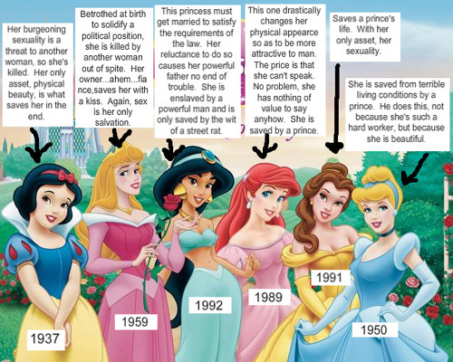
https://filmjamblog.files.wordpress.com/2012/06/sexist.jpg

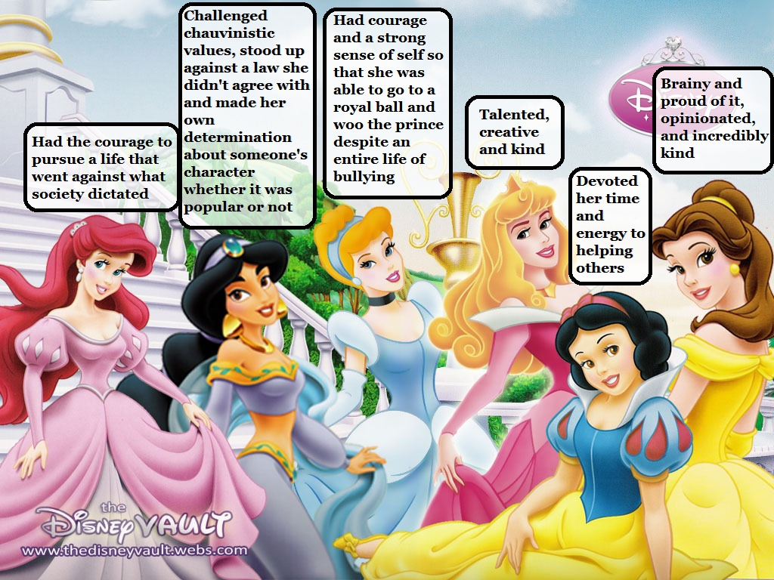
http://data2.whicdn.com/images/29354907/original.jpg

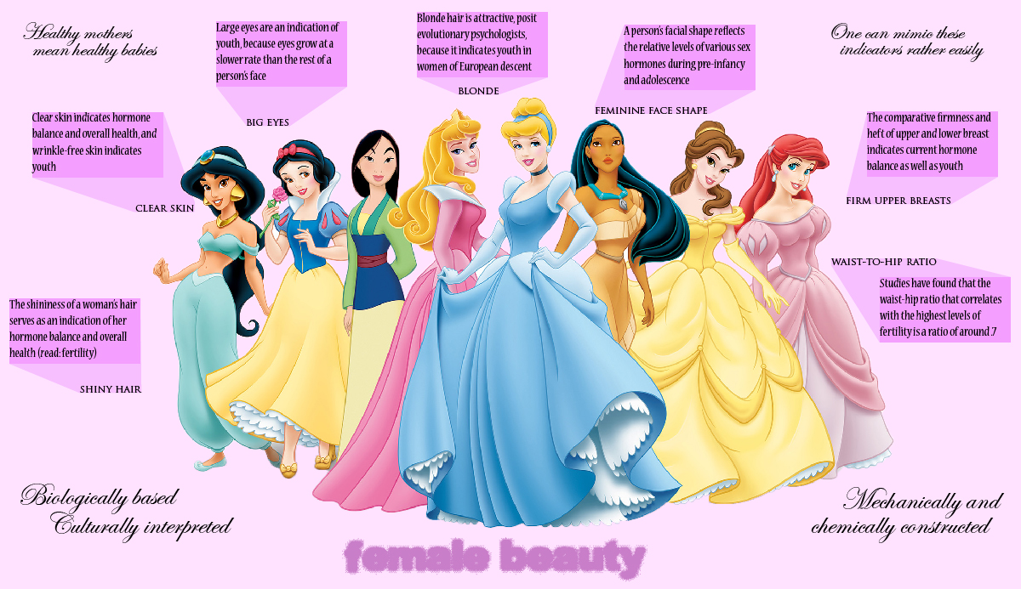
https://gageslaughter.files.wordpress.com/2011/12/beauty.jpg

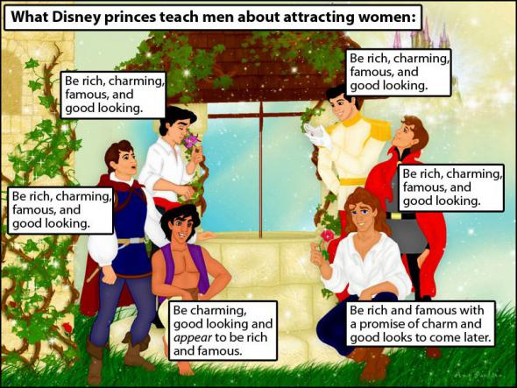
https://cdn.psychologytoday.com/files/u665/prince.jpg
DISNEY & PSYCH. DISORDERS:
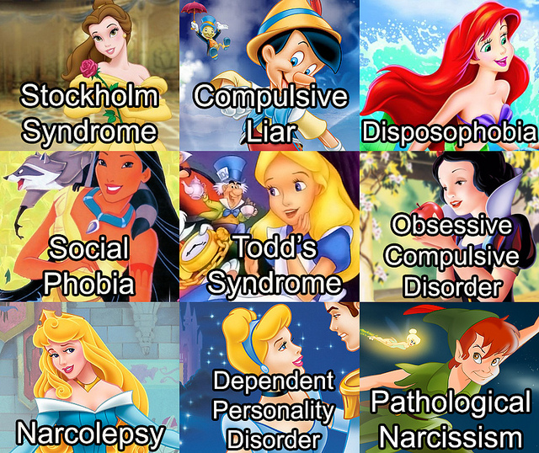
http://41.media.tumblr.com/a10919d11fff5989d1565f4aff0a2f1f/tumblr_mwxlehDFjg1sm67pxo1_1280.jpg

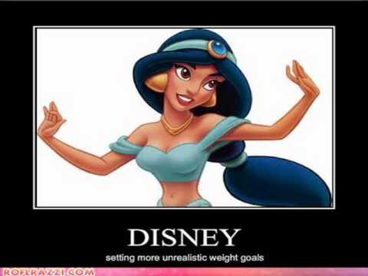
http://i.ytimg.com/vi/5oyGGwjPbLw/hqdefault.jpg

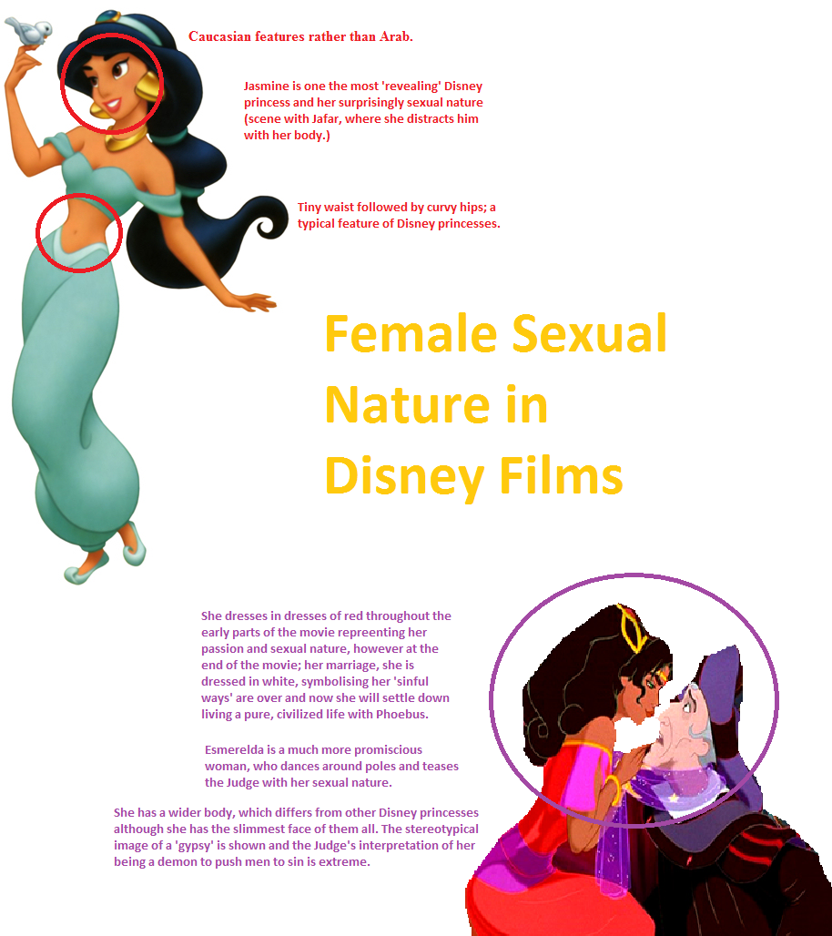
https://melissavmurphy.files.wordpress.com/2011/06/disney-sexual-nature1.png

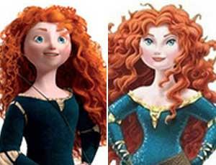
ARTICLE: http://www.mercurynews.com/ci_23249363/brave-creator-brenda-chapman-blasts-disney-blatant-sexism

SEX in DISNEY

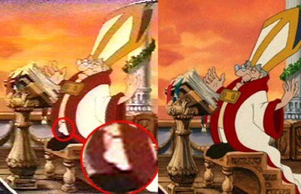
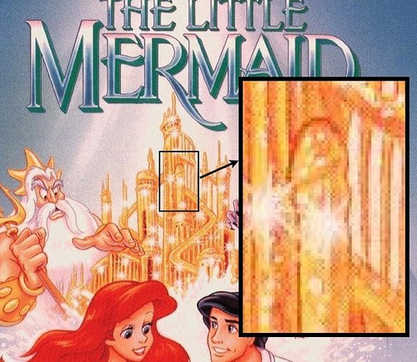
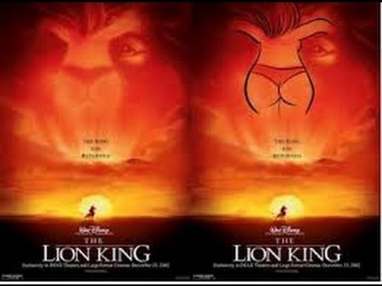

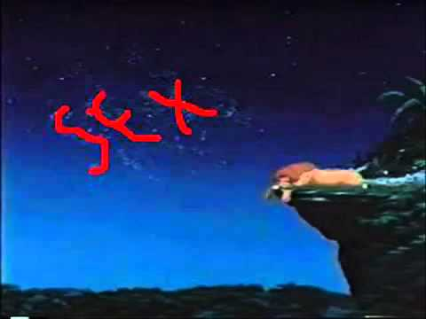
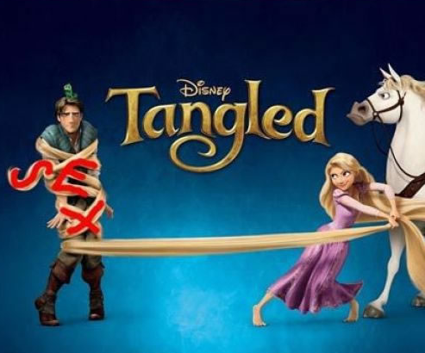
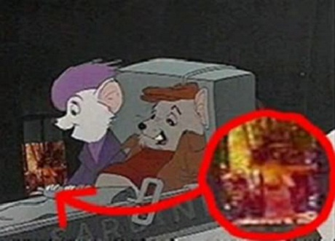
DISNEY & RACISM

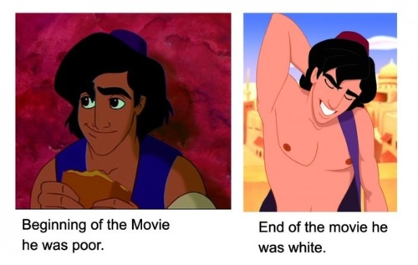
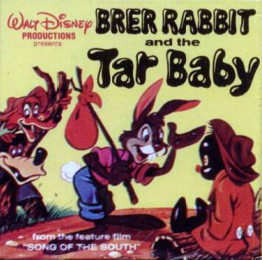
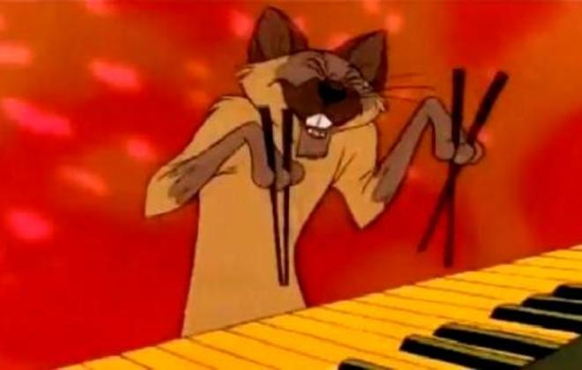
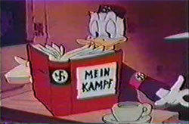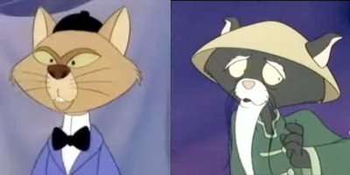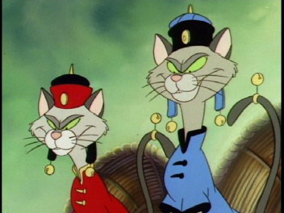
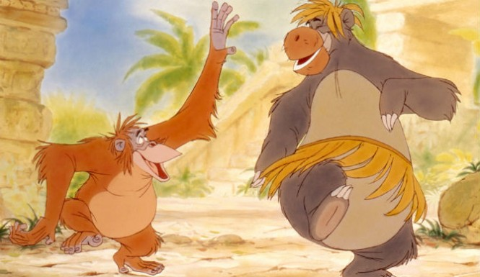
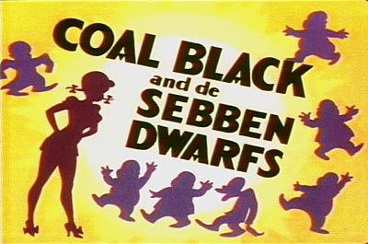

ARTICLE: Hegemony ("whiteness") through Disney: http://lethaldosagevii.blogspot.com/2010/02/racism-gender-sexuality-in-disney.html



