STATS: SERVING SIZE LIES

Serving Size Lies: 6 Potato Chips Anyone?
Susan Harrow
Posted: 01/18/10 01:26 AM ET
http://www.huffingtonpost.com/susan-harrow/serving-size-lies-6-potat_b_426108.html

Don't you hate serving size lies? Food manufacturers are imposing portion control for people who nibble, taste or sample. These guidelines aren't for people who actually eat.

I adore Kettle brand potato chips, for example. But I'm sorry, one bag is NOT five servings. It's two. Or one if I'm in a particularly snacky mood. I remember when Oprah confessed her penchant for eating a bag at a time of blue corn chips. The makers of her favorite brand, Hain-Celestial's spokesperson responded by politely suggesting that Oprah get the single sized bags instead of the ones that were for created for a crowd. A crowd? A companion, maybe.

Serving size suggestions are downright dangerous to my self-esteem. It's become particularly important since I have a gluten-free diet, so I'm reduced to taking pleasure in a select few foods that don't taste like sawdust, cardboard or glue.

It's also made me a bit crazy in the head, this being allergic to gluten. No pasta? No bread? No Tiramisu? No Biscotti? Being Italian I feel like a diabetic in a bakery. Sure, I've discovered a few gluten-free foods that are edible, but few compare to the real thing. It makes me recall something Woody Allen said, "The food is so bad and the portions so small."

When I feel deprived, like at Christmas, when I can't partake of my mother-in-law's fantastic walnut crescents, thumbprints, sugar, and Toll House cookies, I get "The Dream."

I'm at a buffet table piled to the ceiling with cakes, cookies, cupcakes, custards, cobblers, crisps, and puddings. I'm gorging myself. These desserts aren't ordinary. They are gorgeous, the movie stars of the dessert world, and inevitably I wake up in the morning with a horrible hangover, feeling bloated and ill, even though not a touch of gluten has passed my lips. Portion control is not in my vocabulary. I become a sugar whore indiscriminately welcoming anything sweet into my mouth. Size matters. It has to be huge.

In the latest version of "The Dream" I was offered a two-foot tall, three layer yellow cake with a giant bird on the top fashioned of frosting. I uncharacteristically said, "That's a bit too large. Could I have a piece with just one-half of the bird?" See, I do have some sense of portion control. Next, I'll be eating 6 chips and calling it a meal.

Susan Harrow is the author of Sell Yourself Without Selling Your Soul. She runs a Media Consultancy where she helps everyone from Fortune 500 CEOs to celebrity chefs, entrepreneurs to authors grow their business through media coaching and the power of PR. For more information please contact Susan.

Nutrition Label Lies & Loopholes: Serving Size Sleight of Hand
Tom Venuto, Posted: 02/23/10 10:54 AM ET
http://www.huffingtonpost.com/tom-venuto/nutrition-label-lies-loop_b_473065.html

For years, concerned consumers and watchdog organizations have been screaming that the U.S. labeling laws are full of loopholes and in need of serious revision. After years of talk, the Food and Drug Administration (FDA) says they're planning to so something about it. But will it be enough?

There are many food labeling issues we could complain about, but one of the biggest problems (due to its direct relationship to the obesity crisis) is serving sizes.

I'm not just talking about supersizing. What's worse is that the actual calories are being disguised with serving size sleight of hand.

Let me show you some examples:

Tostitos touch of lime. Calories per serving 150. Not too bad for tortilla chips eh? Not so fast. Check that serving size. 1 ounce. That's 6 chips. There are 10 servings per container. That's 1500 calories in the bag.

Most guys could knock off half that bag for a cool 750 calories. Ok, suppose you have some restraint and you only eat a third of the bag (20 chips). You still get 500 calories. But who stops at 6 chips?

Vitamin Water. While I could rant about how sugar water is being marketed as health food, I'll stick with the serving size sleight for now.

The label says there are 50 calories per serving. Wow, only 50 calories! Plus they add all those vitamins. Must be good for you and perfect for dieters, right? Think again. Look at the serving size and servings per container: 8 oz per serving and 2.5 servings per container.

Excuse me, but is there ANY reason for making it 2.5 servings other than to disguise the actual calorie content?

When you see that the entire bottle is 20 ounces, you realize that it contains 125 calories, not 50. Although 20 ounces is a large bottle, I don't know many guys who wouldn't chug that whole thing.

Sobe Lifewater? Same trick in their 20 oz bottles.

Healthy Choice soup, country vegetable. They make these in convenient little microwavable containers with a plastic lid. Just heat and eat.

It says 90 calories and 480 mg of sodium per serving. Wow, less than a hundred calories. Wait a minute though. Turn the container around and you see the serving size is 1 cup and the servings per container says "about 2."

Huh? It looks pretty obvious to me that this microwave-ready container was designed for one person to eat in one sitting, so why not just put 180 calories per container on the label (and 960 mg of sodium). I guess 90 calories and 480 mg sodium sounds... well... like a healthier choice!

Ben and Jerry's chocolate fudge brownie ice cream. This infamously delicious ice cream with its own facebook fan page has 270 calories per serving.

We all know ice cream is loaded with calories and should only be an occasional treat, but 270 calories per serving, that's not too terrible is it?

Look a little closer at the label. The serving size is ½ a cup. Who eats a half a cup of ice cream? In fact, who hasn't polished off a whole pint by themselves? (The "comment confessional" is below if you'd like to answer that.)

According to Ben and Jerry, there are 4 servings in that one pint container. 270 calories times 4 servings = 1080 calories! That's about half a days worth of calories for an average female.

I could go on and on -- crackers, chocolate chip cookies, muffins, pasta, boxed cereals (who eats ¾ a cup of cereal?), etc. But I think you get the point.

What's the solution to this mess? News reports in the last week say that the FDA may be cracking down. Count me among those who are pleased to hear this news. One of their ideas is to post nutritional information, including the calories, on the FRONT of the food labels.

The problem is, this move by itself could actually make matters worse. Suppose Tostitos started posting "150 calories per serving" right on the front of the bag. Most people would assume the chips were low in calories. Putting calorie info on the front of the label would help only if it clearly stated the amount of calories in the entire package or in a normal human-sized serving!

Ah, but the FDA says they're on top of that too. They also want to standardize or re-define serving sizes. Sounds great, but there are critics who say that consumers would take it as approval to eat larger servings so the strategy would backfire.

Suppose for example, the government decides that no one eats ½ a cup of Ben and Jerry's so they make the new serving size 1 cup, or half the pint-sized container. Now by law the label says 540 calories per serving instead of 270. Is that like getting official permission to eat twice as much?

I'm not against the FDA's latest initiative, but what we really need is some honesty in labeling.

Food manufacturers should not be allowed to manipulate serving sizes in a way that would trick you into thinking there are fewer calories than there really are in a quantity that you're likely to eat.

It would be nice to have calories for the entire package listed on the label at a glance. A new rating scale for caloric density would be cool too, if it could be easily interpreted. It would also be nice to have serving sizes chosen for quantities that are most likely to be commonly eaten. But standardization of serving sizes for all types of foods is difficult.

My friends from Europe tell me that food labels over there are listed in 100g portions, making comparisons easy. But when you consider how much each individual's daily calorie needs can vary (easily 3-fold or more when you run the gamut from totally sedentary to elite athlete, not to mention male and female differences), standardization that applies to everyone may not be possible.

I think the recent laws such as requiring calories on restaurant menus are a positive move that will influence some people's behavior. But no label changes by themselves will solve the obesity crisis. A real solution is going to have to include personal responsibility, nutrition education, self-discipline, hard work and lifestyle change.

Changes in the labeling laws won't influence everybody because the people most likely to care about what labels say are those who have already made a commitment to change their lifestyles (and they're least likely to eat processed and packaged foods -- that have labels -- in the first place). Actually, for those who care, all the info you need is already on the labels, you just have to do a little math and watch out for sneaky label tricks.

There's one true solution to this portion distortion and label lies problem: Become CALORIE AWARE. Of course that includes educated label reading, but it goes much further. In my Burn the Fat, Feed the Muscle system, here is how I define "calorie counting":

1. Get a good calorie counter book, chart or electronic device/software and get to know the calorie counts of all the staple foods you eat on a daily basis. Look up the calorie values for foods you eat occasionally.
2. Always have a daily meal plan -- on paper -- with calories printed for each food, each meal and the day. Use that menu as a daily goal and target.
3. Educate yourself about average caloric needs for men and women and learn how to estimate your own calorie needs as closely as you can based on your activity, weight, body composition, height, gender and age.
4. Get a good kitchen food scale and use it. Keep counting calories and doing nutrition by the numbers until you are unconsciously competent and eating the right quantities to easily maintain your ideal weight becomes second nature.

Obviously, saying that calories are all there is to nutrition is like saying that putting is all there is to golf. Calorie quality and quantity are both important. However, it's a mistake to ignore the calorie quantity side of the game. Serving sizes matter and even healthy foods get stored as fat if you eat too much.

You can play "blindfolded archery" by guessing your calories and food portions if you want to. Hey, you might get lucky and guess right. Personally, I wouldn't recommend depending on luck -- or the government -- for something as important as your body and your health. I would recommend the personal responsibility, nutrition education, self-discipline, hard work and lifestyle change.

© 2010 Tom Venuto, author of The Body Fat Solution: Five Principles for Burning Fat, Building Lean Muscle, Ending Emotional Eating, and Maintaining Your Perfect Weight

5 Outrageous Lies Companies Are Legally Allowed to Tell You
By J.F. Sargent July 30, 2013 1,318,793 views
If you tell people that advertisers lie, they'll roll their eyes and say, "DUH! That's what advertising is, you naive buffoon!" But then those same people will walk out the door and buy a phone based on a "coverage map" they just saw in an ad.
That's because advertisers use our cool cynicism against us -- we think we're being savvy by assuming that all ads exaggerate, but we still assume that's as far as it can go -- exaggeration. It's not like these people can just go out and lie right to our faces, right?
They sure can! In fact ...

#5. Companies Have Gone to Court for the Right to Lie
Photodisc/Photodisc/Getty Images
The big assumption we all make is that while every ad contains some bullshit, the basic facts have to be true. Like, what the product looks like and the gist of what it does. After all, there is little room to lie when your essential statement is, say, "It's a phone. You can call with it and take photos." But multiple companies have made the argument -- in court -- that not only do their ads not have to be factual, but only an idiot would think they were.
For example, when Coca-Cola was marketing their line of Vitaminwater by promising the stuff would "boost your immune system" and "help fight free radicals," someone pointed out that the stuff was effectively sugar water. Coke responded that they were completely shocked that anyone thought their drink was healthy, or in their words: "No consumer could reasonably be misled into thinking that Vitaminwater is a healthy beverage."
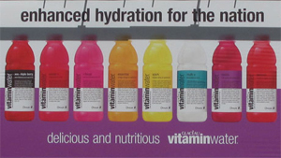Via Guardian.co.uk
In their defense, it never occurred to them that any of their customers could read.
But even if you can make that argument with a product that, to be fair, is basically Kool-Aid, how can you say the same when marketing a product specifically touting never-before-seen capabilities? Like, say, a fancy new phone where your entire campaign is based on all of the things it can do that your old phone can't? You know, like when Apple was advertising their iPhone 3G as, "Twice as fast. Half the price."
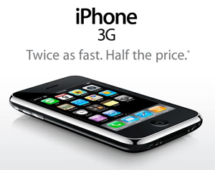Via Yamiya.com
Welp, no misreading that.
That seems like a pretty straightforward statement to us, and the consumer has nothing else to go on. But again, when someone had the audacity to point out that literally each and every one of those words was a lie, Apple's legal defense was the same as Coke's: "No reasonable person in the plaintiff's position could have reasonably relied on or misunderstood Apple's statements as claims of fact." They flat out stated you were a dumbass for buying into their wacky claims, which were obviously fictional and therefore couldn't be lies.
Then in 2012, Nokia took a page out of video game developers' handbook and released a trailer (for their newest Lumia phone) that turned out to be way better than the product itself. The ad featured Lumia's much-touted "Optical Image Stabilization" feature, which they showcased by showing a cute woman flirting with you during a bike ride. If you didn't have OIS, she'd just be a blurry mess!
The ad is actually pretty incredible -- the difference between the two kinds of footage are like night and day. It's a level of image stabilization you'd normally need a big-ass camera crew to achieve, right there on your phone! And then the Internet found out that the reason the footage looks like it was filmed with a big clunky movie camera is because that's exactly what they did:

"Eh, they won't notice. The Internet never notices anything that small and seemingly insignificant."
The company's response was a half-hearted blog post apology that explained the video was obviously supposed to be a simulation of what was possible, not actual footage of the phone's OIS capability. You know, despite the fact that it fucking says "OIS ON" right there in the footage and showing the image quality is the only reason for the ad to exist. As of the writing of this article, all they've done to fix the ad is a YouTube popup that offhandedly mentions the "simulation" thing:

And since most people have annotations turned off, they'll never see it.
Still, at least they did something. That half-hearted effort is better than the standard "you're just an idiot for believing anything we say."

#4. Telecoms Use an Entirely Lie-based Ad Strategy
Comstock Images/Comstock/Getty Images
Hey, know those coverage maps cellphone companies used to bombard us with a couple of years ago? The ones that make the country look like it had the worst case of small pox in history?
Via Richardbliss.typepad.com
Verizon looks like it could use an ointment for its Florida.
In reality, those coverage maps were just a load of unhelpful horseshit. The coverage maps are just ways to avoid giving you any actual numbers (and even when a cell phone ad features actual statistics, chances are they're pulled from a study that the company itself commissioned). But no matter how they paint the country, it doesn't count as lying. It doesn't count as anything.
And it works, because no matter how integral technology is to our lives, most of us have no idea how it works. Sure, most everyone knows that cellphones send signals to towers, Internet access works by connecting us to servers, and we get HBO by plugging our TV into a box powered by tiny elves with the face of a grimacing Ian McShane. But do you know how many cell towers you have in your area, or who they belong to? When your phone drops a call, do you ever know why? Or just assume that it was due to the landscape, or sun spots, or the other caller's phone?
Digital Vision./Digital Vision/Getty Images
Damn you, The sun!
Or, most likely of all, have you just accepted that cellphones get shitty reception and there's nothing you can do about it?
Because the truth is, no matter who you pick, the service is going to be patchy, due to a whole bunch of limitations with capacity and other bullshit that is impossible to predict (that link is to a guide from the FCC that says the only way to find out if you actually have coverage where you are is to fucking find a neighbor with the same service and ask them if it works). Because even if a carrier doesn't have enough towers where you are, they're still happy to color that part of the map red. Why not?
Comstock/Comstock/Getty Images
"Our tower is barely shooting off any signal lightning today. Better save my calls for later."

#3. Food Serving Sizes Are Random and Meaningless
Jeffrey Hamilton/Lifesize/Getty Images
To be fair, lots of marketing tricks are entirely possible to avoid if you know your shit. When you're buying a car, it's good to ignore the salesperson and go right for the manual. When buying a new laptop, you should always pour beer and Cheetos dust all over it just to make sure it can survive your daily life. And when you're in the grocery store, you should go right to the ingredients and nutrition label to see what that Hot Pocket is really made of.
Except that the ingredient lists lie, too. No matter what the sugar, caffeine or sodium content of any given food appears to be, there's always one number that can completely change everything: the serving size. You'd assume that a serving size on, say, a small bottle of soda is that goddamn bottle. And you'd be right -- occasionally. For instance, one serving of Classic Coca-Cola looks like this:
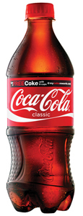Coca Cola Corporation
Meanwhile, this Diet Coke of the exact same size ...
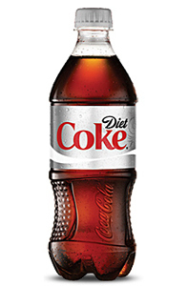Coca Cola Corporation
... is presented as 2.5 servings. Wait, what the hell?
Of course, tinkering with the serving size allows the company to sneakily divide the amounts of each and every ingredient in that bottle by 2.5. All the information is still right there in the ingredients list ... but to decrypt it, you'll need to both spot the serving size trick and be reasonably adept at Surprise Grocery Store Math. And you'll need to be on the lookout for every single product you buy, too. Because this isn't just a soda thing.
Here's a soup-in-a-cup that boasts only 90 calories per cup, which doesn't sound half bad ... until you notice that the package is actually called a container and contains two cups.
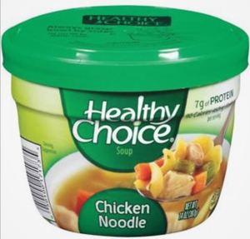Healthy Choice
They'd change the name, but "Death Soup" didn't go over well with the fears-death demographic.
Even the simplest grocery items are not safe from marketing crapjugglery: Each and every package of, say, Top Ramen noodles actually contains two servings.
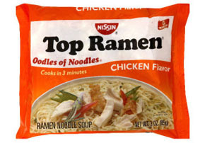Top Ramen
Yes, even the goddamn shrimp flavor.
Nothing like finding out you've been eating quadruple meals all along, college students! But that just brings us to ...


#2. Products Are Still Claiming Bullshit Health Benefits
Brand X Pictures/Brand X Pictures/Getty Images
No, a cup of hot tea won't reduce stress or help you lose weight. Bee pollen has no known health benefits. Acai berries have no magical powers above and beyond those of normal berries.
But there might not be any food category more subject to unwarranted bullshit claims than chewing gum. Will it whiten your teeth? Sure, kinda! Give you energy? Goddamn right it can! Maybe! Still, there are limits to what chewing gum can be presented as, right? It's just inedible candy, after all -- the most pointless of human foods. It's not like anyone has claimed chewing gum is an effective antibacterial medicine and slapped an absurd price tag on it.
Jupiterimages/Brand X Pictures/Getty Images
Don't tell Jenny McCarthy. She'll flip out.
Ah, come on! Of course they have!
In 2008, chewing gum giant Wrigley decided to pull out all the stops and see what the public would really pay for their product. They came up with Eclipse Gum, a chewing gum that would not just mask your bad breath, but actually murder it. Initially priced at around $10, Eclipse was said to contain a natural ingredient that kills the germs that cause bad breath. Later, they introduced a new, improved version that also boasted antiseptic qualities and actually worked as an anti-plaque and anti-gingivitis drug.
Stockbyte/Stockbyte/Getty Images
"Sir, your prescription is ready."
The competitors soon kicked up a fuss and it was revealed that the ridiculously overpriced Eclipse Gum didn't actually do anything. Even though Wrigley denied that they had ever lied (and even though it must have been pretty hard to feel sympathy for people who are willing to drop $10 on a pack of gum), the court ruled against the company and Wrigley was forced to compensate everyone who was willing to admit they'd bought a pack.
Of course, Wrigley took absolutely nothing of this to heart. They just added a small disclaimer here ("We recommend that you do not rely solely on the information presented") and a warning there and went right back to selling Eclipse. Today, Eclipse Gum can knock you back nearly $30 on Amazon -- and the only change to the product's claims is that now they say it's also a good substitute for snacks.
Jupiterimages/Creatas/Getty Images
You're not fooling anyone. We know there's a ham sandwich behind that bubble.

#1. Junk Food Will Forever Claim to Be a Healthy Alternative to Something
Brand X Pictures/Brand X Pictures/Getty Images
There's an old saying in advertising that any food, no matter how unhealthy, can be promoted as low in one thing or high in another. For instance, cotton candy is very low in nicotine, and Krispy Kreme donuts, which are rings of fat that are fried and then coated in sugar, are low in trans fat:
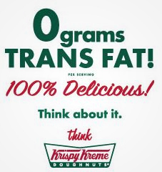Via Krispy Kreme
No, seriously, think. Think about what you're reading versus what you're about to buy.
But even the biggest fans of Coca-Cola probably don't think of it as a health drink -- no one's chugging Coke before they head to the gym. This isn't a Vitaminwater situation. Coke is popular because we, as consumers, have made the decision to willingly purchase and drink candied fart water as a guilty pleasure. And that's totally fine.
Fine for everyone, that is, except Coke. Coca-Cola has long harbored a desire to be perceived as healthy. To combat the fact that their main product is essentially acidic liquid sugar, they employ all sorts of shenanigans to convey a healthy image. From rampant sports advertising to Coke Workout Calculators ("Select your favorite Coca-Cola drink to generate activity suggestions for a healthy, balanced lifestyle!"), the company is constantly blasting the market with visions of Coke as a healthy drink, despite all evidence to the contrary. But the most glaring example of their blatant abuse of the concept of "healthiness" was the Motherhood & Myth-Busting advertisement they ran in Australia.
The ad was formatted like a mythbusting infographic, explaining at length how this poop-colored caffeine water was not only "kiddy safe," but somehow wouldn't contribute to obesity, tooth decay, or health problems in any way. To give this blatant fuckery the shiny veneer of authority, they decided to hire Kerry Armstrong (a popular Australian actress) to endorse their myth busting.
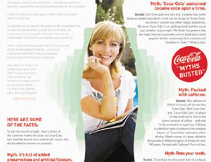Via Theage.com.au
Because who's more trustworthy than someone who makes a living pretending to be other people?
This particular ad was so blatant that the Australian Competition and Consumer Commission forced Coca Cola to immediately pull the plug on the campaign. What's more, the Aussie officials displayed a sense of humor only living in the Spider Kingdom will give you: They forced Coke to embark on a very different kind of ad campaign called "Setting the Record Straight," essentially making the company eat their false claims along with a big bag of dicks. Well played, Australia. Well played.
J.F. Sargent is writing a comedy sci fi action horror novel that you can read for free! He also has a Twitter and a Blog and a Facebook. For more ways you're getting screwed by the food industry, check out 6 Subtle Ways You're Getting Screwed at the Grocery Store and 5 Ways Stores Use Science to Trick You Into Buying Crap.

http://www.cracked.com/article_19485_5-outrageous-lies-companies-are-legally-allowed-to-tell-you.html

SERVING SIZE: EXERCISE
http://teacher.scholastic.com/scholasticnews/magazines/dynamath/pdfs/DYNA-1010-REPRO-4.pdf

NEW FOOD LABELS:
‘User-Friendly’ Food Labels
Mary Clare Jalonick & Darlene Superville, AP
Published: Thursday, February 27, 2014, 12:00 PM
Updated: Thursday, February 27, 2014, 3:30 PM
http://www.nydailynews.com/life-style/health/fda-proposes-nutrition-labels-reflect-reality-article-1.1703844

FDA proposes nutrition labels that reflect reality

The updated labels would emphasize calorie content and note any added sugars. Misleading serving size listings, like those on small bags of chips that are considered multiple servings, would also be updated based on how much people actually eat rather than ideal consumption.
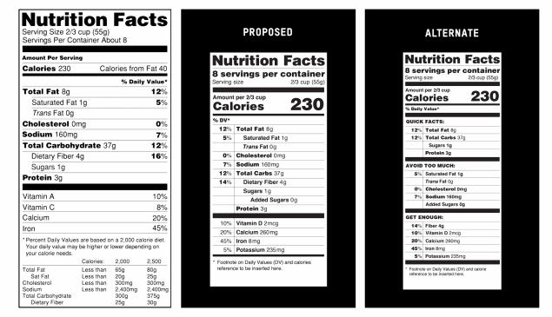

AP-The current food nutrition label, the FDA's proposed version and an alternative. The revamped labels would include added sugars and highlight the number of calories per serving in a bigger, bolder font.

Related Stories
- FDA to give nutrition facts labels a makeover
- New Jersey bakery that put sugar in its ‘sugar-free’ products ordered to shut down
- Caffeine consumption, mainly from soda, common in kids and teens: study
- RELATED: FOOD COMPANIES CUT 6.4 TRILLION CALORIES OVER 5 YEARS: STUDY
- RELATED: FDA TO BAN ARTERY-CLOGGING TRANS FATS
WASHINGTON — Ice cream lovers beware: The government knows you're unlikely to stop after half a cup.
New nutrition labels proposed Thursday for many popular foods, including ice cream, aim to more accurately reflect what people actually eat. And the proposal would make calorie counts on labels more prominent, too, reflecting that nutritionists now focus more on calories than fat.
For the first time, labels also would be required to list any sugars that are added by manufacturers.
In one example of the change, the estimated serving size for ice cream would jump from a half cup to a cup, so the calorie listing on the label would double as well.
The idea behind the change, the first overhaul of the labels in two decades, isn't that the government thinks people should be eating twice as much; it's that they should understand how many calories are in what they already are eating. The Food and Drug Administration says that, by law, serving sizes must be based on actual consumption, not some ideal.
"Our guiding principle here is very simple, that you as a parent and a consumer should be able to walk into your local grocery store, pick up an item off the shelf and be able to tell whether it's good for your family," said first lady Michelle Obama, who joined the FDA in announcing the proposed changes at the White House.
Mrs. Obama made the announcement as part of her Let's Move initiative to combat child obesity, which is marking its fourth anniversary. On Tuesday, she announced new Agriculture Department rules that would reduce marketing of less-healthful foods in schools.
The new labels would be less cluttered. FDA Commissioner Margaret Hamburg called them "a more user-friendly version."
But they are probably several years away. The FDA will take comments on the proposal for 90 days, and a final rule could take another year. Once it's final, the agency has proposed giving industry two years to comply.

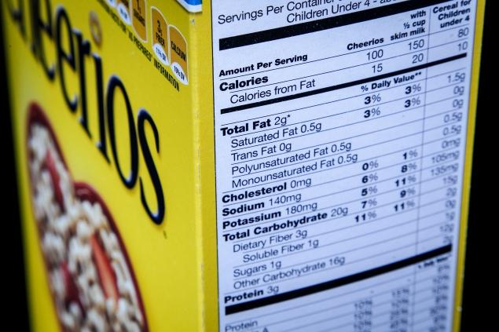 J. David Ake/AP -The current ‘Nutrition Facts’ labels were unveiled in the early 1990s.
The agency projects food companies will have to pay around $2 billion to revise labels. Companies have resisted some of the changes in the past, including listing added sugars, but the industry is so far withholding criticism.
Pamela Bailey of the Grocery Manufacturers Association, the industry group that represents the nation's largest food companies, called the proposal a "thoughtful review."
It is still not yet clear what the final labels will look like. The FDA offered two labels in its proposal — one that looks similar to the current version but is shorter and clearer and another that groups the nutrients into a "quick facts" category for things like fat, carbohydrates, sugars and proteins.
There also would be an "avoid too much" category for saturated fats, trans fats, cholesterol, sodium and added sugar, and a "get enough" section with vitamin D, potassium, calcium, iron and fiber. Potassium and vitamin D are would be additions, based on current thinking that Americans aren't getting enough of those nutrients. Vitamin C and vitamin A listings are no longer required.
Both versions list calories above all of those nutrients in large, bold type.
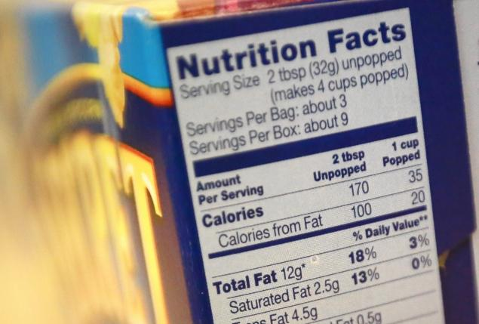

SHANNON STAPLETON/Reuters -Nutrition facts are seen on a box of popcorn. Revamped food labels are likely several years away, and they have a new look.
Serving sizes have long been misleading, with many single-serving packages listing themselves as multiple servings, so the calorie count appears lower.
Under the proposed rules, both 12-ounce and 20-ounce sodas would be considered one serving, and many foods that are often eaten in one sitting — a bag of chips, a can of soup or a frozen entree, for example — would either be newly listed as a single serving or would list nutrient information both by serving and by container.
The inclusion of added sugars to the label was one of the biggest revisions. Nutrition advocates have long asked for that line on the label because it's impossible for consumers to know how much sugar in an item is naturally occurring, like that in fruit and dairy products, and how much is added by the manufacturer. Think an apple vs. apple sauce, which comes in sweetened and unsweetened varieties.
According to the Agriculture Department's 2010 Dietary Guidelines for Americans, added sugars contribute an average of 16 percent of the total calories in U.S. diets. Though those naturally occurring sugars and the added sugars act the same in the body, the department says the added sugars are just empty calories while naturally occurring ones usually come along with other nutrients.
David Kessler, who was FDA commissioner when the first Nutrition Facts labels were unveiled in the early 1990s, said he thinks focusing on added sugars and calories will have a public health benefit. He said the added sweetness, like added salt, drives overeating. And companies will adjust their recipes to get those numbers down.
While some people ignore the panels, there's evidence that more are reading them in recent years as there has been a heightened interest in nutrition. An Agriculture Department study released earlier this year said 42 percent of working adults used the panel always or most of the time in 2009 and 2010, up from 34 percent two years earlier.

