WHY WE RESEARCH
(1) WHY WE RESEARCH
(2) WHY WE CITE

- college = entrance into

OED
- Etymology: Middle French, French recherche thorough investigation (1452; a1704 with spec. reference to investigation into intellectual or academic questions; 1815 in plural denoting scholarly research or the published results of this)
- 1. The act of searching carefully for or pursuing a specified thing or person; an instance of this.
- 2a. Systematic investigation or inquiry aimed at contributing to knowledge of a theory, topic, etc., by careful consideration, observation, or study of a subject. In later use also: original critical or scientific investigation carried out under the auspices of an academic or other institution.

  - academia
  - critical thinking
  - pathway to independence
- independent study
- finding your own voice by listening to others

RESEARCH: purpose
- search for knowledge
- investigate
- solve problems
- establish new facts, interpretations, theories
- prove facts, interpretations, theories
- to inform
- to confirm
- to persuade
- *to advance knowledge
- to help choose a topic
- to help narrow subject to topic
- to weed out weaker theories

- TO CONTINUE THE CONVERSATION
  - a conversation with the ages

- academic research, research in the humanities

- theory = not static
  - continuous, developing

Matthew 7:24-27 (KJV)
²⁴Therefore whosoever heareth these sayings of mine, and doeth them, I will liken him unto a wise man, which built his house upon a rock:
²⁵And the rain descended, and the floods came, and the winds blew, and beat upon that house; and it fell not: for it was founded upon a rock.
²⁶And every one that heareth these sayings of mine, and doeth them not, shall be likened unto a foolish man, which built his house upon the sand:
²⁷And the rain descended, and the floods came, and the winds blew, and beat upon that house; and it fell: and great was the fall of it.

  - trial & error
- thesis = theory/hypothesis
  - needs practice, test, proof
  - research evolves/sharpens/hones/develops our theories
  - research weeds out weaker theories
- GOOD RESEARCH = FOUNDATION OF GOOD THEORY
  - house built on rock or sand
  - sand = Wikipedia & other questionable/dubious sources
  - rock = credible, reliable, proven sources

- DEFINITION/etymology:
  - look on Oxford ED
  - dictionary.com, MW.com
- often implies organized investigation (scientific method)
- types of - scientific, academic/humanities, history,
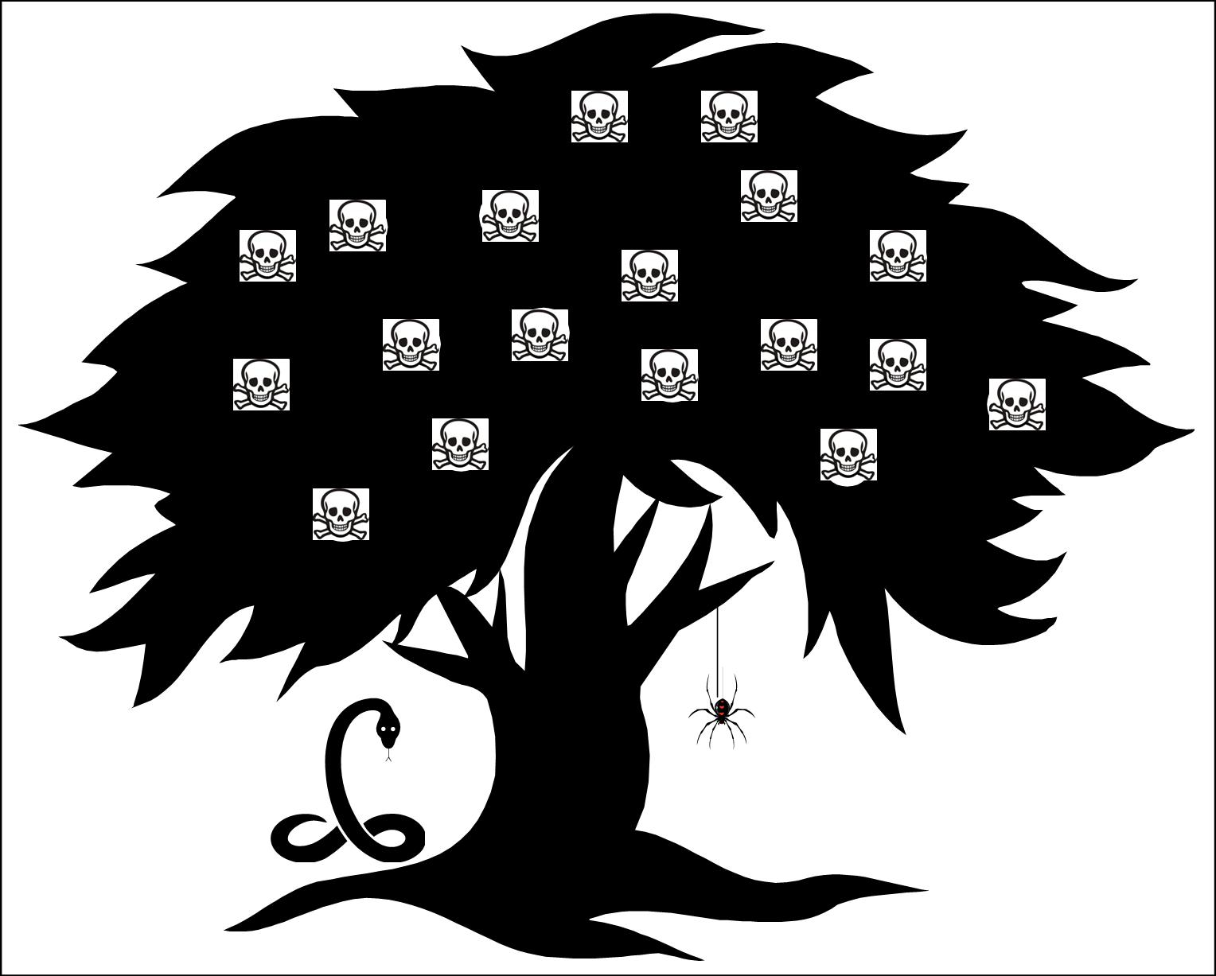

WHY DO RESEARCH?:
- join the conversation
- contribute to an on-going dialogue
- pursue interests
- hone problem-solving skills
- learn something new
- gain appreciation
- visit museums, archives, galleries, laboratories
- create new knowledge
- further explore classroom discussion ideas
- gain perspective
- hyperopic, not myopic vision
- understand how knowledge is created
- to test a hypothesis
- answer a question/solve a problem
- to investigate an issue
- to argue, persuade
- fill in the gaps, crystallizes/clarifies what we don’t understand

RE-SEARCH:
- search the text again
- see it in a different view
- view it from a new perspective
- back & forth –
  - claim, counter-claim, rebuttal
  - the ebb & flow of ideas
  - search, re-search, search again,…
- new ideas, interpretations, voices in the conversation “renew” or “refresh” the conversation
  - doesn’t get old, stale
- challenges our own preconceived notions, beliefs, attitudes
  - forces us to re-think, re-evaluate them
- confirms our beliefs
  - re-affirms our interpretations
  - re-establishes our self-confidence

- leads to deeper understanding & appreciation of the text & of ourselves
- process = never-ending
  - eternal
    - the immortality SHK wrote about
  - conversation = on-going
  - always new, fresh
  - questions lead to answers which lead to more questions….
    - the unanswerable question
    - the perpetual motion machine
    - the eternal marathon
- the ultimate WIKI
  - everyone can participate
  - add to the conversation
  - the true “democracy” that the Internet/Web dreams of
  - “the research conversation =
    - the “comments” after an article or blog post
  - hyper-links =
    - the web-like aspect of the research conversation
- re-discover
  - the text
  - the author
  - the culture
    - then
    - now
    - every culture that reads it
  - the critics
- re-think
  - the past, present, future
  - the text, the author, the culture,…
- re-consider
- re-read
- re-visit
- re-discover

PURSUIT of KNOWLEDGE:
- the cornerstone of higher education
- active
  - not passive, not rote, not mechanical
  - not served, given to – earned – not spoon-fed
- difficult
  - challenging, worth the effort/sacrifice
- exploration
  - element, joy of discovery

RESEARCH BASICS:
- # of sources:
  - 3-5
  - quality, credible sources
    - quality over quantity of sources
  - fewer than that & you haven’t done the topic justice
  - more than that & the material becomes redundant
- types of sources:
  - hard copy: books, journals, magazines, newspapers
  - online, digital/electronic: Web sites, typical hard copy, databases
  - with so many sources available online now, it is difficult to restrict researchers to hard copy only
  - quality, credible sources
    - quality over medium of sources
- Lead-In Expressions
  - esp. the 1st time a source is used (Who is s/he & why should we care?!)
  - NOT every time the source is used
  - esp. with BLOCK QUOTES
  - coherence, flow of the para. (not just thrown in there)
- don’t end a paragraph with borrowed info
  - don’t end a para. in your essay with another’s words or ideas
  - your essay
  - end with a Clincher Sentence
  - “reiterate” the point of the paragraph, the cause, the argument)
  - end with a Warrant Statement: justify the Grounds (example) to the Claim (in the Topic Sentence)
  - BOOK ENDS: 1st & last sentences are yours – always – this is your essay
  - your essay
    - follow up quotes, “warrant” the information to your Claim, reiterate the point of the para.
  - true, a source may phrase your possible Topic or Clincher sentence perfectly, but this is rare
- citations
  - see Parenthetical Citations page
  - cite after EVERY sentence of borrowed info
  - if you didn’t know it before researching, then cite it
  - when in doubt, cite!
  - cite immediately, not eventually
  - you’ll never just throw a citation at the end of a paragraph
  - how will we know whose idea is whose?
  - Who wrote which sentence?
- POV
  - 3rd person POV
  - remain objective
  - one, they
  - people, opponents, proponents (often better to use a plural term, for Pronoun Agreement)
  - avoid 2nd POV
  - no “you” throughout
  - use 1st person
- tone
  - always be polite, even if you disagree
  - never use a 1st name alone
  - last names, professional degree + last names

WHY WE CITE

- Credibility of Argument:
  - opinions are nice, but “everyone has one”
  - what is needed for academic discourse is evidence beyond personal belief
    - research gives us proof

    - evidence by experts, authorities in the given field of study
  - lending credibility to our arguments, our claims
    - and citing points to this research
- Credibility of us as Writers:
  - as research writers, we must be concerned about our ETHOS, our credibility
    - why else should readers care what we have to say
  - so we cite to build this trustworthiness
    - as citing demonstrates the credibility of our arguments
    - as citing demonstrates our academic integrity
    - as citing (and strong Lead-In Expressions) demonstrates the authority of our sources
- Plagiarism:
  - if research writers have a concern above credibility, it is for academic integrity
  - so we cite to give credit for ideas not our own
    - ideas, not necessarily words
      - this is akin to trademark or copyright infringement (ask Samsung & Apple)
  - to demonstrate our respect for Intellectual Property Rights
  - to differentiate clearly our ideas from our sources’ ideas
    - consequently, to demonstrate our academic honesty/integrity


- Stepping Stones:
  - to get readers to our Works Cited page (Works Consulted, References, Bibliography)
    - which will get them to the source itself
    - and then they will be able to find the information you borrowed, in its original context
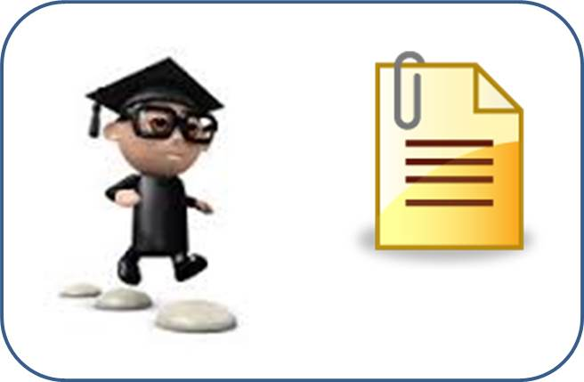

- Continue the Conversation:
  - since research writing is an ongoing, eternal, continual conversation
    - a web of voices taking the issue in numberless different directions
  - we cite to keep the conversation going
    - so now that readers have gone from our citation to our Works Cited page to our source
      - (across the stepping stones)
    - they can learn more about this issue
    - and research it further, add to our research, or take it on some new direction





