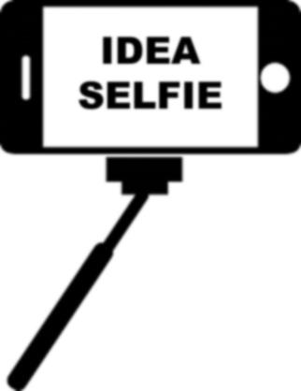
Personal Interest Catalog
Under each subject below, brainstorm ideas, topics, issues that come to you.
While example prompts are given, feel free to create your own.
EDUCATION or CAREER:
- What career/s are you interested in?
- What is your favorite subject? Your major?
- Favorite/ Least favorite part about school? (schooling OR the school you attend)
- Online classes?
WORK:
- What is your “Dream Job”?
- Where do you work?
- What types of jobs have you had?
- What skills do you possess?
POLITICS:
- 2016 presidential race (candidate)
- Favorite/Least president or Law or Act or Bill?
- Electoral College, Primary Election, Absentee ballots, Computerized voting
RELIGION:
- Law or bill or edict to change or to be written?
- Favorite pope OR minister/priest/rabbi/….?
SPORTS:
- What are your favorite teams?
- Who should be the MVP?
- Who is going to win “The Big Game”?
- Which coach should be fired?
- Which player should be traded?
- Exercise? Diet?
TRAVEL:
- Vacations you have gone on
- Best/Worst place to vacation
- Your “Dream Vacation”
MUSIC:
- Who is your favorite musical entity? Genre?
- Do you play an instrument?
- Favorite/Worst concert?
- “Dream Concert”
MOVIES or TELEVISION:
- Favorite/Least movie or show?
- Actor/Actress?
VIDEO GAMES:
- Favorite/Worst?
- Best/Worst gaming console?
FOOD:
- Favorite food? Restaurant?
- What is your go-to recipe?

