PARADIGM SHIFT:
ALTERING PERCEPTION

Love is blind.
Can’t see the forest for the trees.
When you look up in the sky, you can see the stars but still not see the light.

How can we have 20/20 vision and still not see correctly?
The answer lies with the difference between sight and perception – a physical act involving the senses and a mental action involving the neurological and cognitive processes.

What we see isn’t always what’s there to be seen or all there is to be seen. Sometimes we see only what we want to see or only see part of what is there or only the obvious level. Sometimes, it’s scary the gap between what you see and what is there.

So….one goal of this class is to get you to perceive more, to perceive differently, to perceive better. While the demonstration to follow is wholly visual, know that our aim concerns the mental – how you think.

Critical thinking skills – that vague and often-undefined set of abilities that only teachers seem to be interested in and put on their syllabi with all that other edu-babble – that’s what we aim to whet here.

LOOK AWAY NOW if you don’t want to see the world differently!

HIDDEN IN PLAIN SIGHT….

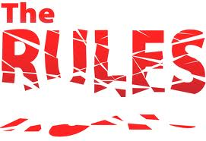
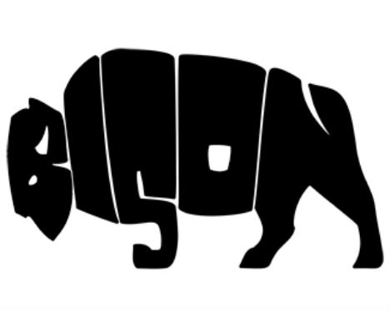
- http://www.greendump.net/tag/branding

MIMAL the Baker
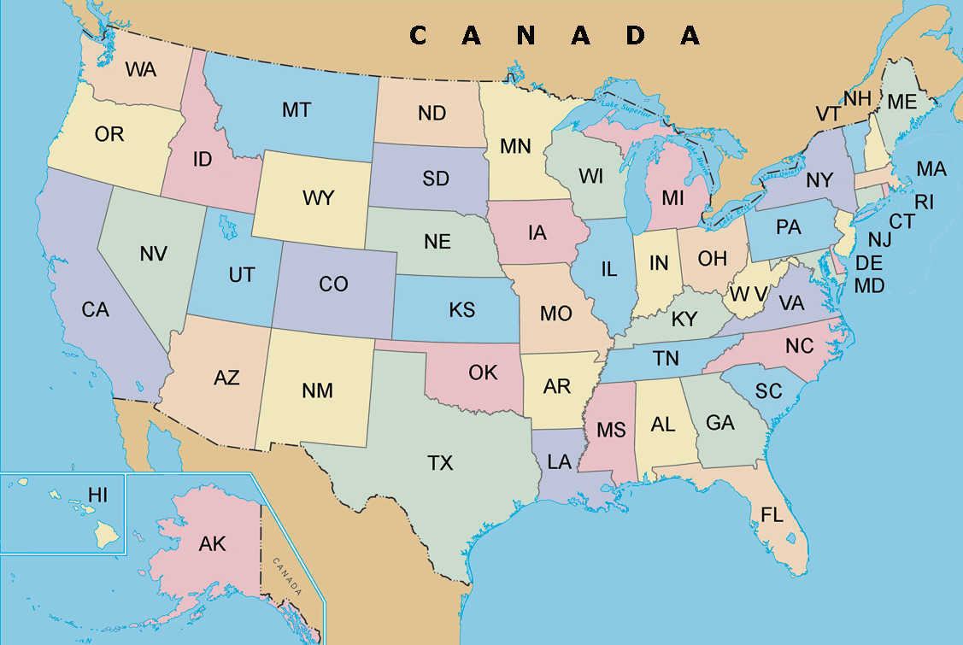
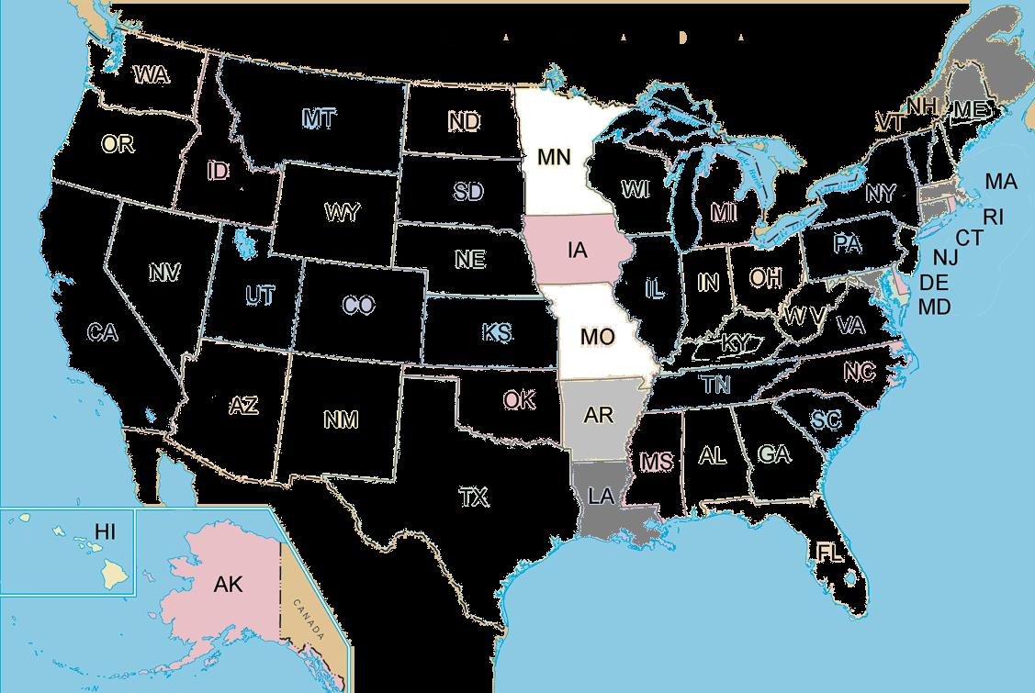
PERCEPTUAL AMBIGUITY…

DUCK SEASON – RABBIT SEASON

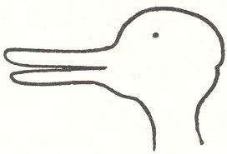
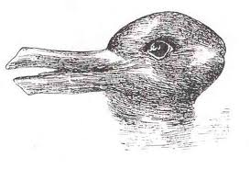
Joseph Jastrow, L. Wittgenstein
- http://socrates.berkeley.edu/~kihlstrm/JastrowDuck.htm
- http://mathworld.wolfram.com/Rabbit-DuckIllusion.html
- http://www.plosone.org/article/info:doi/10.1371/journal.pone.0022614
THE WOMAN
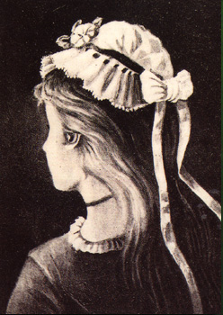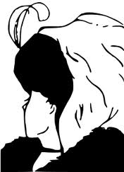
The Boring Figure
Wife/Mother-in-Law
- http://socrates.berkeley.edu/~kihlstrm/SEP06.htm
- http://psylux.psych.tu-dresden.de/i1/kaw/diverses%20Material/www.illusionworks.com/html/perceptual_ambiguity.html
- http://mathworld.wolfram.com/YoungGirl-OldWomanIllusion.html

THE MAN
Husband/Father-in-Law

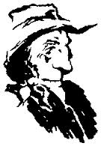
UNCONVENTIONAL THINKING



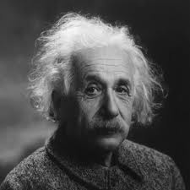

Half of 8:
- 4
- 4+4
- 4x2

- 3
- E
- 0

Crossword Puzzles:

- Leading man? 4
- Grecian vessel? 3
- The 3rd degree? 3
- Short occupation? 3
- Arrow shooter? 4
- Rubber of myth? 7
- Crafts companion? 4
- Foreign one? 4
- Annual quartet? 7
- Flag carrier? 3
- Drop cloths? 10
- Greek leader? 5
  - Adam, urn, PhD, job/biz, Eros
  - Aladdin, arts, eins, seasons
  - Ref, parachutes, alpha

Or….
You can go through life

I. LOCATION:
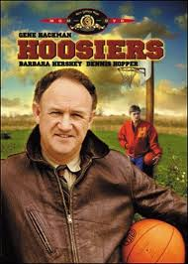
- NBA, NCAA, PAC, WAC, MAC
- teams in different cities
- BUT
- same game
- same court dimensions

II. TIME of YEAR:
- climate, weather
- BUT
- music still sounds the same

III. TIME of DAY:
- laws don’t change
- speed limits, stop signs, street lights
- click it or ticket

