PHOTO TAMPERING HISTORY
< http://www.cs.dartmouth.edu/farid/research/digitaltampering/ >

Home Papers Research

Photo Tampering Throughout History
Photography lost its innocence many years ago. In as early as the 1860s, photographs were already being manipulated, only a few decades after Niepce created the first photograph in 1814. With the advent of high-resolution digital cameras, powerful personal computers and sophisticated photo-editing software, the manipulation of digital images is becoming more common. Here, I have collected some examples of tampering throughout history.
To help contend with the implications of this tampering, we have developed a series of tools for detecting traces of tampering in digital images (contact me at Ma'at Consulting for more information about our services).
circa 1860: This nearly iconic portrait of U.S. President Abraham Lincoln is a composite of Lincoln's head and the Southern politician John Calhoun's body. Putting the date of this image into context, note that the first permanent photographic image was created in 1826 and the Eastman Dry Plate Company (later to become Eastman Kodak) was created in 1881. | 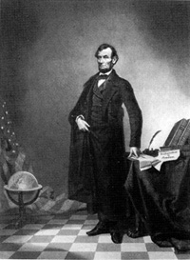
circa 1864: This print purports to be of General Ulysses S. Grant in front of his troops at City Point, Virginia, during the American Civil War. Some very nice detective work by researchers at the Library of Congress revealed that this print is a composite of three separate prints: (1) the head in this photo is taken from a portrait of Grant; (2) the horse and body are those of Major General Alexander M. McCook; and (3) the backgoround is of Confederate prisoners captured at the battle of Fisher's Hill, VA. | 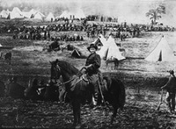  Source: Library of Congress, Prints & Photographs Division
circa 1865: In this photo by famed photographer Mathew Brady, General Sherman is seen posing with his Generals. General Francis P. Blair (far right) was added to the original photograph. | 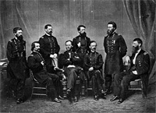
circa 1930: Stalin routinely air-brushed his enemies out of photographs. In this photograph a commissar was removed from the original photograph after falling out of favor with Stalin. | 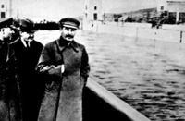
1936: In this doctored photograph, Mao Tse-tung (right) had Po Ku (left) removed from the original photograph, after Po Ku fell out of favor with Mao. | 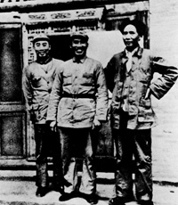
1937: In this doctored photograph, Adolf Hitler had Joseph Goebbels (second from the right) removed from the original photograph. It remains unclear why exactly Goebbels fell out of favor with Hitler. | 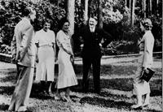
1939: In this doctored photo of Queen Elizabeth and Canadian Prime Minister William Lyon Mackenzie King in Banff, Alberta, King George VI was removed from the original photograph. This photo was used on an election poster for the Prime Minister. It is hypothesized that the Prime Minister had the photo altered because a photo of just him and the Queen painted him in a more powerful light. | 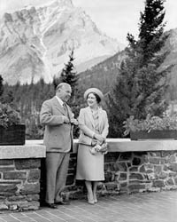
1942: In order to create a more heroic portrait of himself, Benito Mussolini had the horse handler removed from the original photograph. | 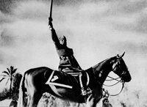
1950: It is believed that this doctored photograph contributed to Senator Millard Tydings' electoral defeat in 1950. The photo of Tydings (right) conversing with Earl Browder (left), a leader of the American Communist party, was meant to suggest that Tydings had communist sympathies. | 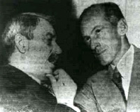
1960: In 1960 the U.S. Olympic hockey team defeated the Soviet Union and Czechoslovakia to win its first Olympic gold medal in hockey. The official team photo was doctored to include the faces of Bill Cleary (front row, third from the left), Bob Cleary (middle row, far left) and John Mayasich (top row, far left), who were not present for the team photo. These players were superimposed onto the bodies of players Bob Dupuis, Larry Alm and Herb Brooks, respectively. | 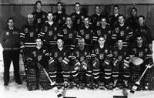
1968: When in the summer of 1968 Fidel Castro (right) approves of the Soviet intervention in Czechoslovakia, Carlos Franqui (middle) cuts off relations with the regime and goes into exile in Italy. His image was removed from photographs. Franqui wrote about his feeling of being erased:  I discover my photographic death.  Do I exist?  I am a little black,  I am a little white,  I am a little shit,  On Fidel's vest. | 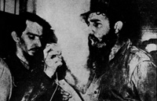
May 1970: This Pulitzer Prize winning photo by John Filo shows Mary Ann Vecchio screaming as she kneels over the body of student Jeffrey Miller at Kent State University, where National Guardsmen had fired into a crowd of demonstrators, killing four and wounding nine. When this photo was published in LIFE Magazine, the fence post directly behind Vecchio was removed. | 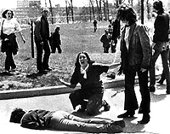
September 1971: The German Chancellor of West Germany, Willy Brandt (far left), meets with Leonid Brezhnev (far right), First Secretary of the Communist Party. The two smoke and drink, and it is reported that the atmosphere is cordial and that they are drunk. The German press publishes a photograph that shows the champagne bottles on the table. The Soviet press, however, removed the bottles from the original photograph. | 
September 1976: The so called "Gang of Four" were removed from this original photograph of a memorial ceremony for Mao Tse-Tung held at Tiananmen Square. | 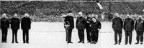
February 1982: In this National Geographic magazine cover story on Egypt by Gorden Gahen, the Great Pyramid of Giza was digitally moved to fit the magazine's vertical format. Tom Kennedy, who became the director of photography at National Geographic after the cover was manipulated, stated that "We no longer use that technology to manipulate elements in a photo simply to achieve a more compelling graphic effect. We regarded that afterwards as a mistake, and we wouldn't repeat that mistake today". | 
August 1989: The cover of TV Guide displayed this picture of daytime talk-show host Oprah Winfrey. This picture was created by splicing the head of Winfrey onto the body of actress Ann-Margret, taken from a 1979 publicity shot. The composite was created without permission of Winfrey or Ann-Margret, and was detected by Ann-Margret's fashion designer, who recognized the dress. | 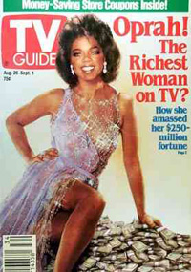
July 1992: This cover of TexasMonthly shows the then Texas Governor Ann Richards astride a Harley-Davidson Motorcycle. This picture was created by splicing the head of Richards onto the body of a model. The editors explained that their credit page disclosed this fact by noting in the credits page "Cover Photograph by Jim Myers ... Stock photograph (head shot) By Kevin Vandivier / Texastock". After the motorcycle cover appeared, Richards said that since the model had such a nice body, she could hardly complain. | 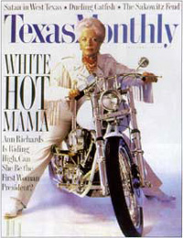
February 1994: This digital composite of Olympic ice skaters Tanya Harding and Nancy Kerrigan appeared on the cover of New York Newsday. The picture showed the rivals practicing together, shortly after an attack on Kerrigan by an associate of Harding's husband. The picture caption reads: "Tonya Harding, left, and Nancy Kerrigan, appear to skate together in this New York Newsday composite illustration. Tomorrow, they'll really take to the ice together." | 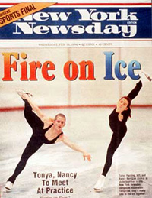
June 1994: This digitally altered photograph of OJ Simpson appeared on the cover of Time magazine shortly after Simpson's arrest for murder. This photograph was manipulated from the original mug-shot that appeared, unaltered, on the cover of Newsweek. Time magazine was subsequently accused of manipulating the photograph to make Simpson appear "darker" and "menacing". | 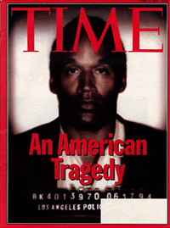
November 1997: After 58 tourists were killed in a terrorist attack at the temple of Hatshepsut in Luxor Egypt, the Swiss tabloid Blick digitally altered a puddle of water to appear as blood flowing from the temple. | 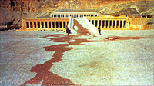
December 1997: This digitally altered photograph of Kenny and Bobbi McCaughey appeared on the cover of Newsweek magazine shortly after Bobbi gave birth to septuplets. This photograph was manipulated from the original that appeared, unaltered, on the cover of Time magazine. Newsweek manipulated the photograph to make Bobbi's teeth straighter, and were accused of trying to make her "more attractive". | 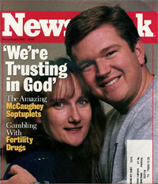
December 2000: The CBS emblem in this single frame of a live video broadcast, was digitally inserted during the new year's eve broadcast so as to conceal the NBC emblem that was on display in the background. The technology used in this case, is the same as that widely employed during the broadcast of sporting events to display advertisements on billboards. | 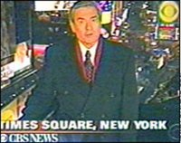
September 2000: Hoping to illustrate its diverse enrollment, the University of Wisconsin at Madison doctored a photograph on a brochure cover by digitally inserting a black student in a crowd of white football fans. The original photograph of white fans was taken in 1993. The additional black student, senior Diallo Shabazz, was taken in 1994. University officials said that they spent the summer looking for pictures that would show the school's diversity -- but had no luck. | 
April 2002: The 1996 Child Pornography Prevention Act (CPPA) extended the existing federal criminal laws against child pornography to include certain types of "virtual porn". In 2002, hearing Ashcroft v. Free Speech Coalition, the United States Supreme Court found that portions of the CPPA, being overly broad and restrictive, violated First Amendment rights. The Court ruled that images containing an actual minor or portions of a minor are not protected, while computer-generated images depicting a fictitious minor are constitutionally protected.
January 2003: This cover of GQ magazine featured a digitally slimmed actress Kate Winslet. Winslet said that the retouching was "excessive." "I don't look like that and more importantly I don't desire to look like that. I can tell you that they've reduced the size of my legs by about a third", said Winslet. | 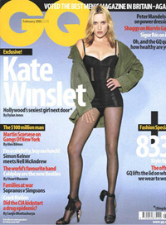
January 2003: The original copy of the Beatles Abbey Road album cover shows Paul McCartney, third in line, holding a cigarette. United States poster companies have airbrushed this image to remove the cigarette from McCartney's hand. This change was made without the permission of either McCartney or Apple Records, which owns the rights to the image. "We have never agreed to anything like this," said an Apple spokesman. "It seems these poster companies got a little carried away. They shouldn't have done what they have, but there isn't much we can do about it now." | 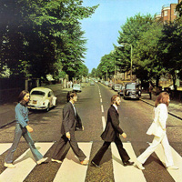
July 2003: This Redbook cover of actress Julia Roberts is a composite of Roberts' head taken at the 2002 People's Choice award, and her body taken at the Notting Hill movie premiere several years earlier. Publisher Hearst admits its mistake: "In an effort to make a cover that would pop on the newsstand, we combined two different shots of Julia Roberts. We acknowledge that we may have gone too far and hope that Ms. Roberts will accept our apology." | 
April 2003: This digital composite of a British soldier in Basra, gesturing to Iraqi civilians urging them to seek cover, appeared on the front page of the Los Angeles Times shortly after the U.S. led invasion of Iraq. Brian Walski, a staff photographer for the Los Angeles Times and a 30-year veteran of the news business, was fired after his editors discovered that he had combined two of his photographs to "improve" the composition. | 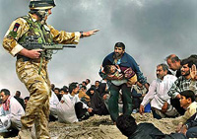
February 2004: This digital composite of Senator John Kerry and Jane Fonda sharing a stage at an anti-war rally emerged during the 2004 Presidential primaries as Senator Kerry was campaigning for the Democratic nomination. The picture of Senator Kerry was captured by photographer Ken Light as Kerry was preparing to give a speech at the Register for Peace Rally held in Mineola, New York, in June 1971. The picture of Jane Fonda was captured by Owen Franken as Fonda was speaking at a political rally in Miami Beach, Florida, in August 1972. | 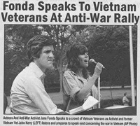
March 2004: This political ad for George W. Bush, as he was running for President, shows a sea of soldiers as a back drop to a child holding a flag. This image was digitally doctored by copying and pasting, from this original photograph, several soldiers to digitally remove Bush from a podium. After acknowledging that the photo had been doctored, the Bush campaign said that the ad would be re-edited and re-shipped to TV stations. | 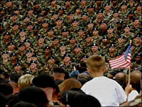
April 2004: This image, which was widely circulated on the Internet, shows a U.S. Marine posing for a photo with two Iraqi children while holding a sign reading "Lcpl Boudreauk killed my Dad then he knocked up my sister". Boudreauk claims that this image was tampered with from the original, in which the sign read "Welcome Marines". A military investigation into potential wrong-doing was inconclusive. It remains unclear if this image is authentic. | 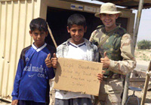
March 2005: This digital composite of Martha Stewart's head on a model's body appeared on the cover of Newsweek as Stewart was emerging from prison "thinner, wealthier and ready for prime time", as the headline reads. Newsweek disclosed the source of the cover image on Page 3 with the lines: "Cover: Photo illustration by Michael Elins ... head shot by Marc Bryan-Brown." | 
March 2005: This Harper's cover, taken at Parris Island, S.C., shows seven Marines lined up in their T-shirts, shorts and socks. The picture accompanied a story about soldiers that go AWOL (absent without leave). The soldiers depicted in the picture, however, were not AWOL. The picture was supplied by Getty Images as a stock photograph. "We are decorating pages," said Giulia Melucci, the magazine's vice president for public relations. "We are not saying the soldiers are AWOL. Our covers are not necessarily representative." | 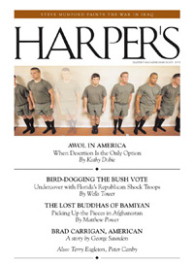
April 2005: An article in the journal Nature reports on the impact of digital photography and image-manipulation software in science. For example, Mike Rossner, editor of the Journal of Cell Biology, estimates that roughly 20% of accepted manuscripts to his journal contain at least one figure that has to be remade because of inappropriate image manipulation. And, in 1990, 2.5% of allegations examined by the U.S. Office of Research Integrity, which monitors scientific misconduct, involved contested scientific images. By 2001, this figure was nearly 26%.
April 2005: In this doctored photograph, British politicians Ed Matts, conservative candidate for Dorset South, and Ann Widdecombe, conservative candidate for Maidstone and the Weald, are shown holding a pair of signs that together read "controlled immigration -- not chaos and inhumanity". This picture appeared as part of Matts' election literature. The original photograph, however, shows the same two candidates campaigning for a Malawian family of asylum seekers to be allowed to stay in Britain. Widdecombe said she was "happy to be associated with either message". | 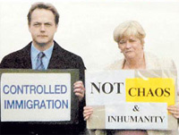
April 2005: This digital composite of actors Brad Pitt and Angelina Jolie, rumored to have a romantic relationship, appeared on the cover of Star Magazine. The picture of Pitt was taken in Anguilla, a Caribbean island, in January 2005. The picture of Jolie was taken in Virginia some time in 2004. On page 8 is a disclaimer noting the image is a "composite of two photographs." | 
June 2005: This picture from the Harvard College viewbook features a doctored version of the Harvard's newspaper March 9, 2005 front page. The headline in the original front page, reading "Summers To Face No Confidence Vote", was replaced with an illegible block of text. A Harvard spokesman confirmed that someone involved with the production of the viewbook had decided to remove the headline -- "It's a mistake, and it should not have happened", he said. | 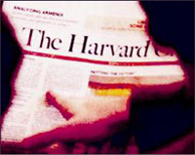
July 2005: This digital composite appeared on a campaign flyer for New York City Democratic mayoral candidate Virginia Fields. The picture shows Fields standing with a diverse group of people. Fields' chief campaign consultant, Joe Mercurio, admitted the picture was a composite of four separate photos. The picture, according to Mercurio, was meant to show that she has broad support and was not intended to deceive anyone. | 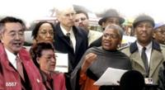
August 2005: Florida Congresswoman Katherine Harris, who is running for a U.S. Senate seat next year, has accused some newspapers of doctoring photos to distort her makeup as a way to poke fun at her. Harris became famous when she oversaw the Florida recount in the 2000 presidential election, that gave George W. Bush a 537-vote victory in Florida. "I'm actually very sensitive about those things, and it's personally painful," she said. "But they're outrageously false. ... Whenever they made fun of my makeup, it was because the newspapers colorized my photograph." Harris and her staff have not, however, been able to cite a specific example of an altered photo. The photo of Harris, shown here, is not known to have been doctored. | 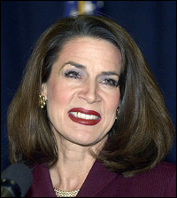
August 2005: A magistrate in Sydney, Australia threw out a speeding case after the police said it had no evidence that an image from an automatic speed camera had not been doctored. This case revolved around the integrity of MD5, a digital signature algorithm, intended to prove that pictures have not been doctored after their recording. It is believed that this ruling may allow any driver caught by a speed camera to mount the same defense.
September 2005: This photo, taken of U.S. President George W. Bush as he sat in a meeting of the United Nations Security Council, shows Bush scribbling a note to Secretary of State Condoleezza Rice reading, "I think I may need a bathroom break. Is this possible?" Reuters' picture editor, Gary Hershorn, explained that sections of the photo were overexposed so a Reuters' processor used the Photoshop technique to "burn down the note." Hershorn says that the photo was not manipulated in any way, but that it was standard practice for such news photos to be enhanced. | 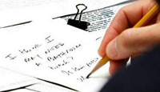
October 2005: In August of 2005, the actor Tom Sizemore was convicted on charges of domestic violence, criminal threats, vandalism, and making obscene and harassing phone calls. In appealing this decision, Sizemore's lawyers contend that pictures showing the victim, Heidi Fleiss, with injuries, were faked. Los Angeles Superior Court Judge Antonio Barreto Jr. has given prosecutors 30 days to prove the photos were not doctored, or produce the person who took the photographs.
October 2005: This doctored photo of Secretary of State Condoleezza Rice appeared alongside a USA Today news story about Rice's comments to U.S. Lawmakers regarding U.S. Troops in Iraq. After receiving complaints from readers, this photograph was removed from USA Today's website, and the following Editor's note appeared alongside a "properly adjusted copy": Photos published online are routinely cropped for size and adjusted for brightness and sharpness to optimize their appearance. In this case, after sharpening the photo for clarity, the editor brightened a portion of Rice's face, giving her eyes an unnatural appearance. This resulted in a distortion of the original not in keeping with our editorial standards. | 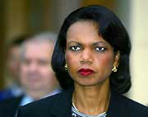
November 2005: This digitally altered image of illustrator Clement Hurd appeared in a newly revised edition of the book "Goodnight Moon", a classic children's book written by Margaret Wise Brown and illustrated by Hurd. The publisher, HarperCollins, altered the original photograph to remove a cigarette from Hurd's hand. HarperCollins said it made the change to avoid the appearance of encouraging smoking and did so with the permission of the illustrator's estate. But Mr. Hurd's son said he felt pressured to allow it. Prior to this latest edition, the photograph of Mr. Hurd grasping a cigarette has been on the book for at least two decades. | 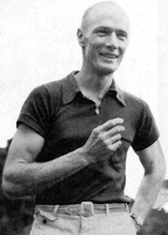
November 2005: Former Rolling Stones' bassist Bill Wyman was digitally removed from this cover of the Rolling Stones album "Rarities, 1971-2003" (Wyman was the bassist for the Rolling Stones from 1962 to 1992). The original photo from which Wyman was removed dates back to 1978 when Wyman was still with the group. | 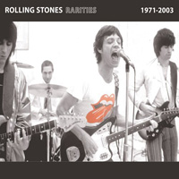
December 2005: A political video produced by the Republican National Committee (RNC) depicts a U.S. solider watching a television where Democratic leaders are speaking critically of the Bush administration's handling of the war in Iraq. The final screen shot, shown to the right, reads "Our soldiers are watching and our enemies are too." As shown in this original frame, this video was digitally altered -- the solider was watching the movie How the Grinch Stole Christmas. | 
January 2006: In 2004, Professor Hwang Woo-Suk and colleagues published what appeared to be ground-breaking advances in stem cell research. This paper appeared in one of the most prestigious scientific journals, Science. Evidence slowly emerged that these results were manipulated and/or fabricated. After months of controversy, Hwang retracted the Science paper and resigned his position at the University. An independent Korean panel investigating the accusations of fraud found, in part, that at least nine of the eleven customized stem cell colonies that Hwang had claimed to have made were fakes. Much of the evidence for those nine colonies, the panel said, involved doctored photographs of two other, authentic, colonies.
January 2006: In 2001, Dr. Jon Sudbo of the Norwegian Radium Hospital in Oslo published a study, in the prestigious journal Lancet, contending that long-term use of certain non-steroidal anti-inflammatory drugs reduced the risk of oral cancer. This finding was touted as a way to shift the focus of treatment away from surgery and toward new drug therapies. These results were cast into doubt when it was revealed that 250 of Sudbo's sample of 908 people in that study all shared the same birthday. In addition, it was revealed that two photographs from a microscope, reportedly representing two different patients at different stages of precancerous mouth lesions, were different magnifications of the same image. The editors of Lancet issued an "expression of concern" saying Sudbo's research was "just complete fabrication."
January 2006: Famed Indian movie star Khushboo is taking legal action against the publishers of Maxim magazine for the publication of a doctored photograph. The photograph was created by digitally splicing Khushboo's head onto another model's scantily clad body. This photograph was published in the Indian version of Maxim under the heading "Women you will never see in Maxim - 100% fake". Magazine editor, Sunil Mehra, said "We are deeply apologetic for causing any inadvertent hurt and offence to Khushboo." Despite an apology, Khushboo plans to go to court, "Indeed the punishment that is finally meted out to them should be a deterrent against anyone who tries to treat women as a commodity and exploit them as they please. I will not opt for any kind of out-of-court settlement," she said. | 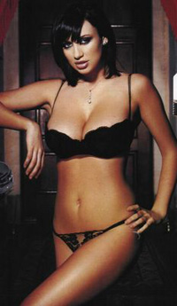
March 2006: This cover of the San Antonio Observer features a San Antonio police officer wearing a white hood of the Ku Klux Klan. The newspaper admits that they digitally inserted the hood and gun into the original photograph. Police spokesman Joe Rios said that the Observer defamed the character of the officer in the photograph. "You can clearly read his badge number," Rios said. "I can tell you that the officer who was depicted in that picture is very upset." Ida Brown, an Observer spokeswoman, disputed that the officer's badge number could be discerned on the cover and said the image was not intended as a personal attack. "Primarily, the picture shows that there are racist police officers on the force, and they do target minorities who are innocent," Brown said. | 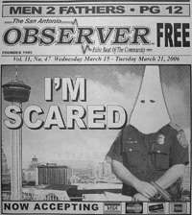
March 2006: This March 12th cover of the New York Times Magazine shows former Virginia Governor Mark Warner, a possible contender in the 2008 U.S. presidential race. After receiving complaints from Warner's campaign about the accuracy of this photo, the New York Times published the following correction. "The cover photograph in The Times Magazine on Sunday rendered colors incorrectly for the jacket, shirt and tie worn by Mark Warner, the former Virginia governor who is a possible candidate for the presidency. The jacket was charcoal, not maroon; the shirt was light blue, not pink; the tie was dark blue with stripes, not maroon. The Times's policy rules out alteration of photographs that depict actual news scenes and, even in a contrived illustration, requires acknowledgment in a credit. In this case, the film that was used can cause colors to shift, and the processing altered them further; the change escaped notice because of a misunderstanding by the editors." | 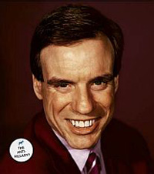
April 2006: New Orleans Mayoral Candidate Kimberly Williamson Butler digitally inserted herself into this photograph of what appeared to be the French Quarter in New Orleans. The setting, however, was the New Orleans Square at Disneyland. This photo was then manipulated again to remove a Disneyland trash can from the background. | 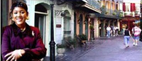
June 2006: This photograph, showing two police officers standing by as prostitutes in Cuba hail a foreign tourist, appeared in the El Nuevo Herald under the headline "Hookers: The Sad Meat of the American Dollar". This image, however, was a composite of two separate photographs taken by veteran photographer Roberto Koltun, and published over his objections. "Two things were put together," commented photo coordinator Orlando Mellado. Asked why the photograph was published, Mellado responded "that's a decision that was made by another editor." | 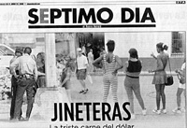
July 2006: This controversial ad appeared as part of the Ohio Senate campaign between incumbent Mike DeWine (R) and challenger Sherrod Brown (D). DeWine's campaign created a video of the World Trade Center in flames to attack Brown as soft on terrorism. The ad shows the south tower burning -- the north tower was hit first, however, so the south tower could not be burning without the north tower burning as well. A DeWine spokesman acknowledged the image was a "graphic representation" by the firm that produced the ad, which used a still photo of the towers with computer-generated smoke added. | 
July 2006: The Charlotte Observer fired Patrick Schneider, a staff photographer, for altering this image of a fire fighter. Following the incident, the paper released the following statement: "Photographer Patrick Schneider's photo depicted a Charlotte firefighter on a ladder, silhouetted by the light of the early morning sun. In the original photo, the sky in the photo was brownish-gray. Enhanced with photo-editing software, the sky became a deep red and the sun took on a more distinct halo. The Observer's photo policy states: No colors will be altered from the original scene photographed." Schneider said that he only meant to restore the actual color of the sky that was lost when he underexposed the photo. Schneider was suspended in an earlier episode after it was revealed that his award-winning photographs had been manipulated. Scheider allowed this case to be used to educate other professional photographers in ethics seminars. At the time he pledged, "I will no longer tone my background down that far." | 
August 2006: This photograph by Adnan Hajj, a Lebanese photographer, showed thick black smoke rising above buildings in the Lebanese capital after an Israeli air raid. The Reuters news agency initially published this photograph on their web site and then withdrew it when it became evident that the original image had been manipulated to show more and darker smoke. "Hajj has denied deliberately attempting to manipulate the image, saying that he was trying to remove dust marks and that he made mistakes due to the bad lighting conditions he was working under", said Moira Whittle, the head of public relations for Reuters. "This represents a serious breach of Reuters' standards and we shall not be accepting or using pictures taken by him." A second photograph by Hajj was also determined to have been doctored. | 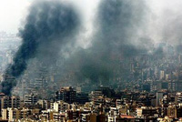
August 2006: The Reuters news agency published a photograph showing the remnants of an Israeli bombing of a Lebanese town. In the week that followed, hundreds of bloggers and nearly every major news organization reported that the photograph had been doctored (see above entry). These political cartoons reflected the general consensus of outrage and anger. | 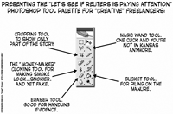  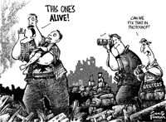
August 2006: An Easton, Middlesbrough (UK) man, Stafford Sven Tudor-Miles, scanned photographs of adult porn stars into his computer and digitally altered them so that the women appeared to be of girls under the age of 18. The 38-year-old fine art student was charged with possessing indecent pseudo-images of children. His barrister argued that the pictures were of adults and, therefore, no offense had been committed. Under the Protection of Children Act 1978, as amended by the Criminal Justice and Public Order Act 1994, a pseudophotograph of a child is defined as an image, whether made by computer graphics or otherwise, which appears to be that of a child. Possession or creation of such an image is, therefore, illegal. Tudor-Miles pleaded guilty to five counts of attempting to make indecent pseudo-photographs of children, one charge of possessing indecent pseudo-photographs and one of breaching a sex offenders order. Tudor-Miles will be sentenced on September 8.
August 2006: Nathan Noy, a rival of Rep. Jean Schmidt (R-Ohio), contends that this picture on Schmidt's webpage showing her at a 1993 Marathon has been doctored. The photo shows Schmidt near the finish line with the time clock showing 3:19:06. But a newspaper list does not include Schmidt's name. Joseph Braun, an attorney representing Schmidt, denied that the photograph is fake. He produced what he said was an official race results book, listing Schmidt as the fifth-place finisher in her age group with a time of 3:19:09. A four-member commission panel ruled that there was enough evidence to look into the complaint. UPDATE: Citing the lack of evidence or witnesses, a unanimous Ohio Elections Commission dismissed the campaign complaint against Schmidt. After the hearing, Noy admitted he made a mistake pursuing the complaint. | 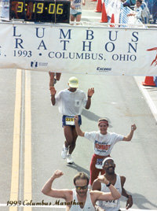
September 2006: A photograph of CBS news anchor Katie Couric was digitally altered from this original to give Couric a trimmer waistline and a thinner face. This photo appeared in CBS' in-house magazine Watch! CBS spokesman, Gil Schwartz, said "the doctored image was the work of a CBS photo department employee who got a little zealous". Schwartz added, "I talked to my photo department; we had a discussion about it; I think photo understands this is not something we'd do in the future." | 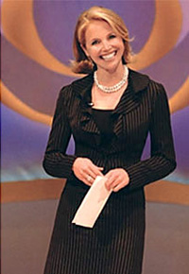
September 2006: This image was posted on no-to-ned.blogspot.com, a website supporting Senate Democrat Joseph Lieberman. In reference to Lieberman's opponent, the accompanying caption read "Four out of Five Terrorists Agree Ted Lamont for Senate". "As soon as we saw it, we immediately pulled it down," Lieberman campaign spokeswoman Tammy Sun said. "We condemn things like this. It has no place in our political discourse or on our web site." | 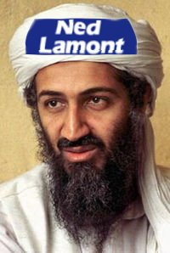
September 2006: The Dubliner apologized for a story depicting the wife of famed golfer Tiger Woods in doctored pornographic images. The article read, in part, "Most American golfers are married to women who cannot keep their clothes on in public. Is it too much to ask that they leave them at home for the Ryder Cup? Consider the evidence - Tiger Woods' wife Elin Nordegren can be found in a variety of sweaty poses on porn sites across the Web.". After Woods publicly denounced the story, the magazine apologized: "The publisher and staff acknowledge that the satirical article was inappropriate. We wish to sincerely apologise to Tiger Woods, his wife Elin Nordegren and other Ryder Cup players and their families for any offence they may have taken to it. The article was written as a satirical piece and, in the context of the entire article, the publishers believed the readers would not be left with the impression that there was any truth in the assertions, it being an absurd parody of inaccurate tabloid publishing generally. If any contrary impression was given it certainly was not intended and for this the publishers unreservedly apologise"
October 2006: This movie poster for Shut Up and Sing (a film about the criticism of the musical group Dixie Chicks that followed lead singer Natalie Maines' comments about being ashamed that President Bush was from her home state of Texas) was doctored from its original. In this doctored version, sheets were added to the members so as to be less revealing. | 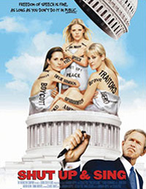
October 2006: An Ohio Republican Party news release attacked Democratic Rep. Sherrod Brown for enlisting the support of comedian Al Franken. The news release was accompanied by a photograph, showing Franken dressed up like a baby bunny, wearing adult diapers and clutching a fluffy white teddy bear. Andy Barr, director of Franken's Midwest Values PAC, confirmed, "The picture is a fake." The Ohio Republican Party used a 2004 photo of Franken for the doctored image. UPDATE (July 2009): Shortly after Senator Al Franken was seated in the U.S. Senate, Cincinnati Enquirer columnist Peter Bronson re-published this doctored photo under the heading "Is this who you want making decisions about your health care?" In his retraction, Bronson wrote "Last week I posted a blog about comedian Al Franken joining the Senate, including a picture of Franken wearing bunny ears and a diaper. Franken did many things on Saturday Night Live that could be embarrassing to a Senator. But apparently, that was not one of them. It turns out the picture was photoshopped. We don't knowingly run false pictures, so I took it down and replaced it with another goofy picture of Sen. Franken." | 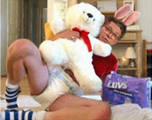
November 2006: This photo of ABC News' Elizabeth Vargas breastfeeding her baby while at her anchor desk accompanied an article with Vargas about balancing work and motherhood. The image was created by digitally combining a head shot of Vargas with another image. The article is scheduled to appear in next month's issue of Marie Claire Magazine. A spokesperson for the magazine called Vargas "a great journalist," and added that "We do not believe anyone seriously thought she would nurse and report the news at the same time!" | 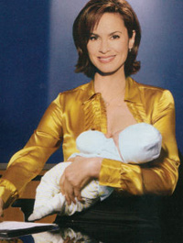
February 2007: The campaign of Tung Nguyen (second from left) for Orange County supervisorial candidate doctored a photo placing Nguyen close to Governor Schwarzenegger. The photo appeared in two Vietnamese-language daily newspapers. Although Nguyen attended the event with Schwarzenegger, he was not standing next to him. Instead, Nguyen's head was spliced onto another person's body. Nguyen's campaign first blamed the alteration on an advertising company and then on a campaign volunteer. | 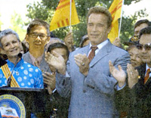
March 2007: This image of former U.S. President Ronald Reagan appeared on the cover of Time magazine under the headline "How the Right Went Wrong". The image was doctored to include a tear on Reagan's face. Time issued a statement saying it regularly runs what it calls "conceptual covers." They said: "This week's cover image is clearly credited on the table of contents page, naming both the photographer of the Reagan photo and the illustrator of the tear." | 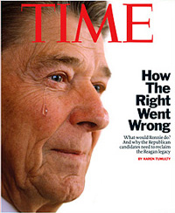
April 2007: Under the headline "Rove personally connected to email scandal", this photo of presidential adviser Karl Rove, was said to provide evidence that the White House had created an independent e-mail system for communicating outside of the White House's email system, which is automatically archived for record-keeping. The doctored photo, however, was part of an April Fool's joke, and marketing campaign by the Internet design company Coptix. "We watched the misinformation filter upward and outward," said a Coptix spokesman. "This has driven tens of thousands of visitors to our Web site. ... We consider our Web marketing experiment a success." | 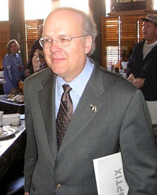
April 2007: Newspaper photographer Allan Detrich resigned from The Blade of Toledo Ohio after admitting he had altered a photo that appeared in the paper. Detrich submitted at least 79 photos for publication since the beginning of the year that were digitally altered, 58 of which appeared in print. In a printed letter to readers, Blade Editor Ron Royhab said "the changes Mr. Detrich made included erasing people, tree limbs, utility poles, electrical wires, electrical outlets, and other background elements from photographs. In other cases, he added elements such as tree branches and shrubbery." The Blade released three examples of how Detrich altered photos. "Readers have asked us why this was such a big deal. What's wrong with changing the content of a photograph that is published in a newspaper? The answer is simple: It is dishonest," Royhab wrote. "Journalism, whether by using words or pictures, must be an accurate representation of the truth." | 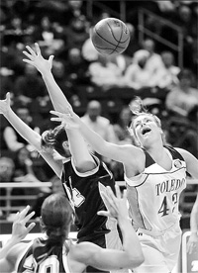
April 2007: The New York Times published this digitally altered photograph. In a correction, the Times' editor said "The wood siding at the far left of the building was out of alignment because the picture was retouched by a Times staff member who took the picture, but who is not a staff photographer. He altered it because a flash created a white spot on the picture when he shot it through the window of a train. Also, the retouching tool left a round circle on the building's window at the right". The Editor's note concludes with "Times policy forbids the manipulation of any photograph. Had editors been aware of the manipulation and seen the original picture, they would have either published the picture with the blemish or not used it." | 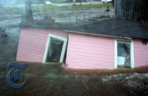
May 2007: In an advertisement for IMAX 3D theaters promoting the latest Harry Potter movie, the bust of actress Emma Watson was digitally enlarged. A similar advertisement in regular theaters was unaltered. Warner Brothers Pictures released a statement that said "This is not an official poster. Unfortunately this image was accidentally posted on the IMAX website. The mistake was promptly rectified and the image taken down." | 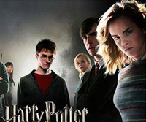
May 2007: The biceps of tennis player Andy Roddick were conspicuously enlarged on the cover of Men's Fitness magazine. Roddick commented that he was "pretty sure I'm not as fit as the Men's Fitness cover suggests". He also noted that a prominent birthmark on his right arm had been erased. Richard Valvo, a spokesman for Men's Fitness, said, "We wouldn't comment on any type of production issue." Adding, "I don't see what the big issue is here." | 
July 2007: This cover of Redbook magazine shows a heavily re-touched (and thinner) image of singer and actress Faith Hill. Redbook was accused of contributing to the unattainable body image created by digital re-touching. In response, Redbook's editor in chief Stacy Morrison said, "The retouching we did on Faith Hill's photo for the July cover of Redbook is completely in line with industry standards." | 
July 2007: Missouri University professor R. Michael Roberts and co-authors retracted their paper (Cdx2 Gene Expression and Trophectoderm Lineage Specification in Mouse Embryos) published in Science after an investigation revealed that accompanying images were doctored. Contrary to conventional wisdom, the published research presented evidence that the first two cells of mouse embryos possess markers that indicate from a very early stage whether they will grow into a fetus or placenta. An investigating university committee found that lead author and post-doctoral researcher Kaushik Deb deliberately altered images of the embryos. Deb abruptly resigned his position and moved with no forwarding address or explanation. The committee said Roberts was cleared of wrongdoing by the committee, but that there was some concern over "whether he had acted appropriately at all times" during the research period. "Since he addressed that in the letter he sent to Science, we had no reason to suspect anything other than that he had been tricked." | 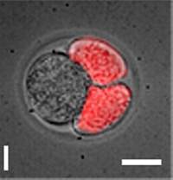
August 2007: The Kentucky state Republican Party distributed campaign flyers that depict Steve Beshear, the Democratic nominee for Governor, as a high-roller leaning on a casino table. "Don't gamble on Steve Beshear and his fool's gold casino plan," says the campaign material. State Republican party chairman Steve Robertson said the photo is of Beshear's head but someone else's body. "It is a humorous way to communicate the message", Robertson said. | 
August 2007: The French Magazine Paris Match altered this photograph of French President Nicolas Sarkozy by removing some body fat. The magazine said it had tried adjusting the lighting on the picture. "The correction was exaggerated during the printing process," the magazine said. | 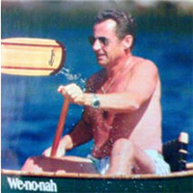
September 2007: British Culture Secretary James Purnell (far right) was digitally inserted into this photo at the opening of Tameside hospital in Lancashire. Purnell arrived late to the opening and the hospital asked if it could add his image to their record of the event. The hospital said in a statement: "As we would not be able to stage a repeat of this historic day for the hospital, we decided to take a photograph of Mr Purnell in the same spot very shortly after and merge it with the earlier photograph, to which Mr. Purnell kindly consented." A Purnell spokeswoman denied that he agreed to the picture being doctored. "He was assured they would show the three MPs in one picture and have him separately in the corner." | 
September 2007: Mikhail Delyagin was (mostly) digitally removed from a video after he made remarks critical of Russian Prime Minister Vladimir Putin. Shown here is a still frame from video of the television show "The People Want to Know". Only part of Delyagin was completely removed -- his leg and hand remain visible to the right of the man holding the microphone. | 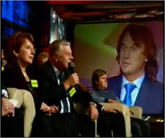
November 2007: Zhou Zhenglong from Shaanxi China claimed to have taken 71 photographs of the almost extinct South China tiger. Shown here is one image that was released to the public. Shortly after its release, it was determined that this image was a fake -- the most likely scenario is that the photograph is that of a life-size poster. This animation shows that the poster and photograph are nearly identical. | 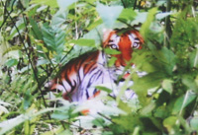
November 2007: A study by Dario Sacchi, Franca Agnoli and Elizabeth Loftus, published in the journal Applied Cognitive Psychology, shows that people's memories of events can be altered by viewing doctored images. For example, when presented with doctored images of the 1989 Tiananmen Square protest participants recalled the event as larger and more violent (shown in the lower panel is the doctored image in which the crowd was added). | 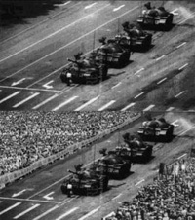
November 2007: Artists Nora Ligorano and Marshall Reese created the exhibit "Line Up" depicting doctored photographs of George W. Bush and members of his administration. The exhibit, being shown at the New York City Public Library, is critical of the war in Iraq. "It is simply inappropriate to have political attack art, in the form of egregious doctored photographs of the President and other high-ranking officials who have dedicated their lives to public service, in a taxpayer-funded building frequented by schoolchildren and the general public," said Matthew Walter, director of communications for the state GOP. In response, Roberta Waddell, curator of the library's print collection, said the exhibit was in keeping with a historical tradition, calling the exhibit a relevant example of political commentary. | 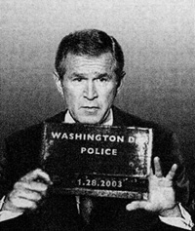
December 2007: The Asbury Park Press published this doctored photo of New Jersey Governor Jon Corzine as part of a story critical of Corzine's financial restructuring plans. In a letter to the Press, Corzine's chief of staff, wrote, in part, "Images that are nothing more than editorial cartoons morphed into photographs are fine -- for the editorial page. But placement of such images on the front page of the Sunday edition demonstrates a disregard for objective reporting." The Press's executive editor said that the photo did not blur the line between news reporting and editorial commentary. "That wasn't what we were trying to do," he said. "We were just trying to frame the story for readers. We were doing it in a way that was a little edgy, and in a way that would grab your attention." | 
January 2008: Taiwan's newspaper Liberty Times published this doctored photo of a delegation, led by the chairman of the Franz Collection, being met by the Pope. In the original photo, Wang Shaw-lan, a publisher of competing newspaper United Daily News, was removed. A Liberty Times reporter said that she removed Wang whom she said was "not an essential presence" and in order to shrink the picture for "better display". Later, Liberty Times said that the doctored picture came from the Franz Collection, but a Franz Collection spokesman said the newspaper had asked it to airbrush out Wang. | 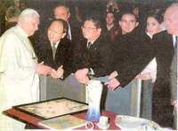
January 2008: This brochure of Texas Republican Congressional candidate Dean Hrbacek was mailed to voters. The photograph is a composite of Hrbacek's head and another person's (slimmer) body. Campaign manager Scott Broschart acknowledged that the image is a composite. Hrbacek has been so busy that he had no time to pose for a full-length photo for the mailing, Broschart said. "He may appreciate that we took a few pounds off him," Broschart said. "I think the voters ... are more concerned with the issues as opposed to pretty photo shoots." | 
January 2008: This magazine cover featuring pop star Britney Spears is a composite of her head and a model's body. The magazine cover states "Truthiness Alert: This cover image is a composite photo. Britney did not pose for this picture. That, sadly, is not her body." | 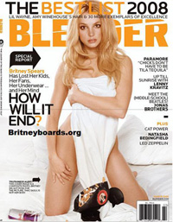
February 2008: This photograph, by Liu Weiqiang of the Daqing Evening News, won an award for "one of the ten most impressive news photos of 2006". This photograph was recently revealed to be a composite of two separate photographs: the antelopes and the train. Weiqiang says that he never published the picture as a news photograph. Weiqiang also wrote in his blog, "I admit it's unfaithful, as well as immoral for a photographer to present a fabricated picture. I'm truly sorry." | 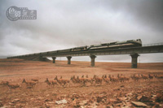
July 2008: In response to a New York Times story that suggested the FOX network’s ratings might be slipping, the co-hosts of “Fox & Friends” broadcasted photos of Times reporter Jacques Steinberg and editor Steven Reddicliffe. The photos were doctored to make the journalist appear less attractive. A FOX spokeswoman said the executive in charge of “Fox and Friends” is on vacation and not available for comment but added that altering photos for humorous effect is a common practice on cable news stations. | 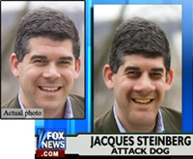
July 2008: This image of an Iranian missile test appeared on the front page of many major newspapers. The image is from the web site of Sepah News, the media arm of Iran's Revolutionary Guards. After the publication of this photo, it was revealed that the second missile from the right was digitally added to the image in order to conceal a missile on the ground that did not fire. | 
July 2008: This photo of Britian's Prince William appeared on the pages of The Sun. A person in the back of the boat was digitally removed from this photo (except for their knee). The Metro ran the unaltered photo, as did the on-line version of The Sun. | 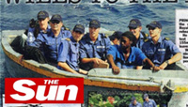
August 2008: Chris Myers, the Republican candidate for the U.S. House of Representatives, is criticizing his opponent, John Adler, and the Democratic Congressional Campaign Committee for a doctored photo that appeared on a campaign mailer produced by the DCCC. The mailer includes a photo that appears to show Myers walking with President George W. Bush. Myers said he has never met the President. | 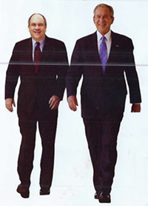
September 2008: This photo of Governor Sarah Palin was widely distributed across the Internet shortly after Palin was announced as the vice presidential nominee for the Republican ticket. Shortly after its release the photo was revealed to be a composite of Palin's head, and somebody else's body. | 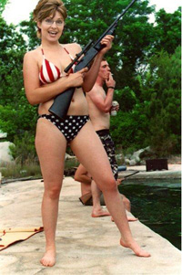
September 2008: After publishing photos of two deceased United States soldiers, the Associated Press retracted the photos after learning that one of the photos was digitally altered. Shown here are the photos, where the photo on the left is a composite of this soldier's head and the body of the soldier on the right. The photos were released by the U.S. Army at Fort Stewart in Georgia. | 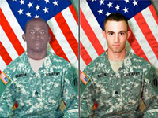
November 2008: This cover of Time Magazine shows an electronic voting machine with an incongruous shadow that was digitally inserted into the photo (notice that the shadow from the two front legs emerge directly from underneath the legs, while the shadow for the wide back leg is floating between the front and back legs). | 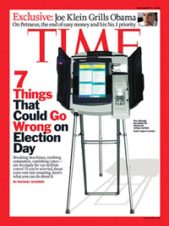
October 2008: This front-page photo of Justice Minister Rachida Dati appeared in the French newspaper Le Figaro in June of 2008. A large diamond ring on Dati's hand was digitally removed. This photo editing caused controversy regarding the alleged influence that the Sarkozy administration wields over the French press. The head of Le Figaro's photo department defended the editorial decision saying that the newspaper did not want to distract readers from the content of its interview with Dati. | 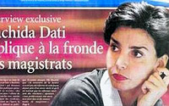
February 2009: This photo of Heath Ledger and Christopher Nolan of "The Dark Knight" appeared in Vanity Fair as part of a series of photographs of acclaimed actors and directors. The photo of Ledger, who died in 2008, is from 2005 as he was promoting the film "Brokeback Mountain". Nolan (shown on the left) was digitally inserted into this photo. | 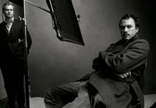
March 2009: A ceremony on March 7th in Taiwan was held to honor Chinese soldiers who died in Papua, New Guinea during World War II. This photo shows a "spirit tablet" used as part of the ceremony. When the photo appeared on Sina, a Chinese website, the text which read "The army of Republic of China" was digitally removed. In Taiwan, the government uses the phrase The Republic of China, while the Chinese government uses the phrase The People's Republic of China. | 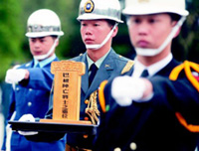
April 2009: This photo shows Prime Minister Benjamin Netanyahu (center left), President Shimon Peres (center right), along with members of the Cabinet. The Israeli newspaper Yated Neeman digitally removed two female Cabinet members from the photo and replaced them with male members. The newspaper Yated Neeman is considered to be ultra-orthodox and not supportive of females in the cabinet. | 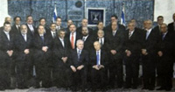
June 2009: This cover of Toronto's summer edition of Fun Guide was digitally altered to be more inclusive, keeping with an editorial policy to reflect diversity. "He superimposed the African-Canadian person onto the family cluster in the original photo," said communications director John Gosgnach. The original image was of a family of indeterminate ethnic background. "When you're publishing something with the deadlines and you don't have the right photo, the objective is to communicate the service," Mr. Sack, director of strategic communications, said. | 
June 2009: This photo of a group of members of the Scottish National Party (SNP) appeard in a SNP newsletter. The two photos in the background of Scottish legends William Wallace and Robert the Bruce were digitally inserted, replacing royal portraits of the Queen and the Duke of Edinburgh. Local SNP councillor Cecil Meiklejohn blamed an "overly enthusiastic" local party member for removing the royal portraits. | 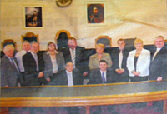
July 2009: A picture essay in The New York Times Sunday Magazine entitled "Ruins of the Second Gilded Age", by Edgar Martins, showed large housing construction projects that were halted due to the housing market collapse. The introduction said that the photographer "creates his images with long exposures but without digital manipulation." After discovering the photo manipulations, the Times posted the following on their website. "After a reader discovered that the photos were digitally altered, Editors later confronted the photographer and determined that most of the images did not wholly reflect the reality they purported to show. Had the editors known that the photographs had been digitally manipulated, they would not have published the picture essay, which has been removed from NYTimes.com." | 
August 2009: This photo from the web site of Microsoft's Polish subsidiary was doctored to change the race of one of the people. The original photo appeared on Microsoft's U.S. web site. "We are looking into the details of this situation. We apologize and are in the process of pulling down the image", said a Microsoft representative. The doctored photo on the Polish was removed and replaced with the original photo. | 
September 2009: This magazine advertisement by Ralph Lauren depicts a heavily manipulated photo of model Filippa Hamilton. After numerous reports citing this latest example of extreme photo manipulation, a Ralph Lauren representative admitted to "poor imaging and retouching", and added, "we have learned that we are responsible for the poor imaging and retouching that resulted in a very distorted image of a woman's body. We have addressed the problem and going forward will take every precaution to ensure that the calibre of our artwork represents our brand appropriately." | 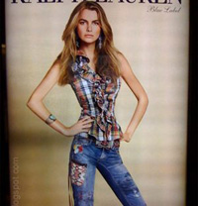
December 2009: A magazine ad for an Olay beauty product featuring the model Twiggy has been banned in the United Kingdom by the Advertising Standards Authority (ASA). "Olay is my secret to brighter-looking eyes," read the ad, "... reduces the look of wrinkles and dark circles for brighter, younger-looking eyes," the ad continued. In its ruling, the ASA said that it considered that the post-production retouching of the original ad, specifically in the eye area, could give consumers a "misleading impression of the effect the product could achieve". An Olay spokesperson said the "minor retouching" had been inconsistent with its policies and it had already replaced the image with one with "no postproduction work in the eye area". | 
April 2010: Three astronauts living aboard the International Space Station sent to Mission Control this April Fool's Day prank photo of themselves floating in space without spacesuits. "You have a real problem", responded Mission Control. "Don't worry, we are wearing sunscreen", responded the astronauts. | 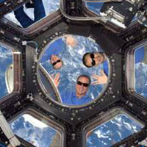
Home Papers Research

