COMPUTERS vs. NEWSPAPERS

DUSTIN by Steve Kelley & Jeff Parker
(week of 12/5/11)

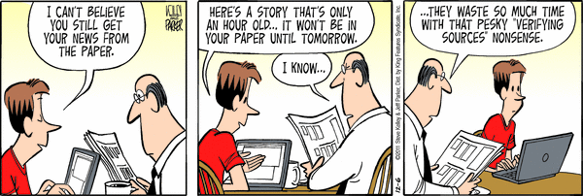



BUCKLES by David Gilbert
(week of 12/5/11)



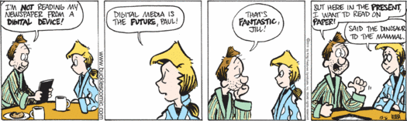

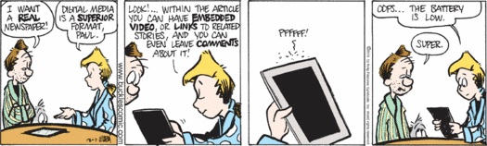

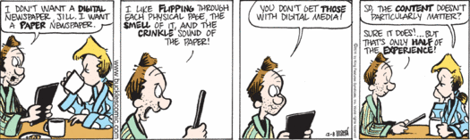

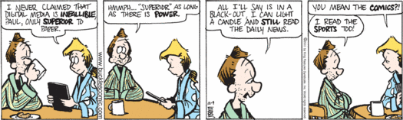
< http://www.seattlepi.com/comics-and-games/fun/Buckles/2011-12-05/ >

