ANALOGY: Valentine’s Day is like Welfare
- Mallard Fillmore
- by Bruce Tinsley
- 2/14/16
- http://mallardfillmore.com/comics/february-14-2016/

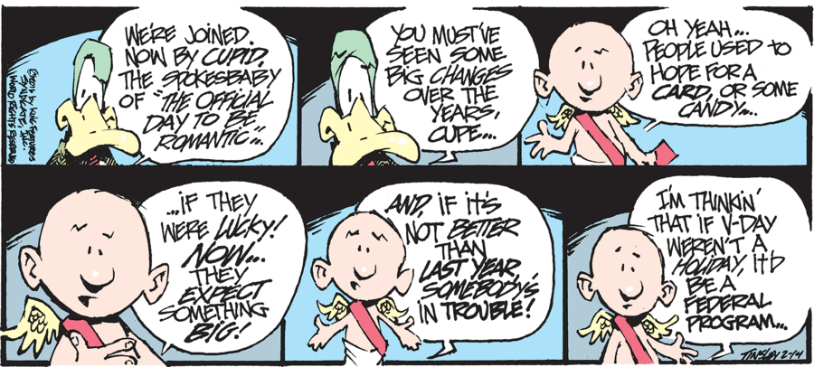

- Started with the best of intentions
  - Now warped into a perversion of its former self
- Something for nothing
- While can be for anyone, it’s especially for certain people
- Something that’s always there – now it seems “natural,” expected, like it’s always been there
- A holiday, a special day, a break, a reward, a day of exception, a suspension of work
- Sense of entitlement
- Escalation: more & more each year

BUT
- If you’re in favor of Valentine’s Day, or look at it favorably
- Then you might look to other government programs
- SOCIAL SECURITY:
  - a reward for hard work
  - you’ve paid into something & now it’s time to get something back
  - the government doesn’t “have to” give us money back (it could just keep it!)
  - maybe there’s a sense of need – just when you need it most (that time of life or of the year that something like this come in handy, just in time)
  - …

* I’m neither agreeing nor disagreeing with Tinsley – merely showing how an analogy topic can be sparked by something in the newspaper.

