POLITICS
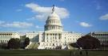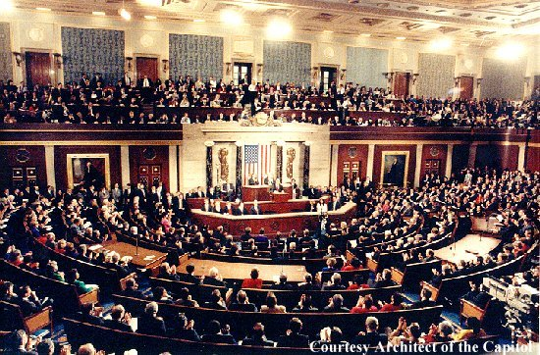
+
THEATER
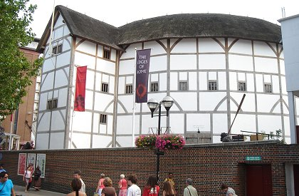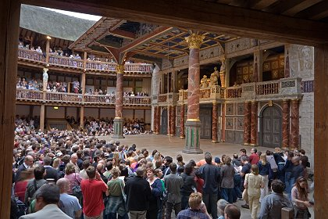
=
The THEATRICALITY of POLITICS
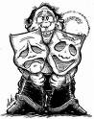

- politics = a play
  - costuming
  - staging
  - blocking
  - script
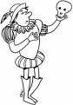
  - a show/performance
  - an audience
  - acting (feigned actions, behaviors, feelings,…)
  - ….
- or politics & the WWE:
  - costuming
  - staging
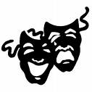
  - blocking
  - script
  - a show/performance
  - an audience
  - acting
  - "sides" (good guys & bad guys)
  - fans choose favorites, associate w/them
CASE IN POINT: 2008
- “Unity” New Hampshire?
- “She rocks”?!
- “Unite for Change”?!
- “To anyone who voted for me and is now considering not voting or voting for Senator [John] McCain, I strongly urge you to reconsider […] to create an unstoppable force for change we can all believe in.”
- “Unity is not only a beautiful place as we can see, it's a wonderful feeling, isn't it?”
- “I've admired her as a leader, I've learned from her as a candidate. She rocks. She rocks. That's the point I'm trying to make. […] I know firsthand how good she is, how tough she is, how passionate she is, how committed she is the causes that brought all of us here today.”

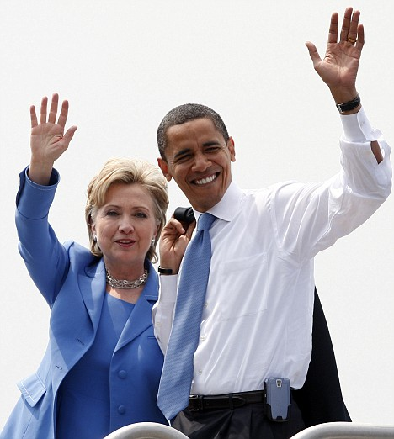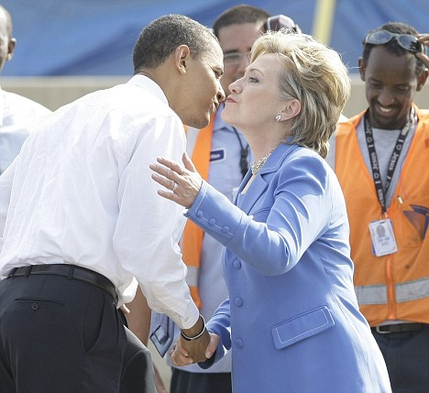
<http://www.dailymail.co.uk/news/worldnews/article-1029952/
Unity-Clinton-Obama-helps-pay-debts-declares-We-family.html>
<http://www.abcnews.go.com/Politics/Politics/story?id=5260946&page=1>

