Little Seagull Handbook –
COMPANION SITE
http://www.wwnorton.com/college/english/write/little-seagull-handbook-2/section/exercises/exercises.aspx

- 1st PAGE screen shot:
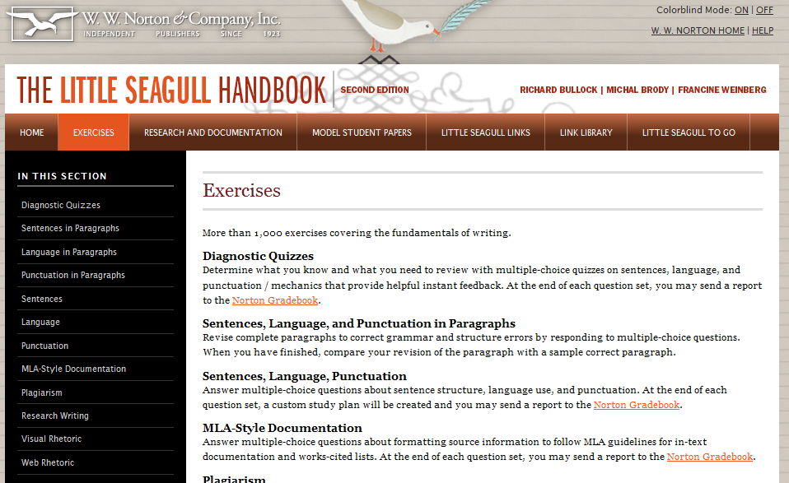
Links to the Exercises: Sentences (S-) & Punctuation (P-)

- SENTENCES in Paragraphs:
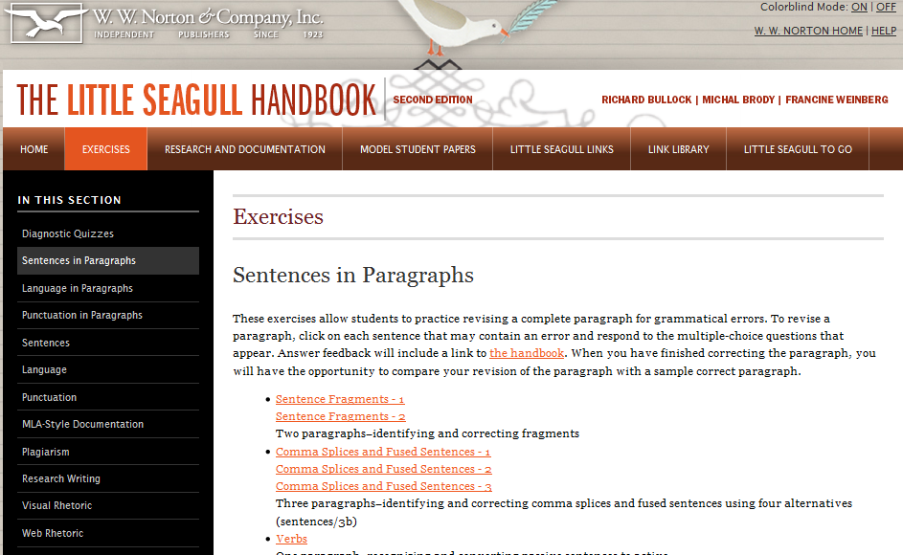
This page has exercises for:
- Fragments
- CS & RO
- S-V Agree.
- PN Agree., Reference
- Parallelism

- PUNTUATION in Paragraphs:
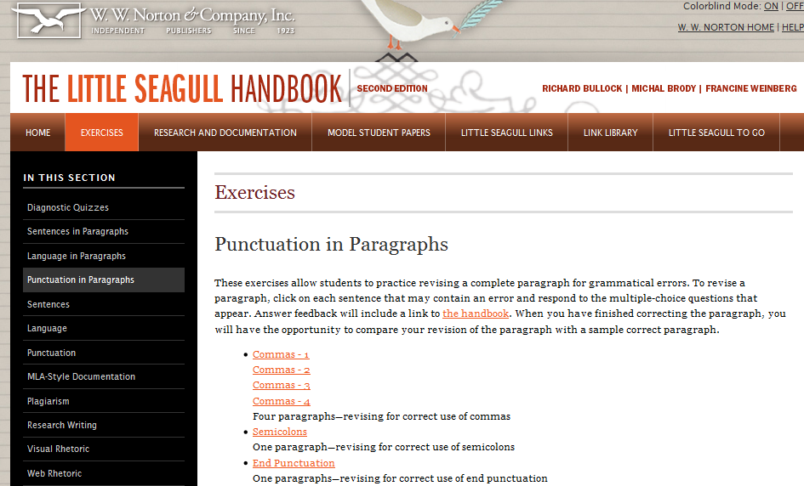
This page has exercises for:
- Commas
- Semicolons
- Apostrophes
- Hyphen

- # of QUESTIONS:
  - some exercises have a choice of the # of questions
  - I tell you this for each exercise in the 4th column of the Exercises Sheet

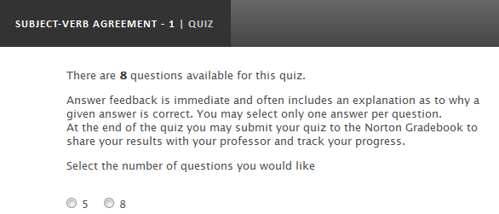
- Do how many I tell you

- SUBMIT YOUR RESULTS TO ME:
  - at the end of each exercise (“quiz”) you the box below appears:
  - send to me at shousenick@luzerne.edu

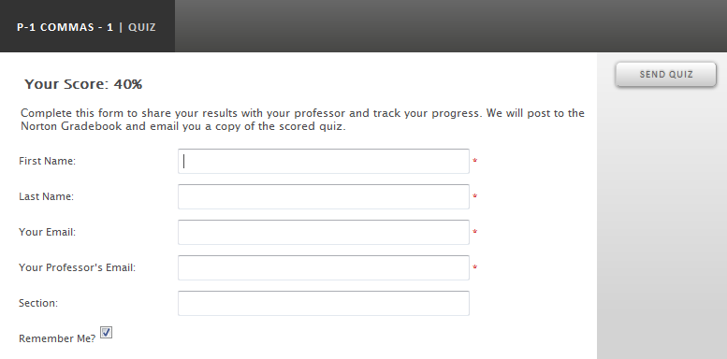
shousenick@luzerne.edu
most of the exercises I have chosen are sets of 10 multiple choice, self-grading questions

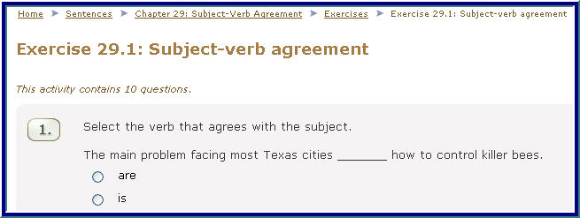

  - “submit answers for grading” & receive immediate feedback

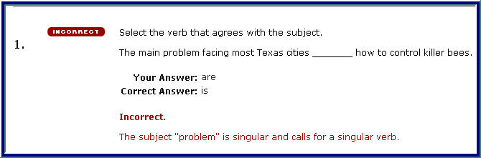

- Email me the results:
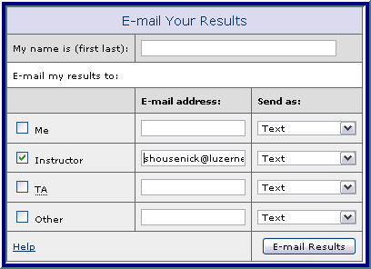
shousenick@luzerne.edu
First Last, Course & Section

you must achieve at least 75% correct
on each grammar exercise

